Tableau Lecture 4

Table of content:

| Table of content:  Agenda:  Dataset used for the class:  Filters in tableau  Extract filter  Business Problem 1 [Data Source Filter] : Show orders which made profit >= 1K  Business Problem 2 [Dimension and Measure filters] : Create a visualization to show all subcategories and categories along with average profit. Just show those categories which are profitable and sort the data in descending order per category  Business Problem 3[Context Filter] : Show top 10 furniture items based on sales  Business problem 4: Allow users to filter out the top 10 products subcategories by average discount.  Business problem 5: Build a Hierarchy of Product category and Sub Category and have a plot which displays sales of product by category and drill it down using the hierarchy to display sales by sub category  Business problem 6: -find average cost of each product sub categories  Business problem 7 - Find profit ratio of each product sub categories  Business problem 8: Allow users to select the field against which they want to compare the sales value. |
| --- |

#### Agenda:

* Parameters
* Hierarchy
* Filters
  + Data source
  + Context filter (Asked frequently in interviews)
  + Dimension filter
  + Measure filter
* Calculated field
* Types of calculation
* Basic expression
  + Row-level
  + Aggregate level
* Using parameters in a calculated field
* Data granularity and Aggregation and the difference between them

### Dataset used for the class:

[Sample - Superstore-Main.xlsx](https://docs.google.com/spreadsheets/d/1sM1Kjgy99k2tHBtKP5OXcpQLz7SC5yGr/edit?usp=sharing&ouid=107681937864127182413&rtpof=true&sd=true)

Post Read: [Post Read Doc](https://docs.google.com/document/d/1jl7y79QbdWKFJD48Od9yIo984VuFI4BKkao86F-8kn0/edit?usp=sharing)

#### Filters in tableau

Filtering is nothing but removing some scope of data from a data set. Filters are very helpful to create dashboards in Tableau. Filters can help to minimize the size of data sets for efficient use, eliminate irrelevant dimension elements, clean up underlying data, set date ranges and measures as required, simplify and organize data, etc.

#### Business Problem 1 [Data Source Filter] : Show orders which made profit >= 1K

* **Business Context**
  + Very frequently, we need to create customized report to identify the high value clients so we can provide customized or high touch support. Think about privileged clients of bank or members of hotel
* **Intro to Data Source Filter:**
  + The data source filter in tableau helps in the direct application of the filter environment to the source data and quickly uploads data that qualifies the scenario into the tableau workbook.
* **Demonstration of creating data source filter**
  + Step-1: import the data

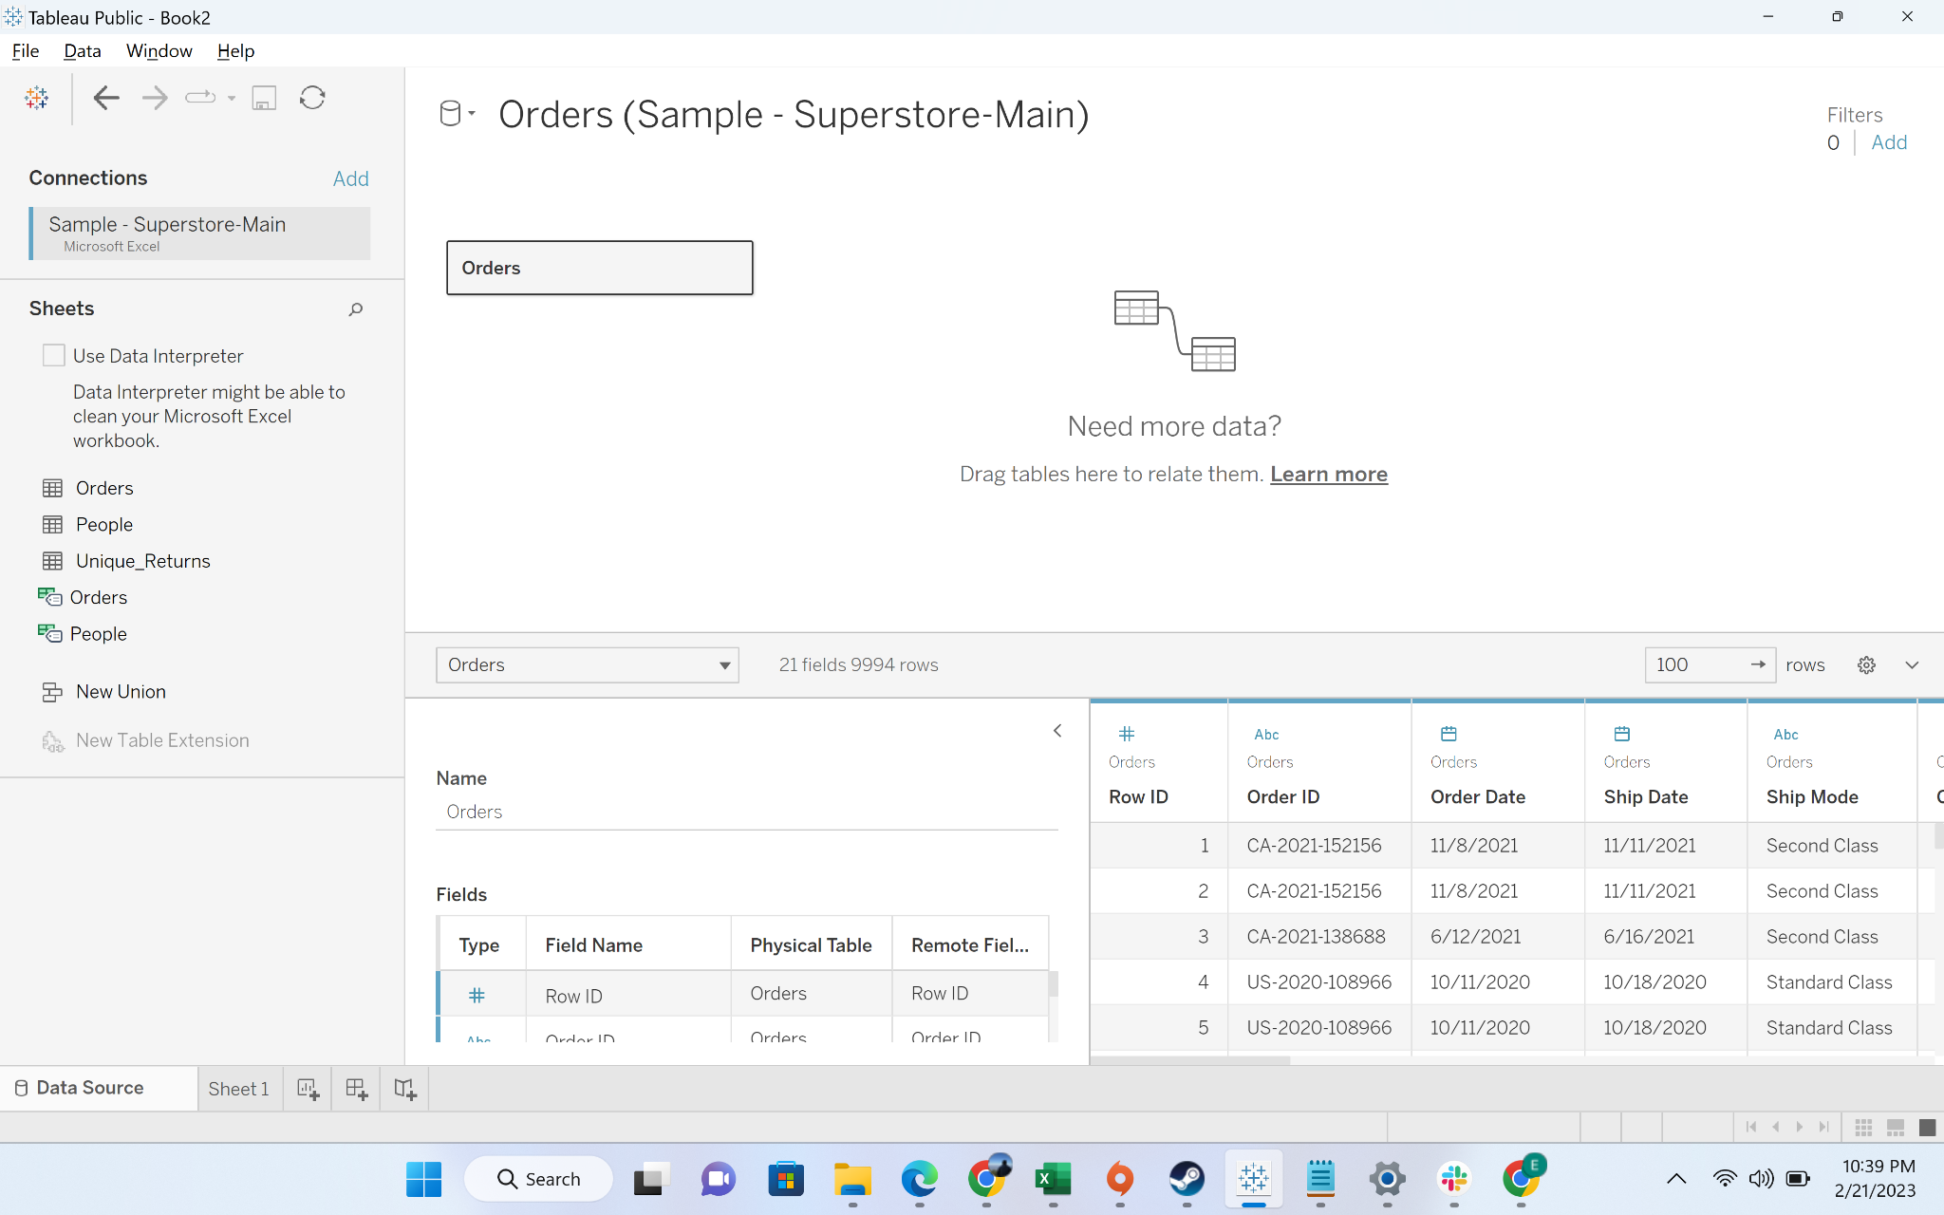

* + Step-2: Click on the “Add” button under the filter

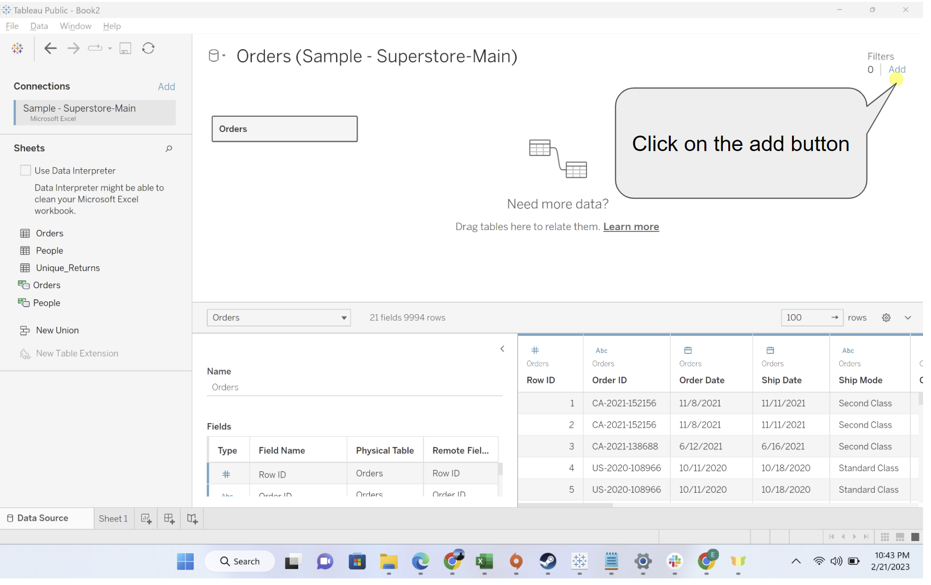

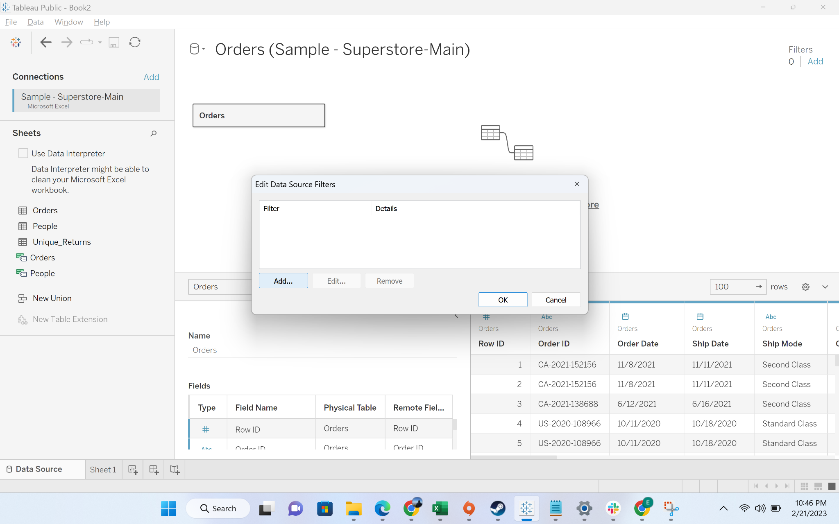

* + Step-3: Click on the “Add” button

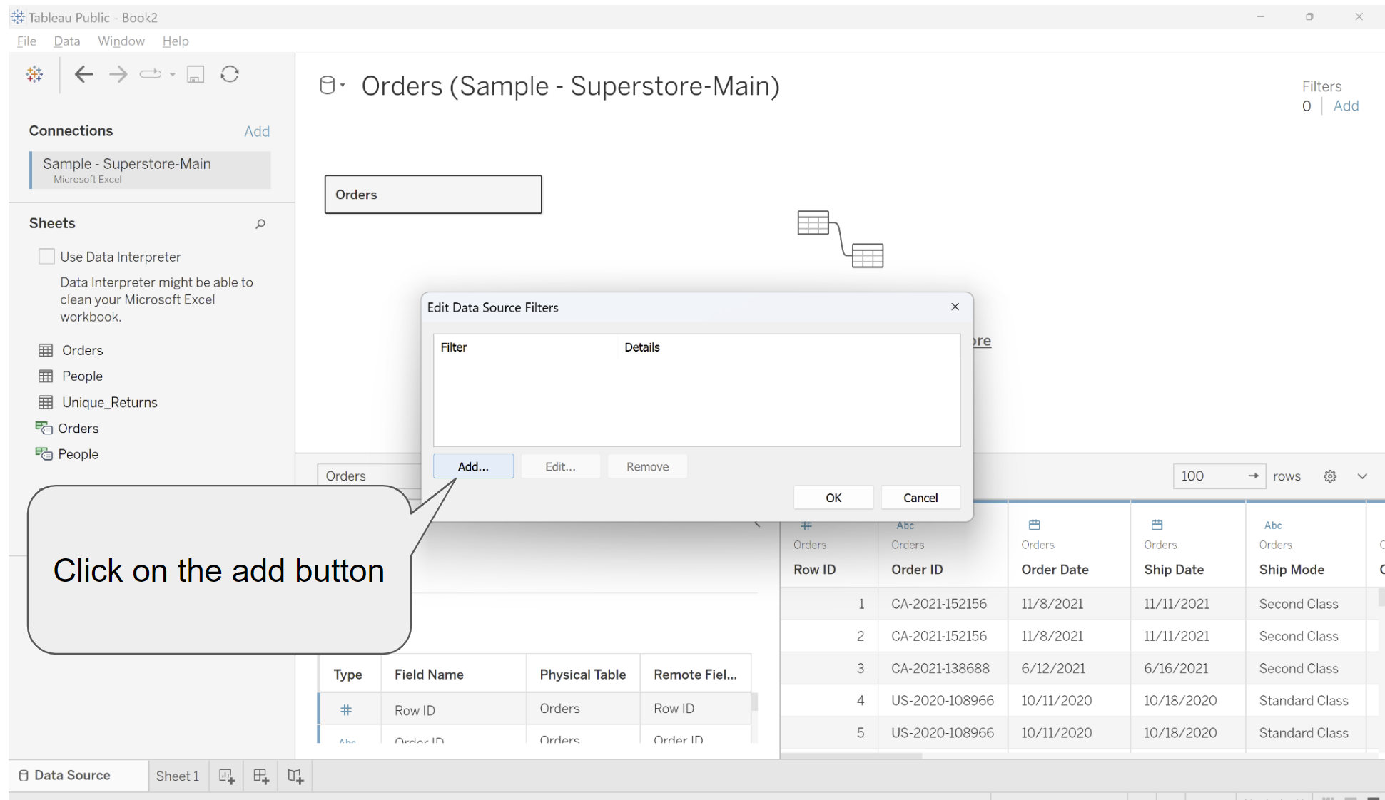

* + Step-3: Click on the “Profit” field

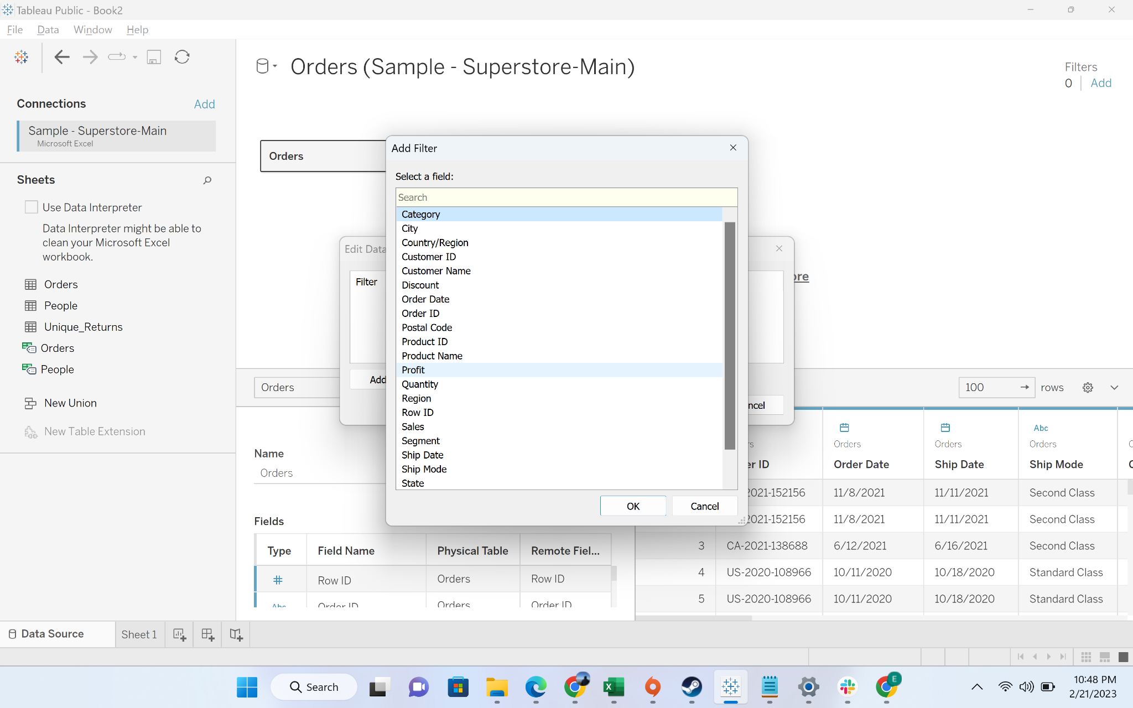

* + Step-4: Replace the minimum value with 1000 and press ok

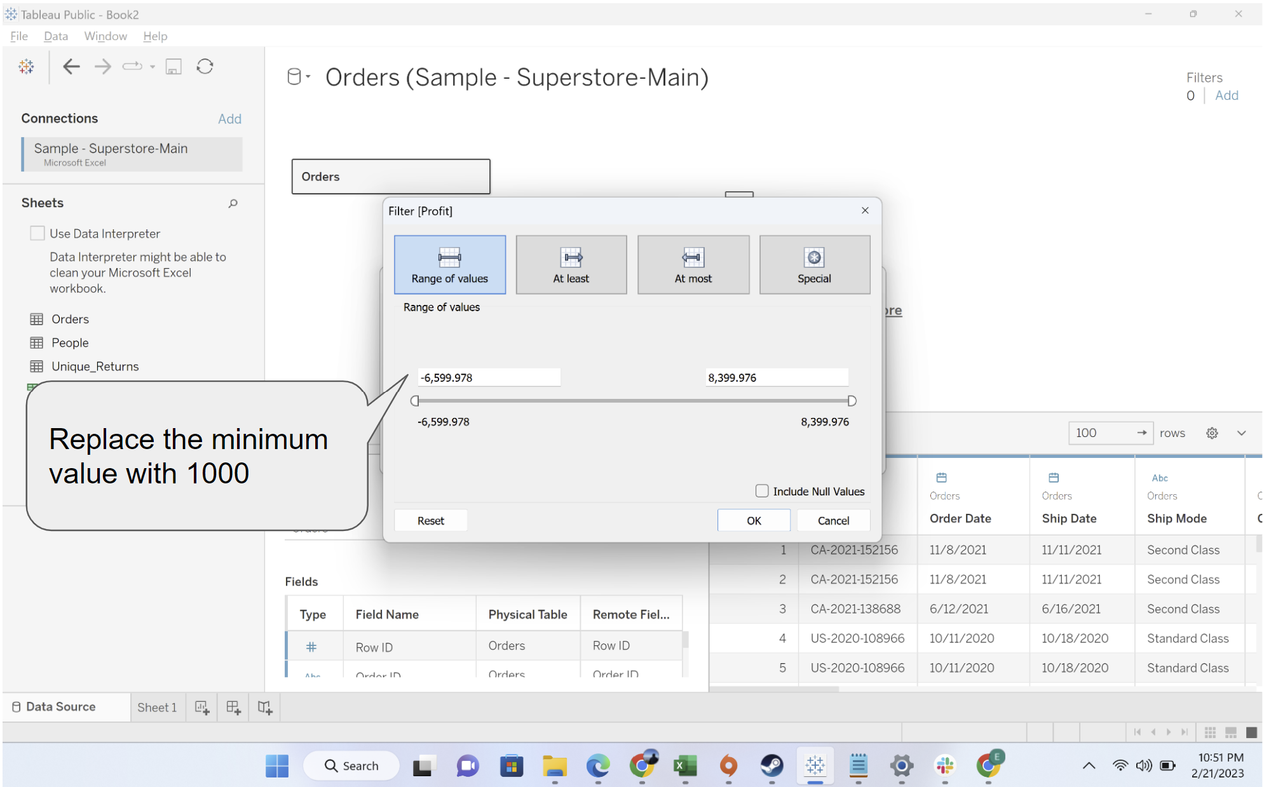

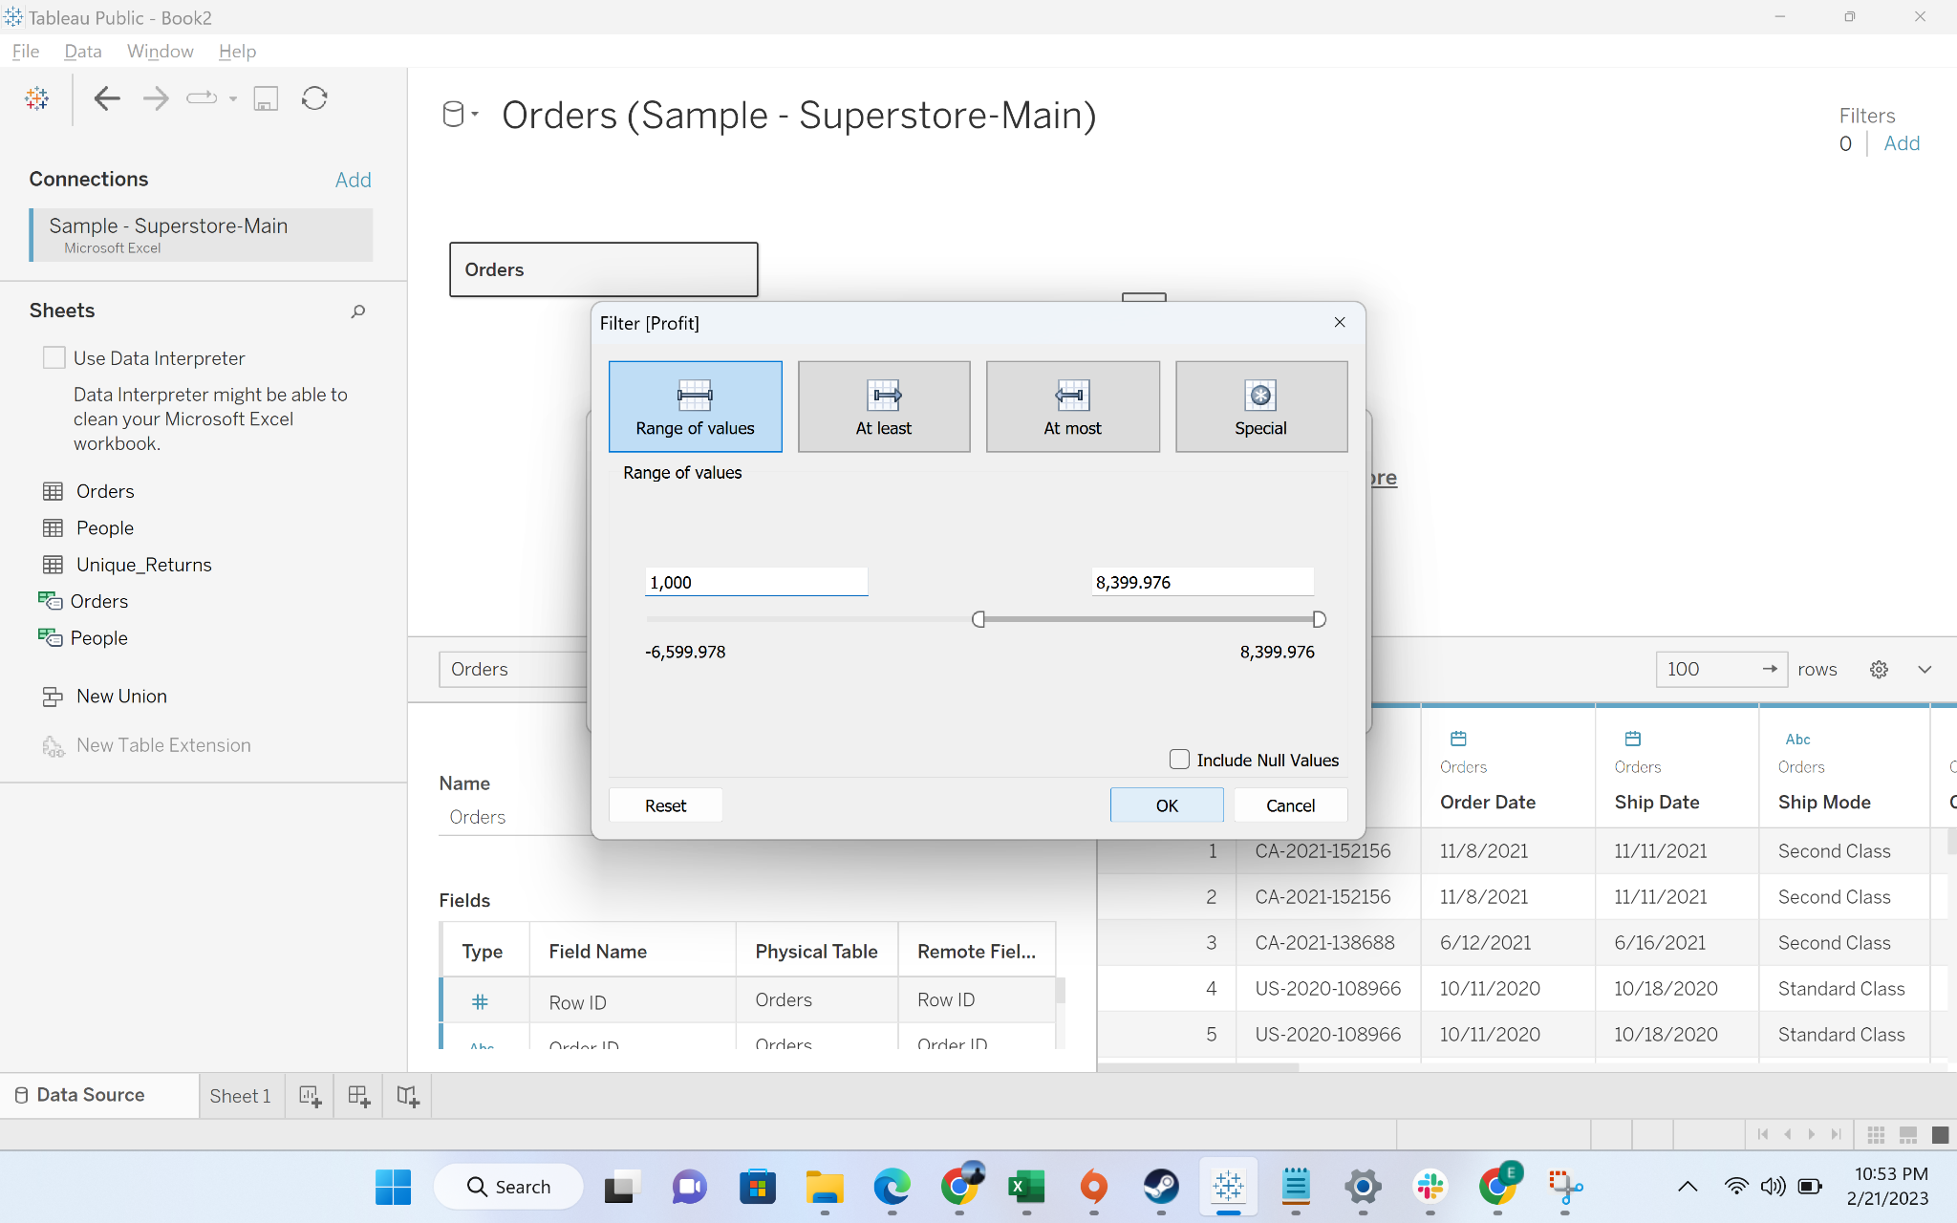

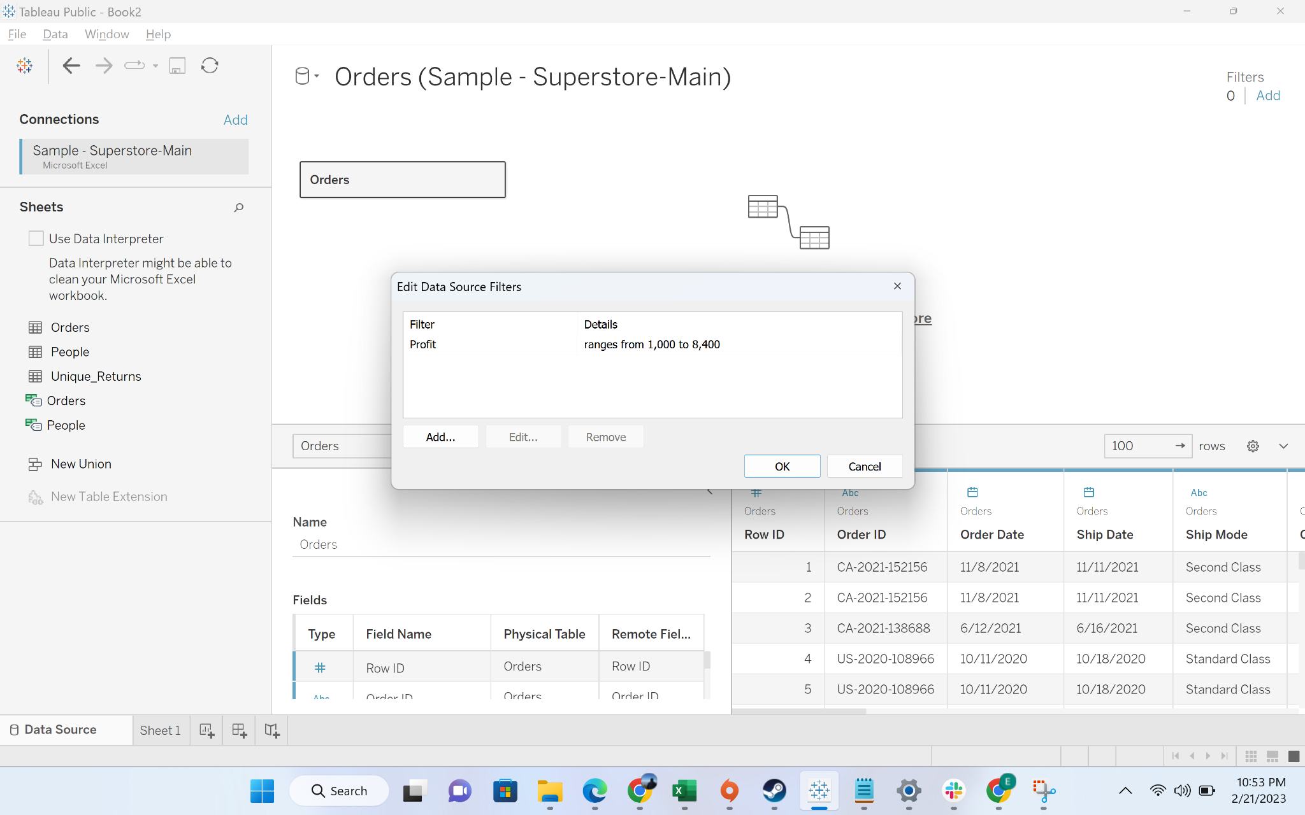

* + Step-5: Filter is applied

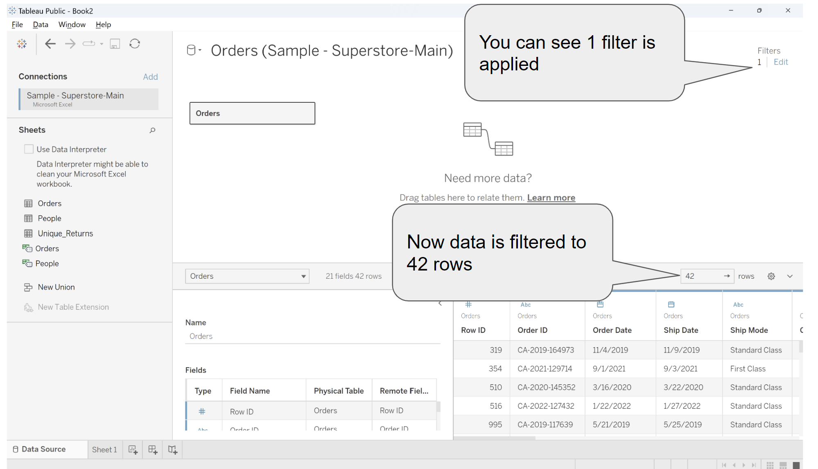

#### Business Problem 2 [Dimension and Measure filters] : Create a visualization to show all subcategories and categories along with sum/average profit. Just show those sub-categories which are profitable and sort the data in descending order per category

* **Business context:** In business reviews, analysts frequently need to highlight the health of business areas through visualization. Leadership frequently asks options to do filtering and play around and some time request specific cuts
* **Intro to dimension and measure filters:**
  + **Dimension filters:**Dimension Filters are those Tableau Filters that are applied to dimensional data. It's a non-aggregated filter that allows you to add a dimension, group, sets, and bins. The top or bottom conditions, wildcard match, and formula can all be used to apply a Dimension Filter.
  + **Measure filters:** Measure filter are applied on measures. It allows for various operations and aggregate functions such as sum, median, avg, standard deviation, etc.
* Applying dimension and measures filter:
  + Drag category and sub-category to rows and profit to column

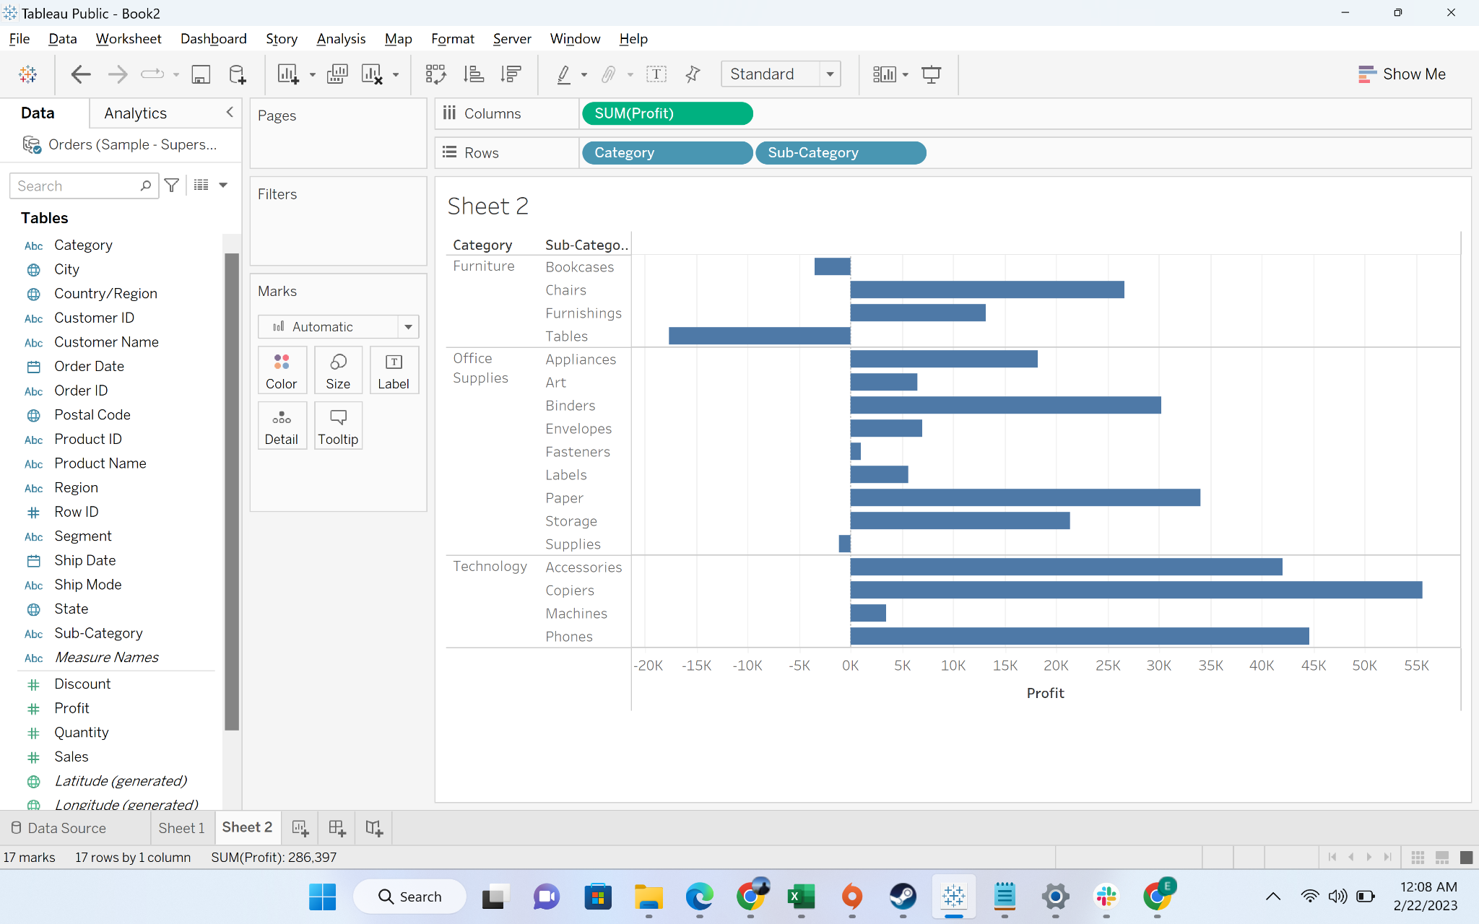

* + Change profit aggregation from sum to average

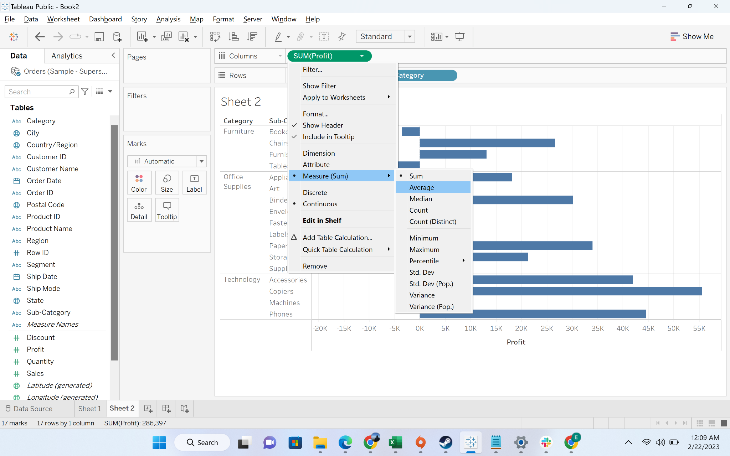

* + You can see bookcase, tables and supplies have negative profit

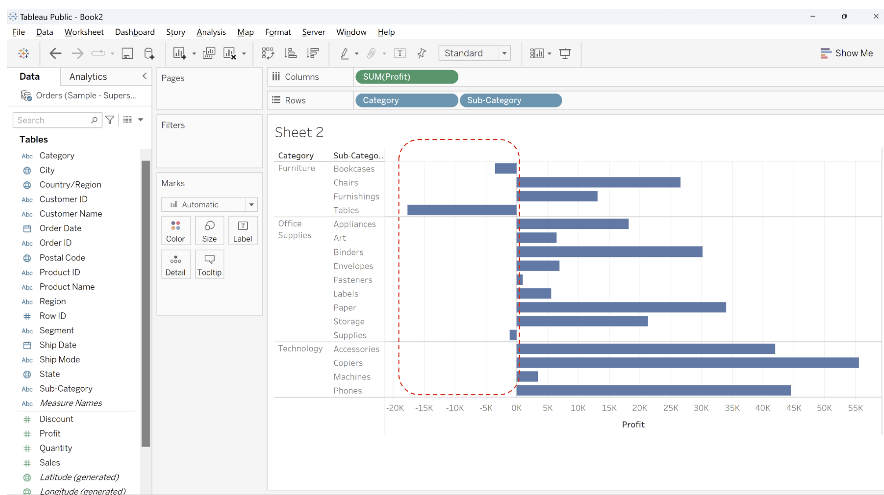

* + To get the desired result, we can adopt two approaches: 1) we can filter out subcategories with negative profit : bookcase, tables, supplies, 2) we can apply a filter on profit to only consider subcategories with profit>0
  + **Dimension filter:** drag the subcategories to filter and remove the check mark against bookcase, tables, supplies. You can see the desired output

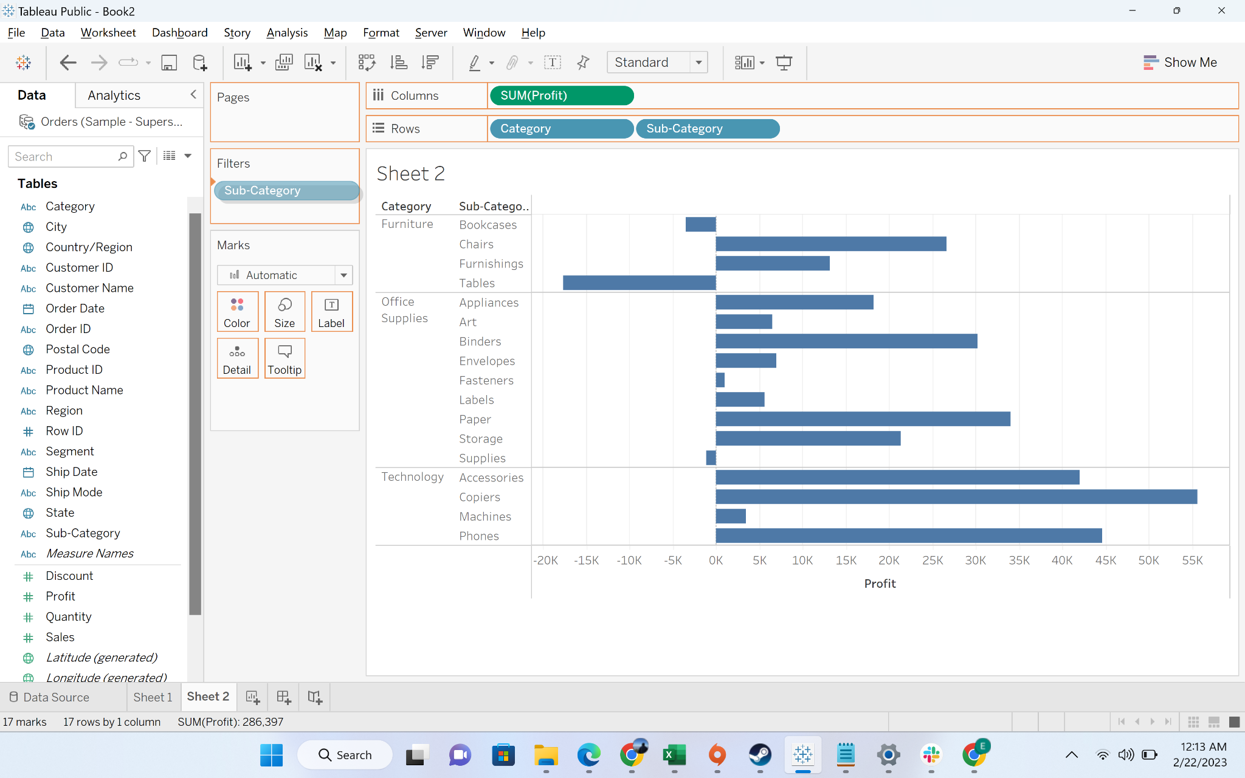

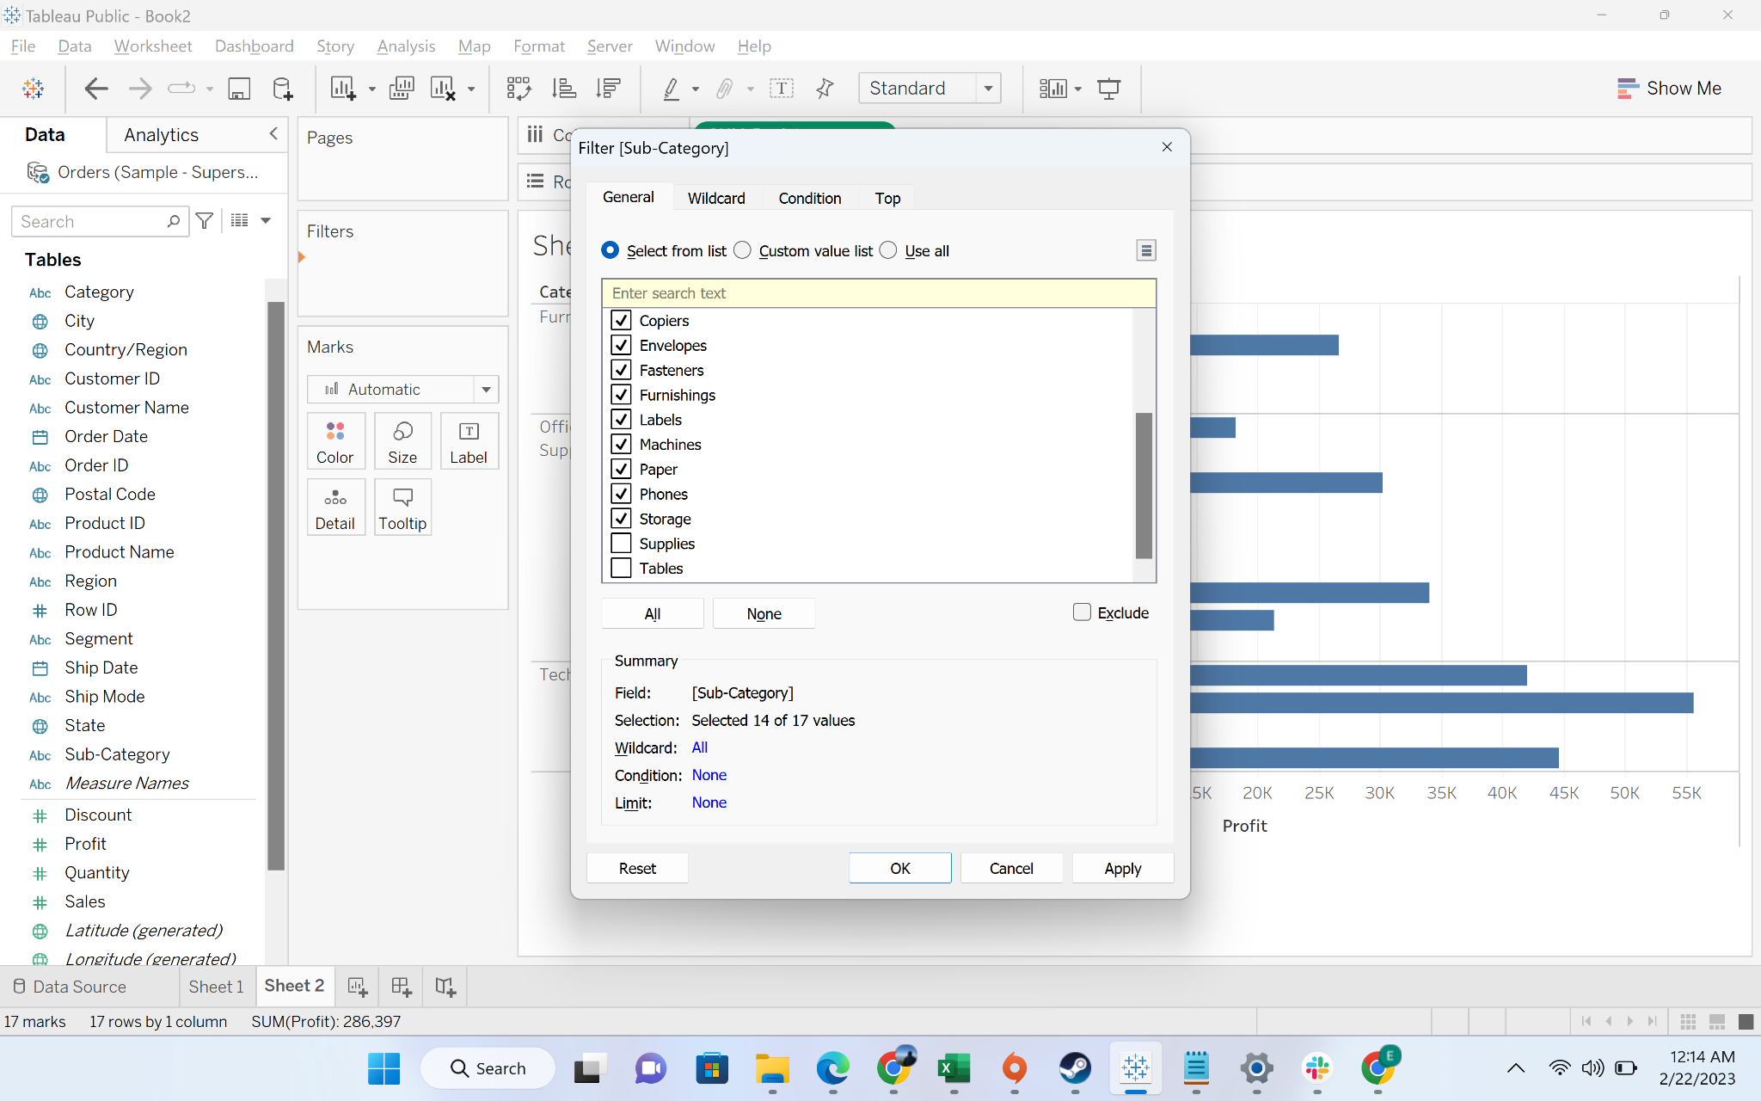

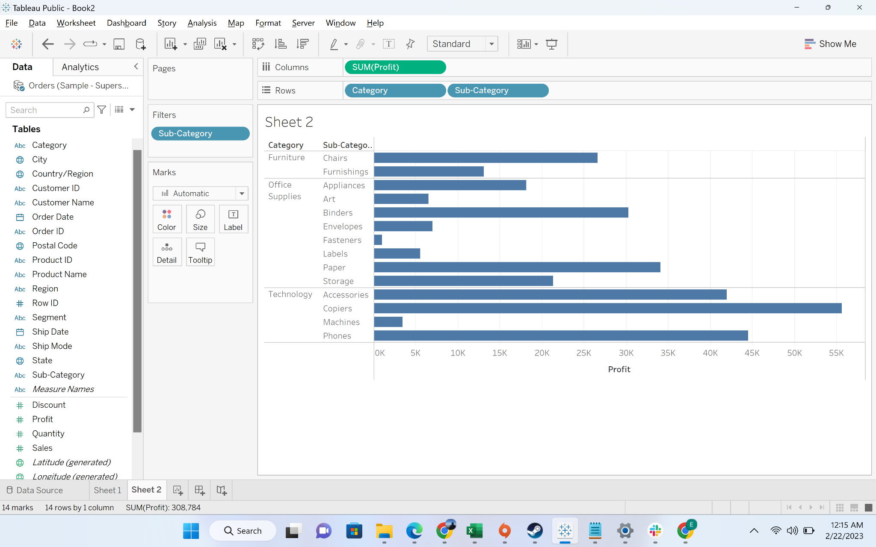

* + **Measure filter:** drag the profit to filter, choose average for filtering, choose the minimum value of range to 0.001

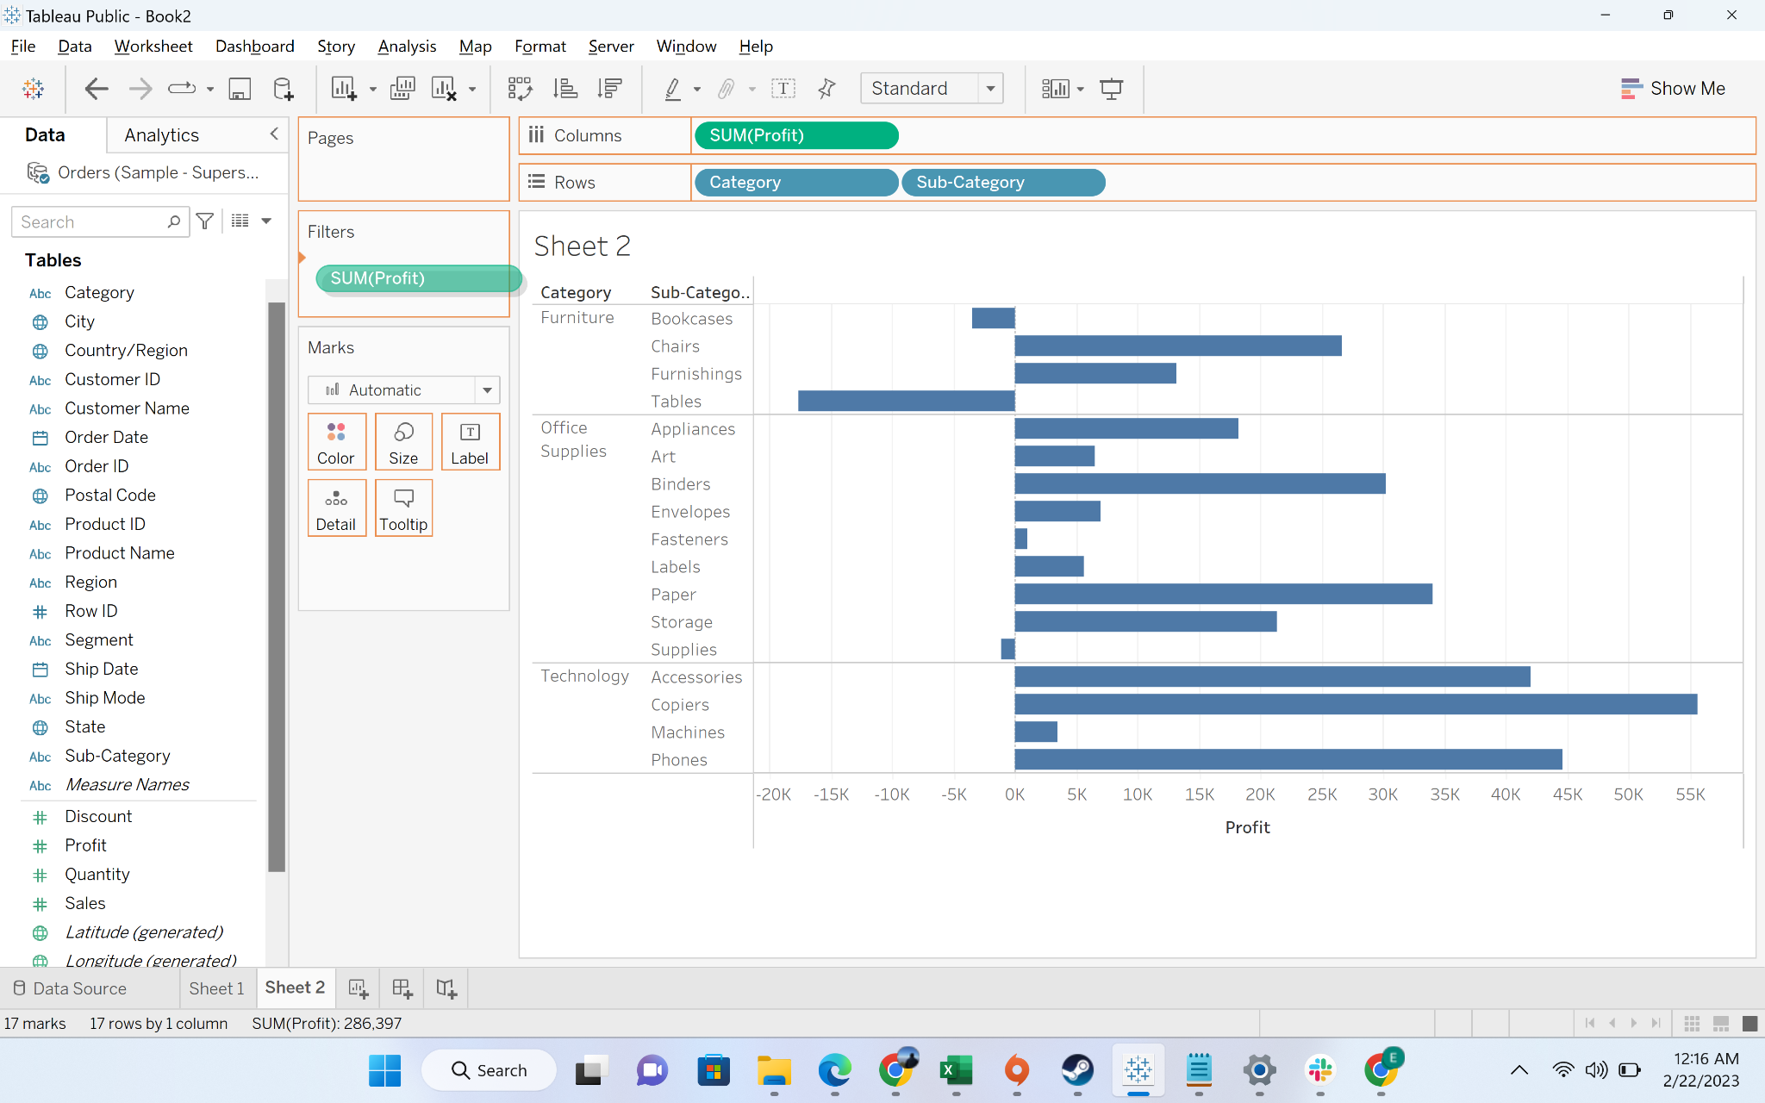

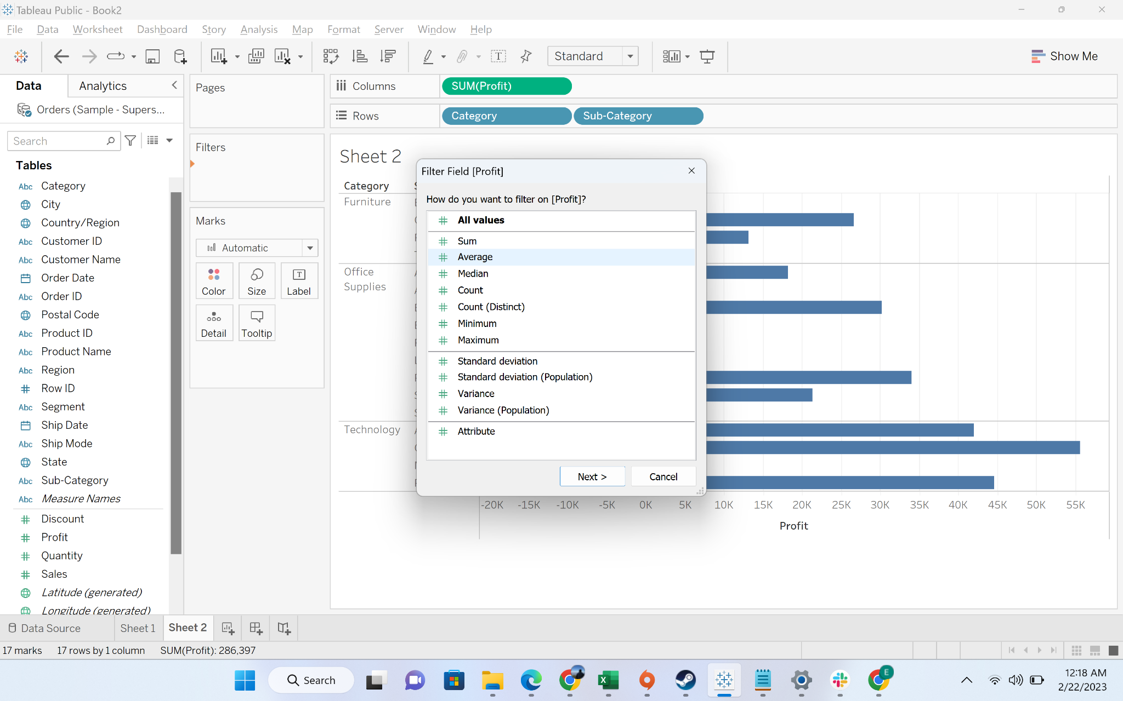

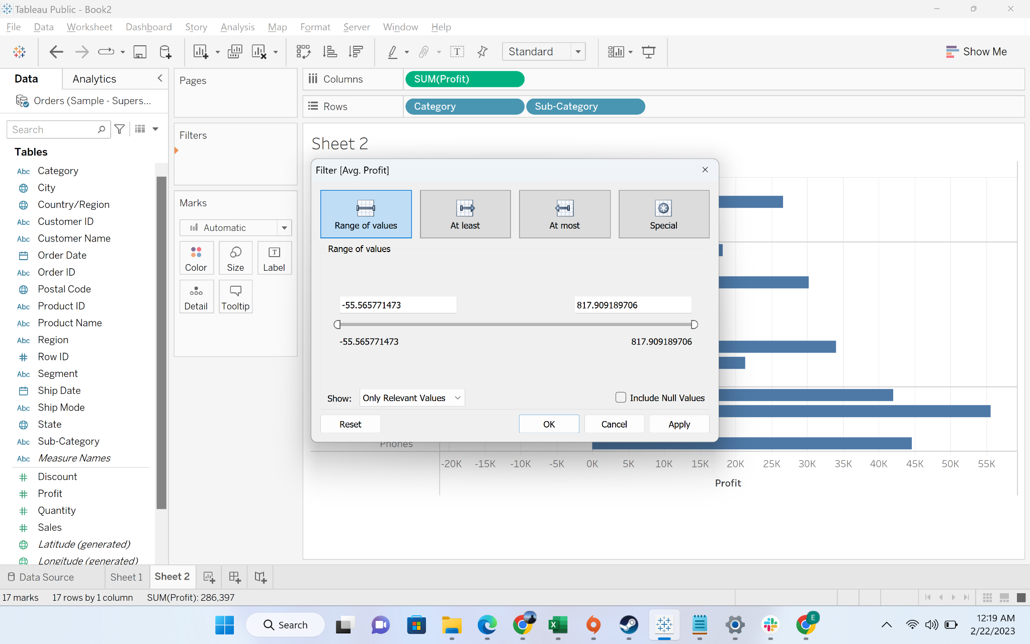

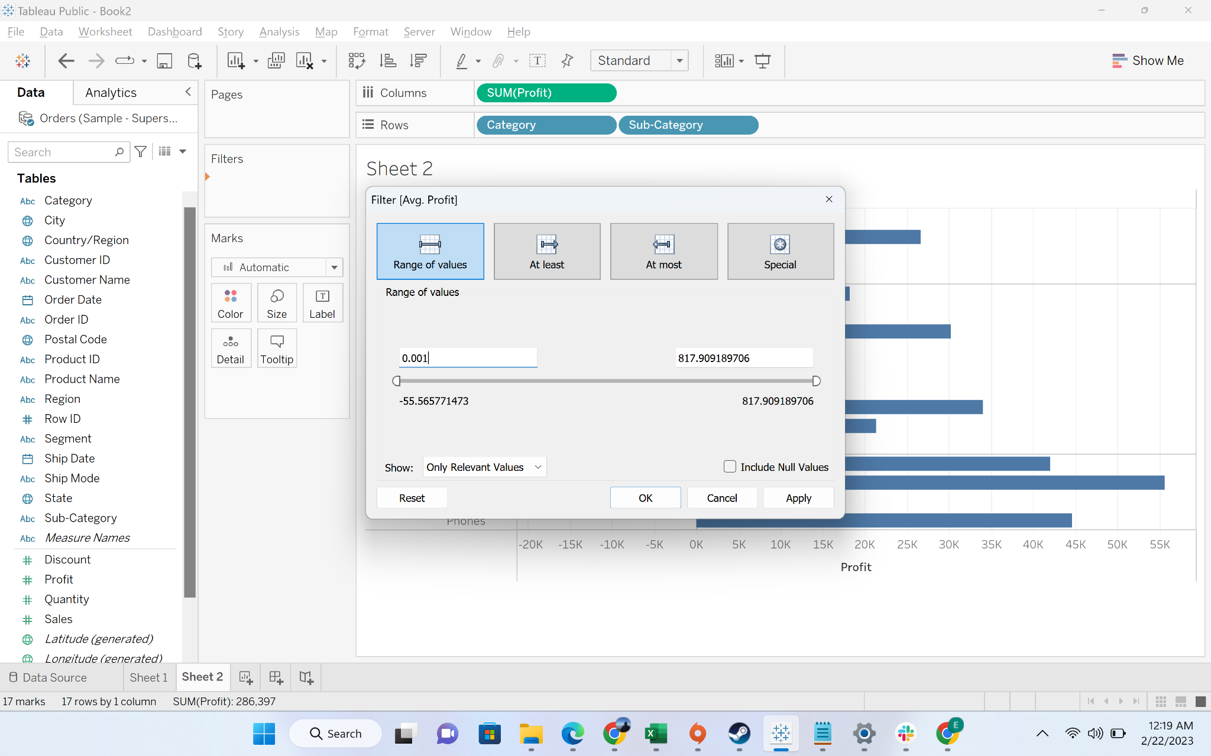

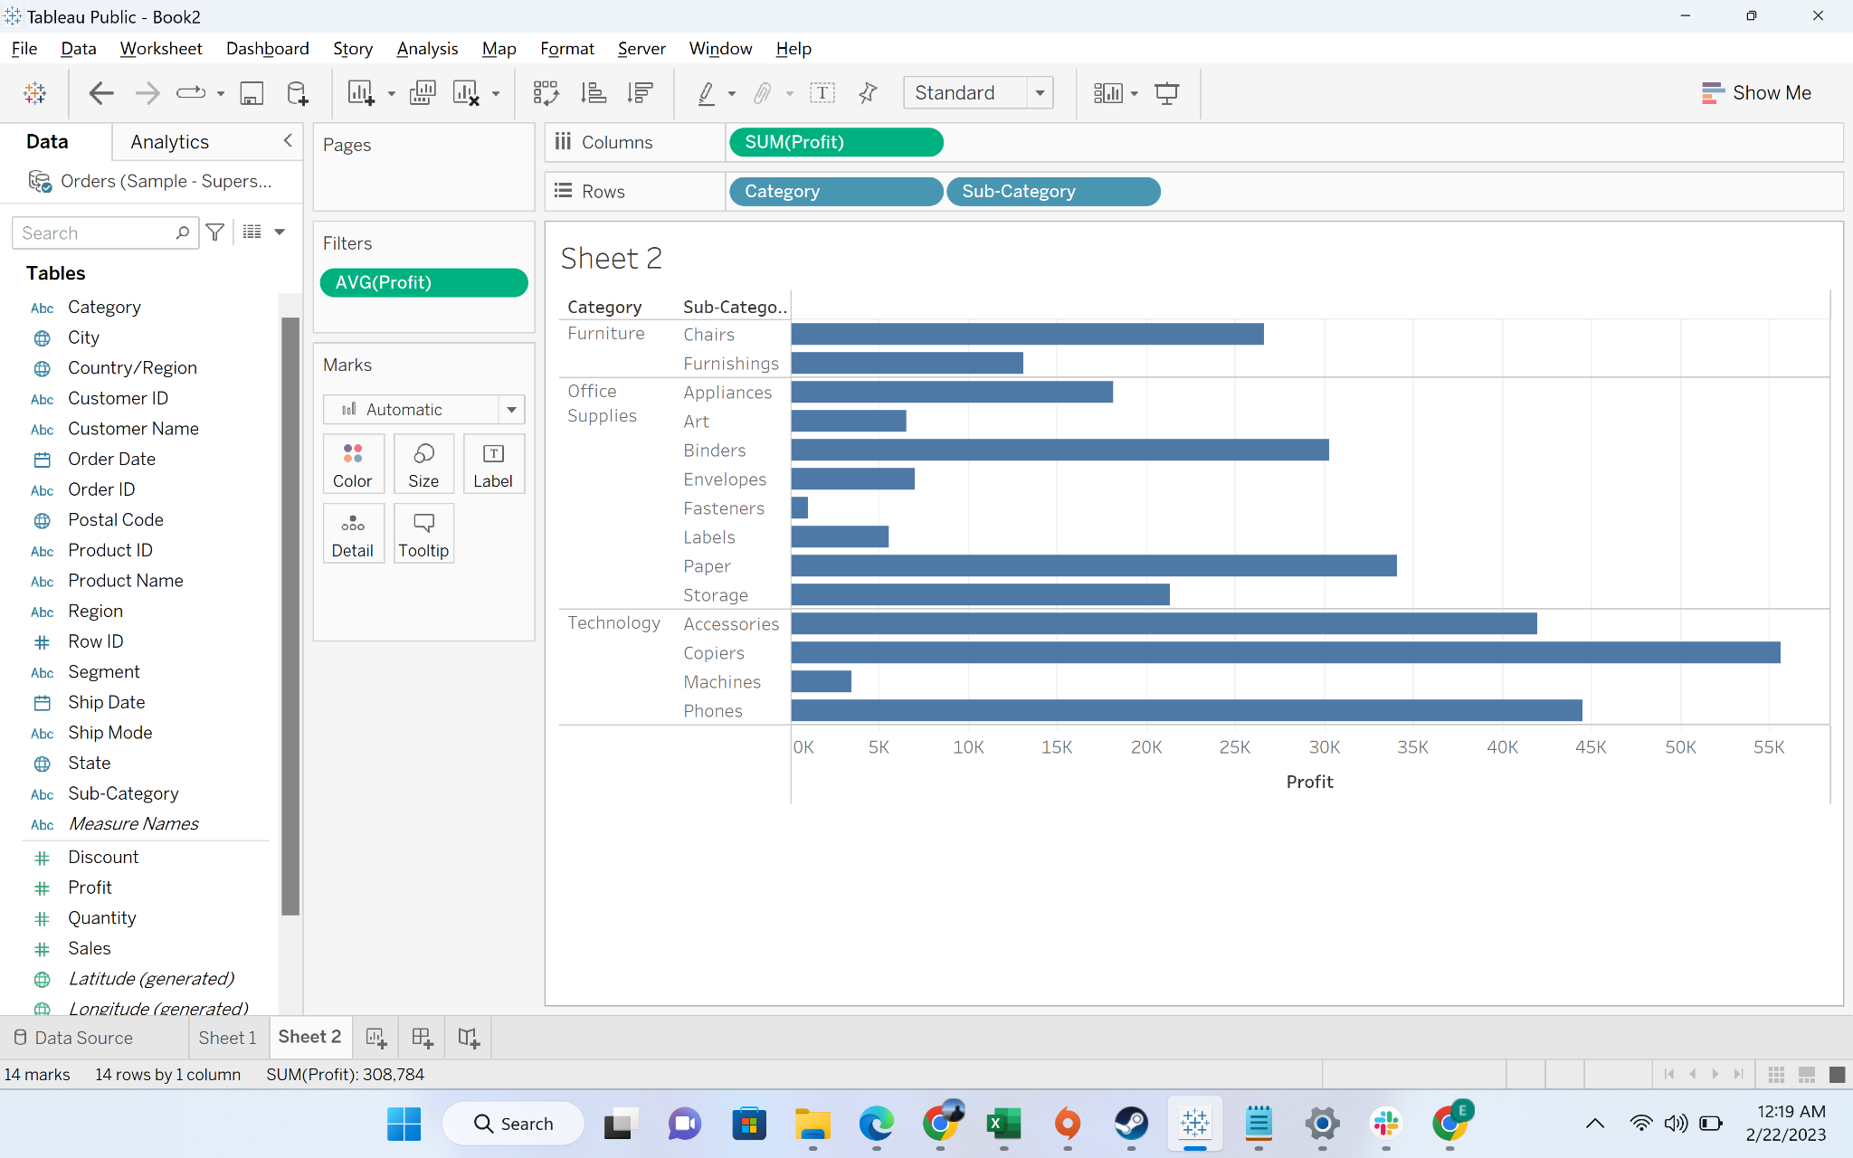

#### 

#### Business Problem 3[Context Filter] : Show top 10 furniture items based on sales

First we filter out 10 sub categories of items based on sales. Then we add the category “furniture” as a context filter to show the top 10 furniture items only. Since there are only 4 subcategory items under the furniture category, the result returns 4 furniture items.

* **Business Context**
  + Sometimes in a business report we need to apply multiple filters. All the filters in tableau are independent of each other and reduce data according to its condition. Then we find a unique set of datapoints common to both filter
* **Intro to Context Filter:**
  + Context Filter is a filter in Tableau that gets applied before any other filter, applied on a worksheet.The normal filters in Tableau are independent of each other. It means each of the filter reads all the rows from the source data and creates its own result. However, there may be scenarios where you might want the second filter to process only the records returned by the first filter. In such a case, the second filter is known as dependent filters because they process only the data that passes through the context filter. Context Filters serve two main purposes.
    - Improves performance − If you set a lot of filters or have a large data source, the queries can be slow. You can set one or more context filters to improve the performance.
    - Creates a dependent numerical or top N filter − You can set a context filter to include only the data of interest, and then set a numerical or a top N filter.
* **Demonstration of context filter:**
  + Drag sub-category to row, then drag sales to column

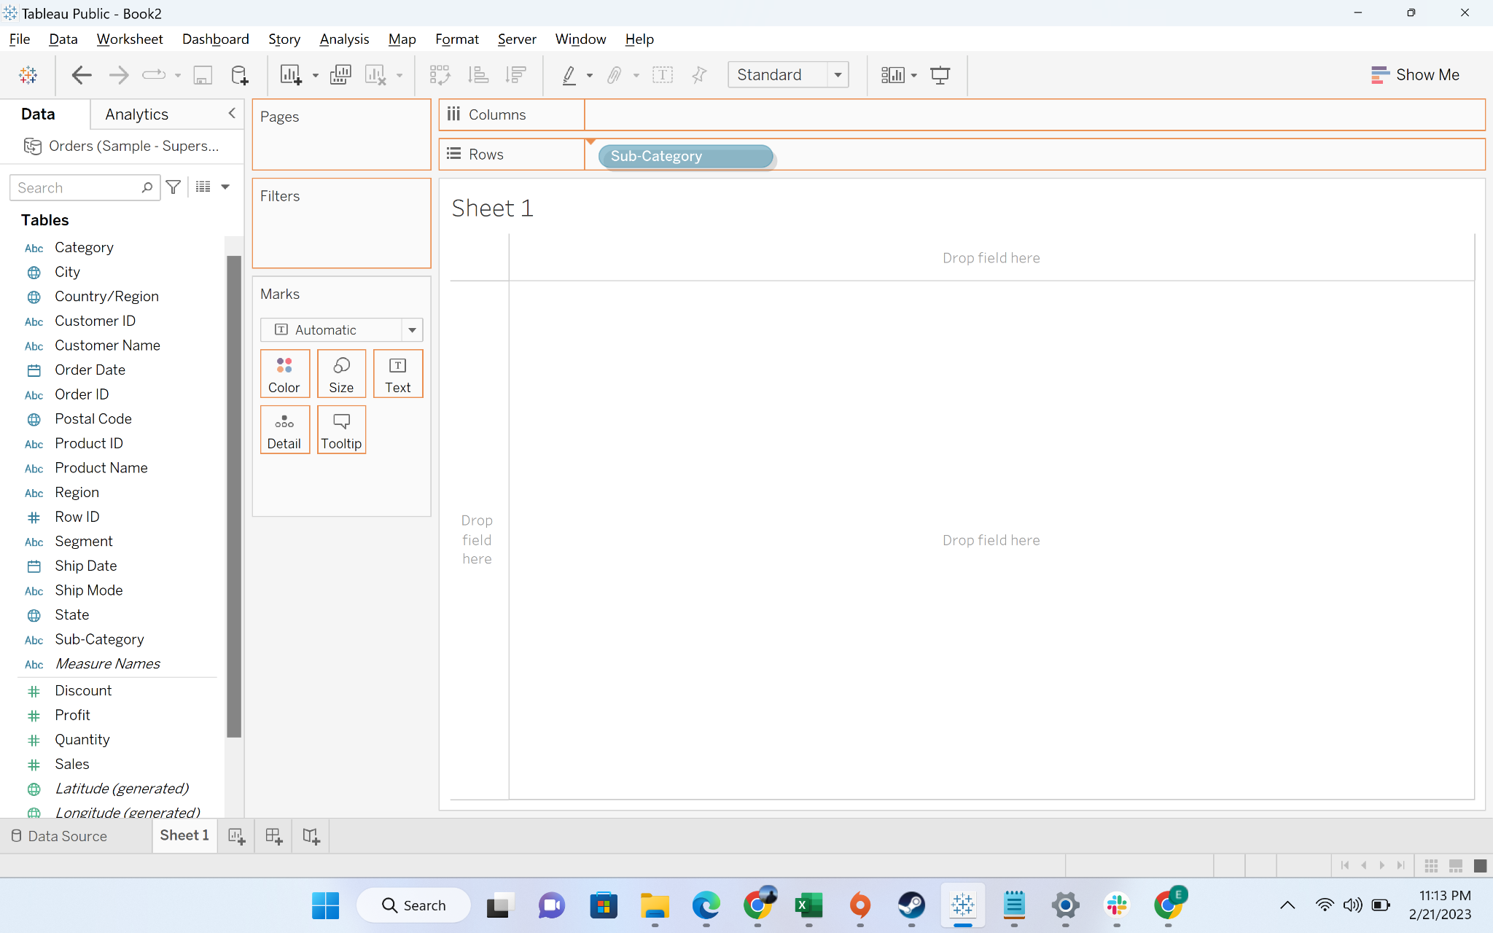

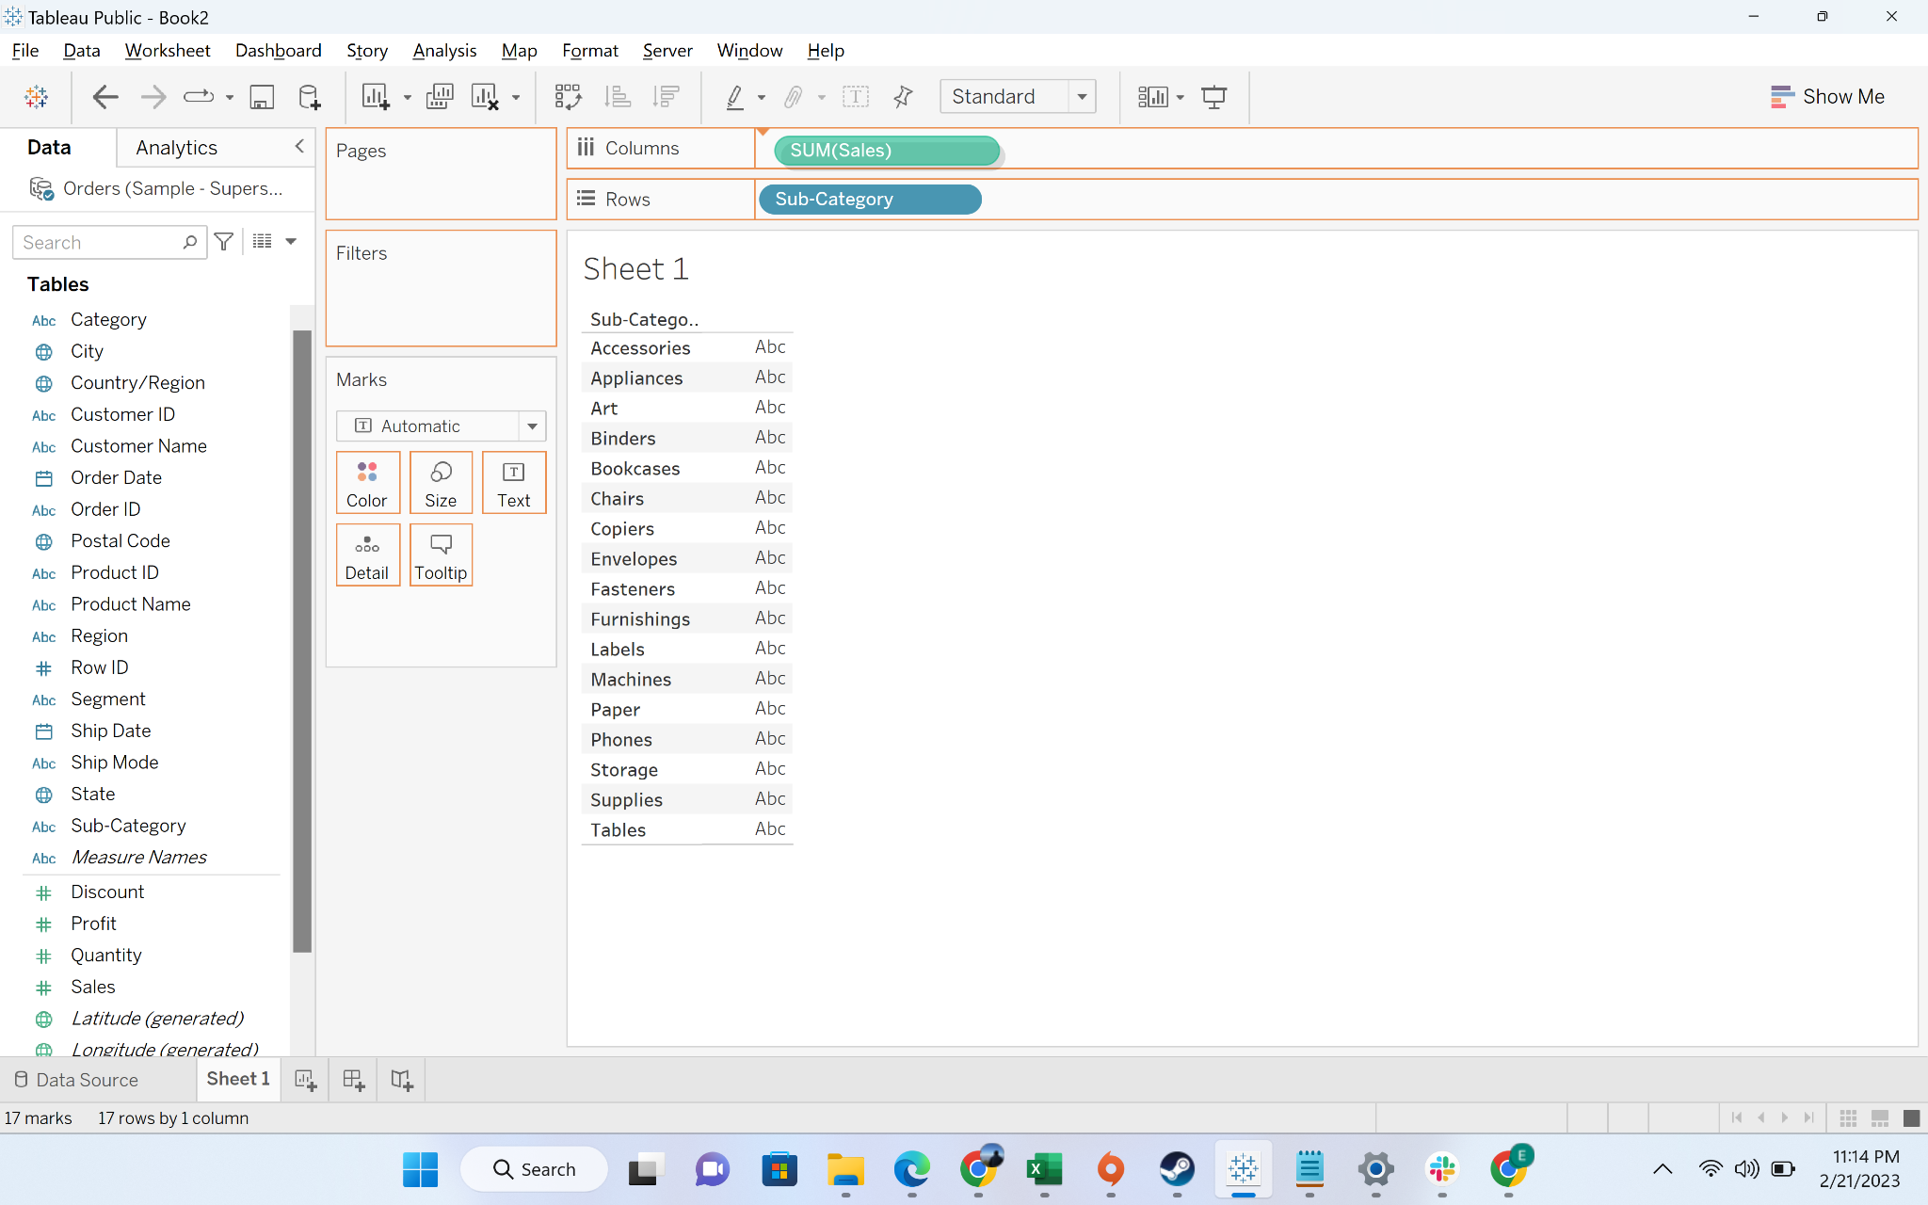

* + Move subcategory to filters and choose the top 10 subcategories by sales

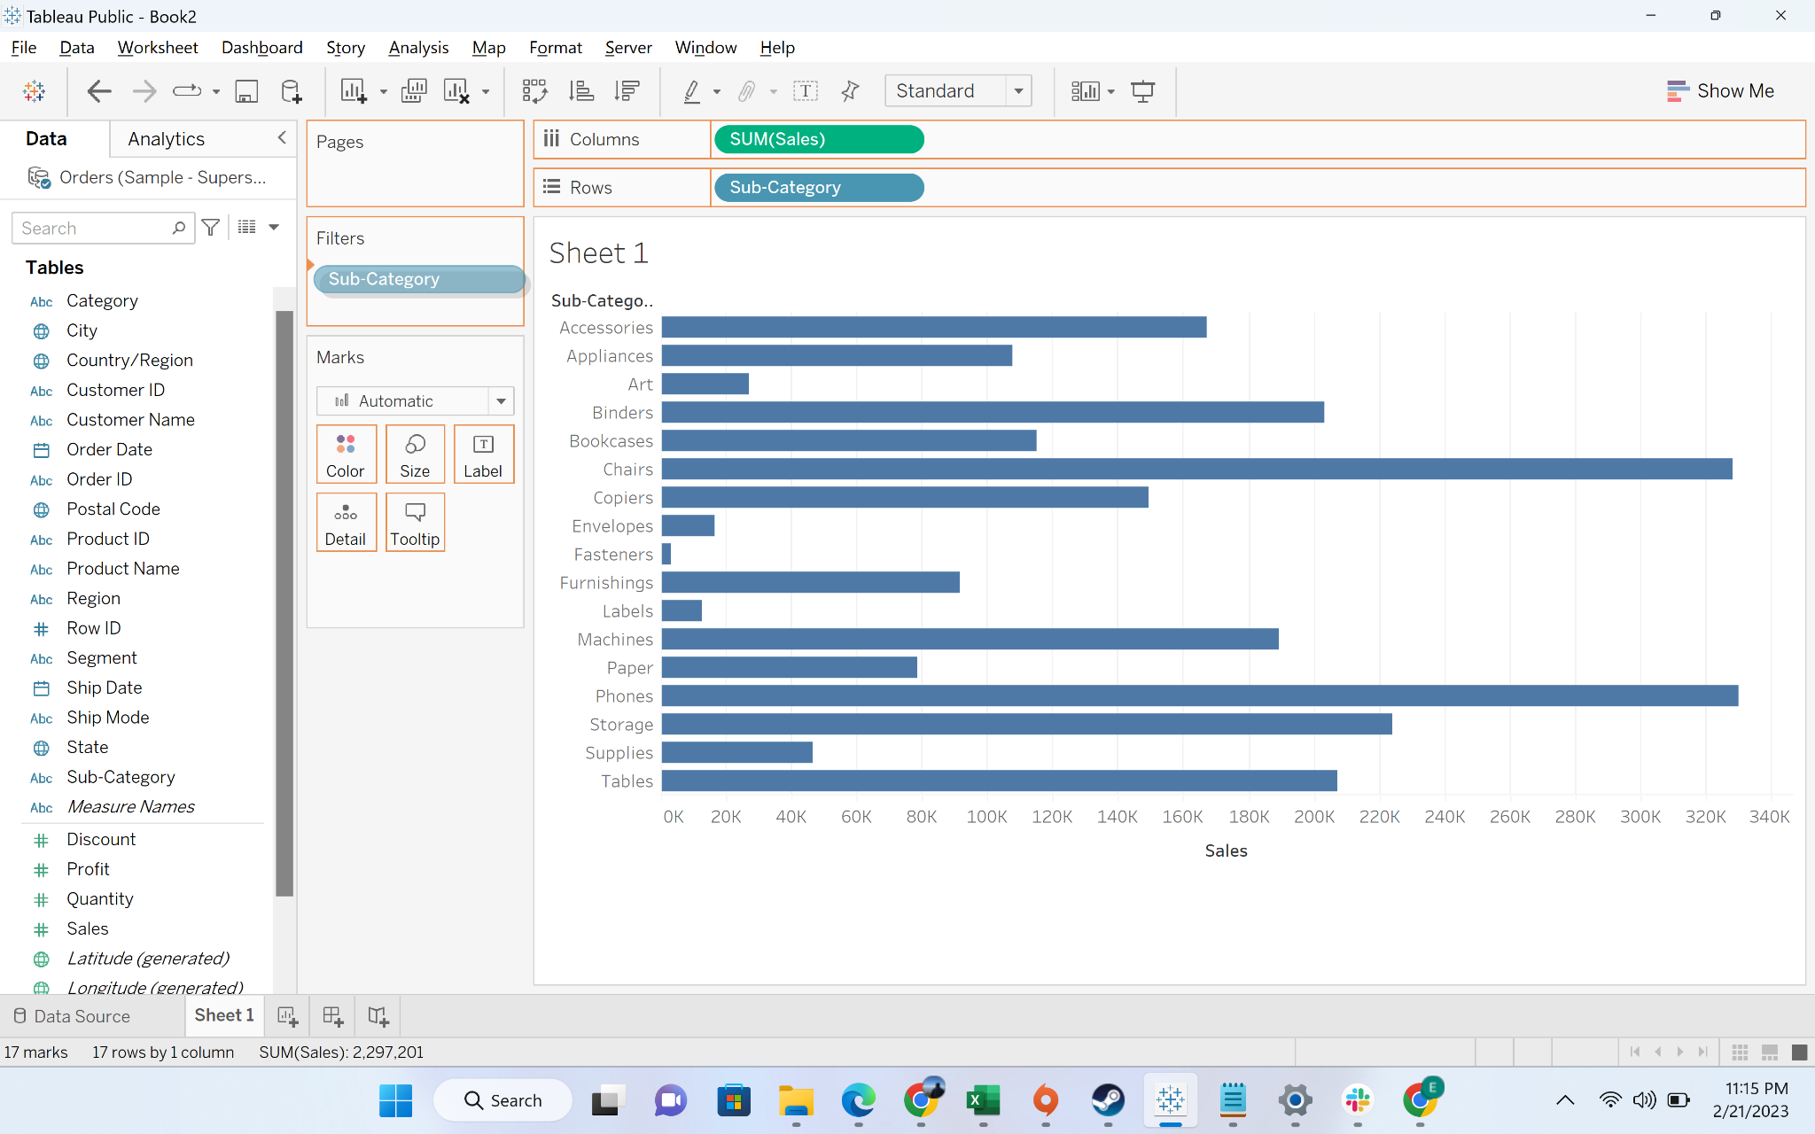

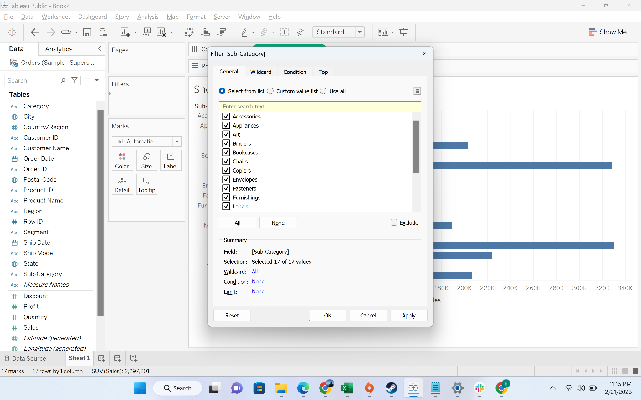

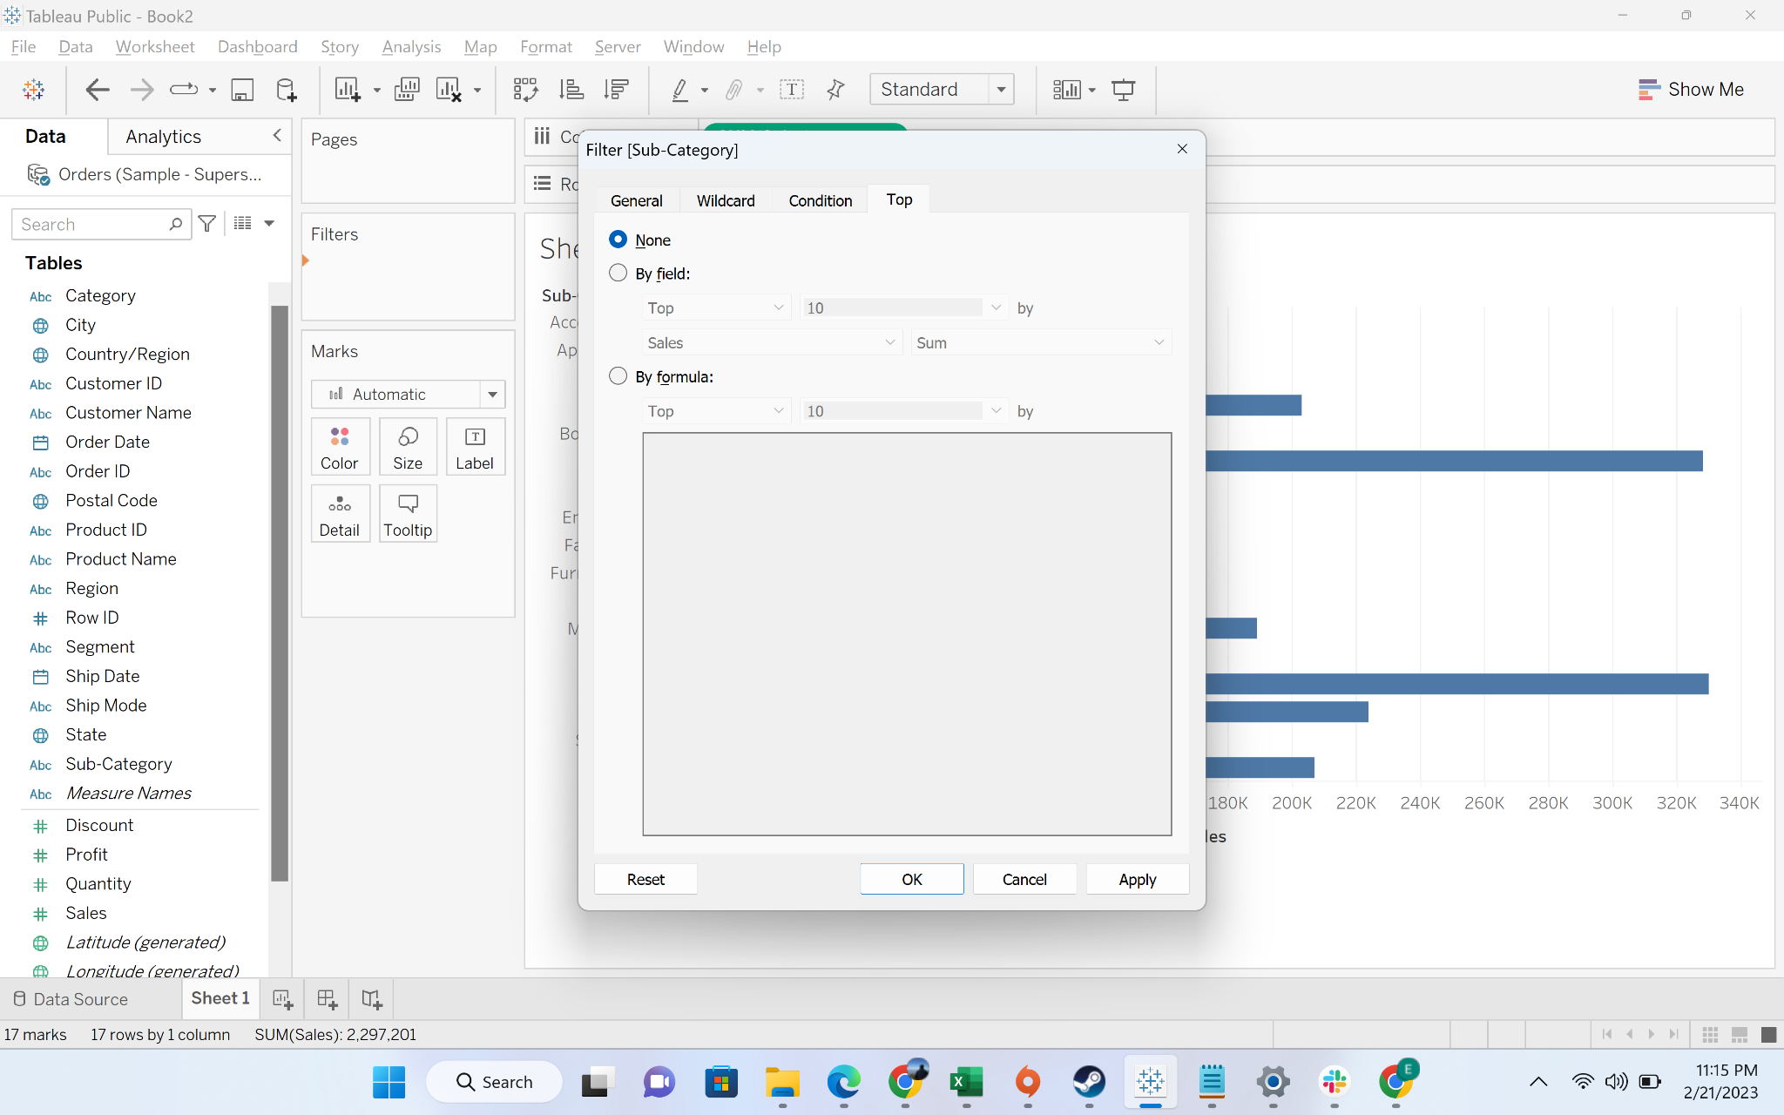

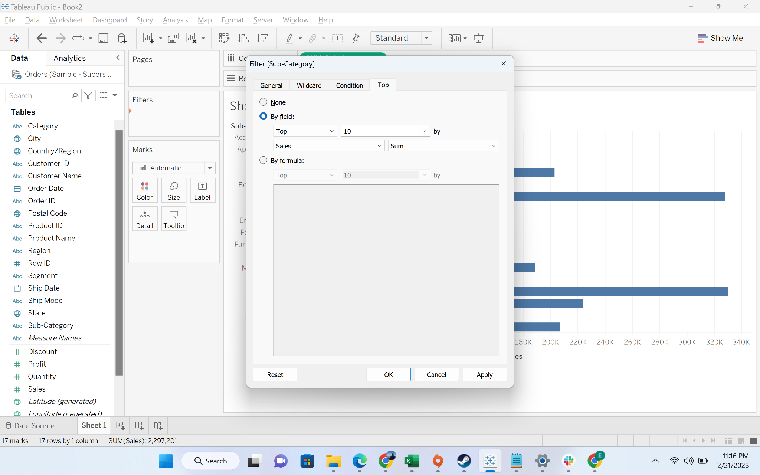

* + You can see top 10 sub-categories by sales

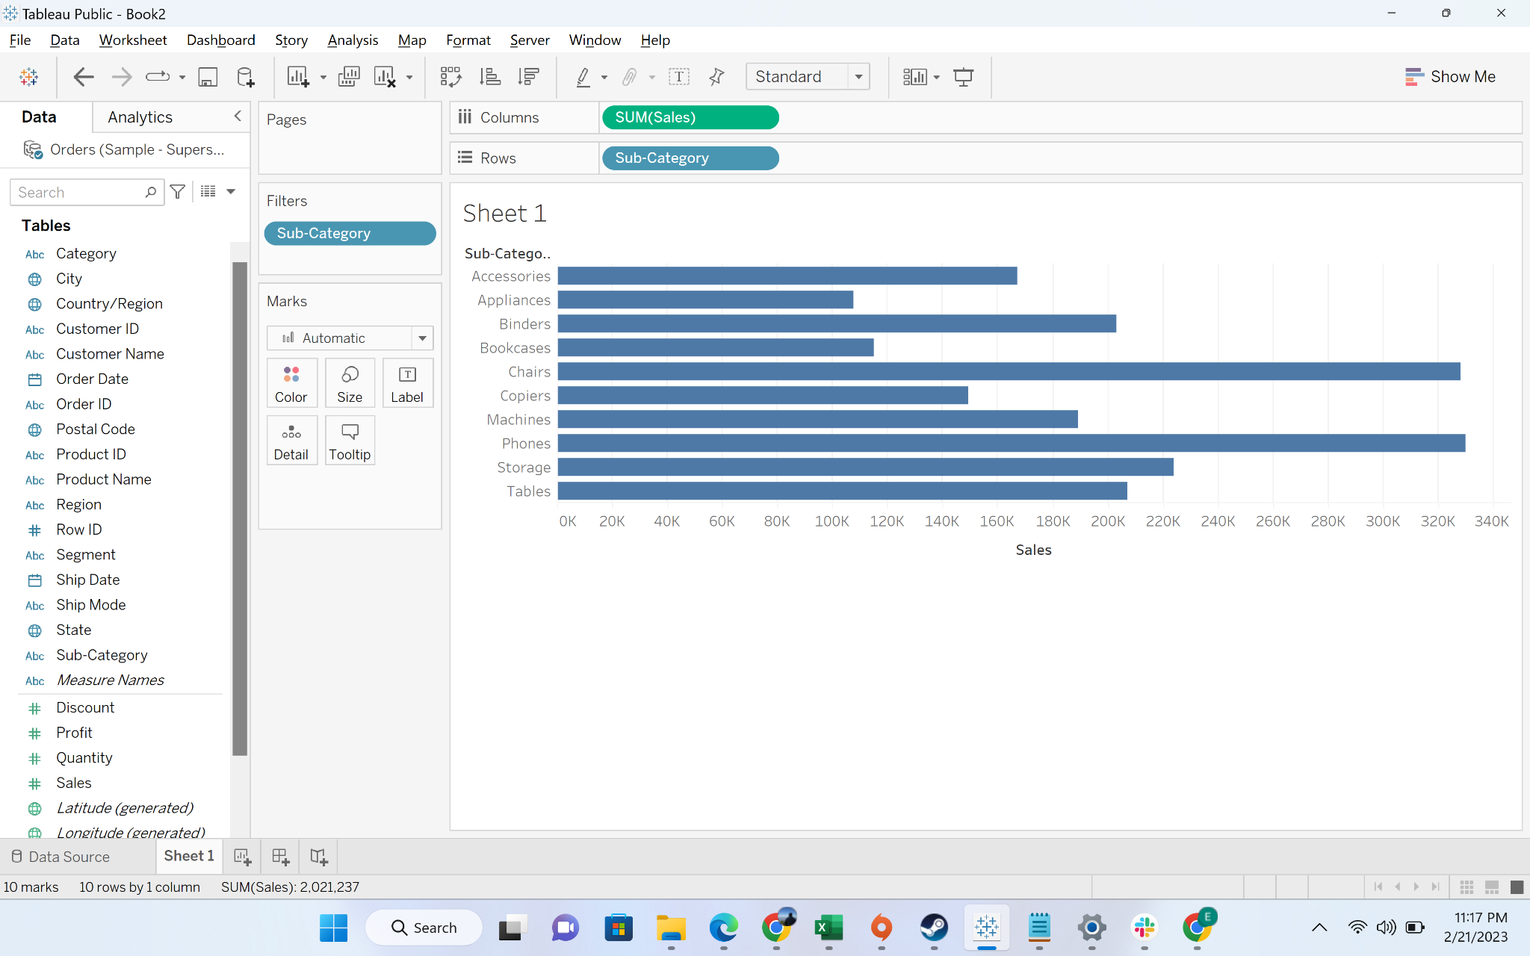

* + Move “Category” dimensions to the filter and choose furniture

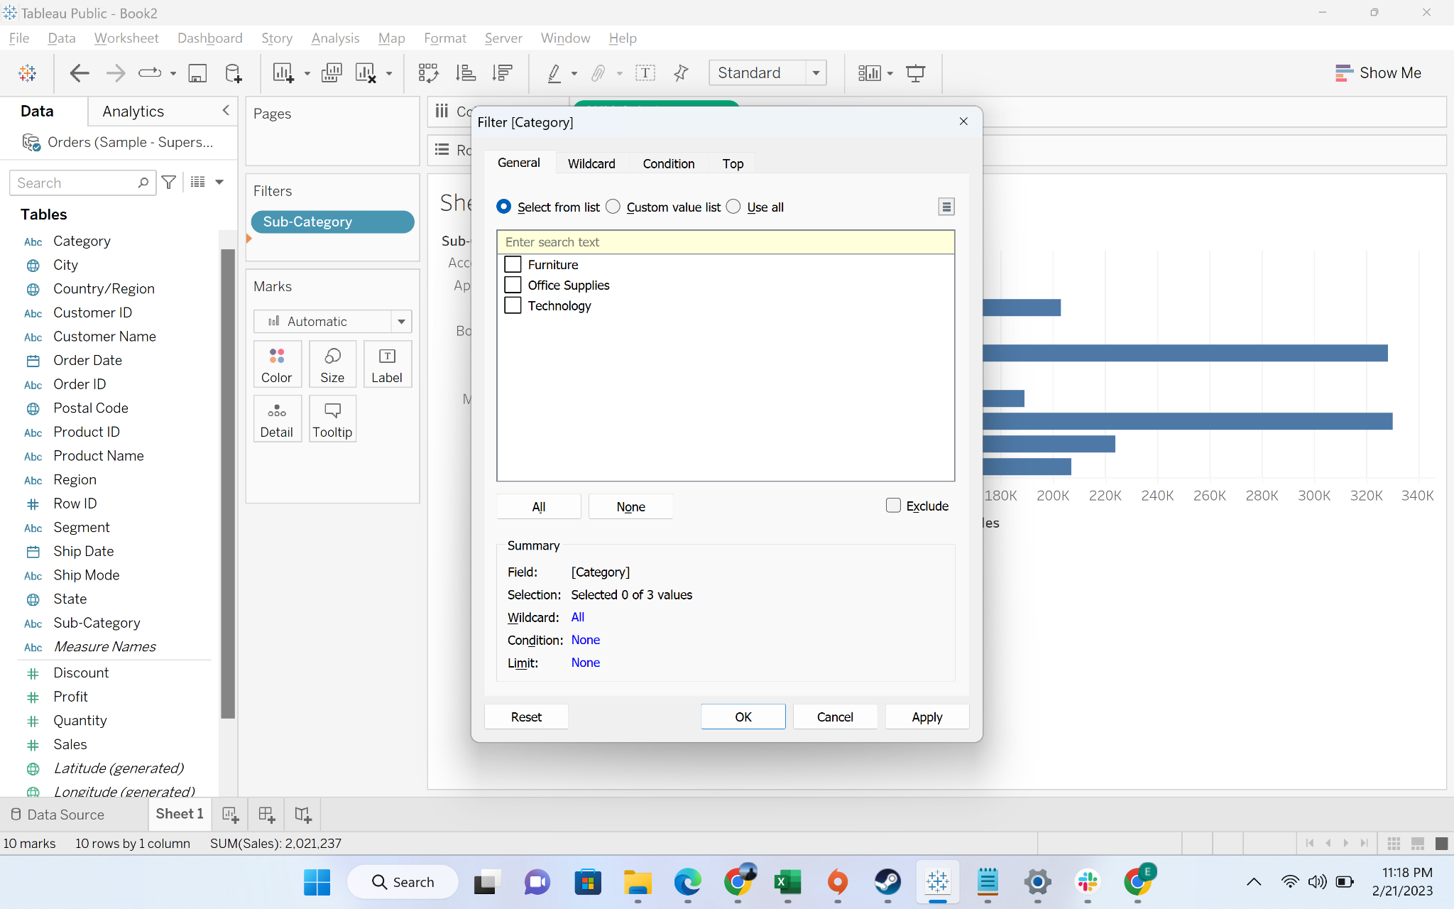

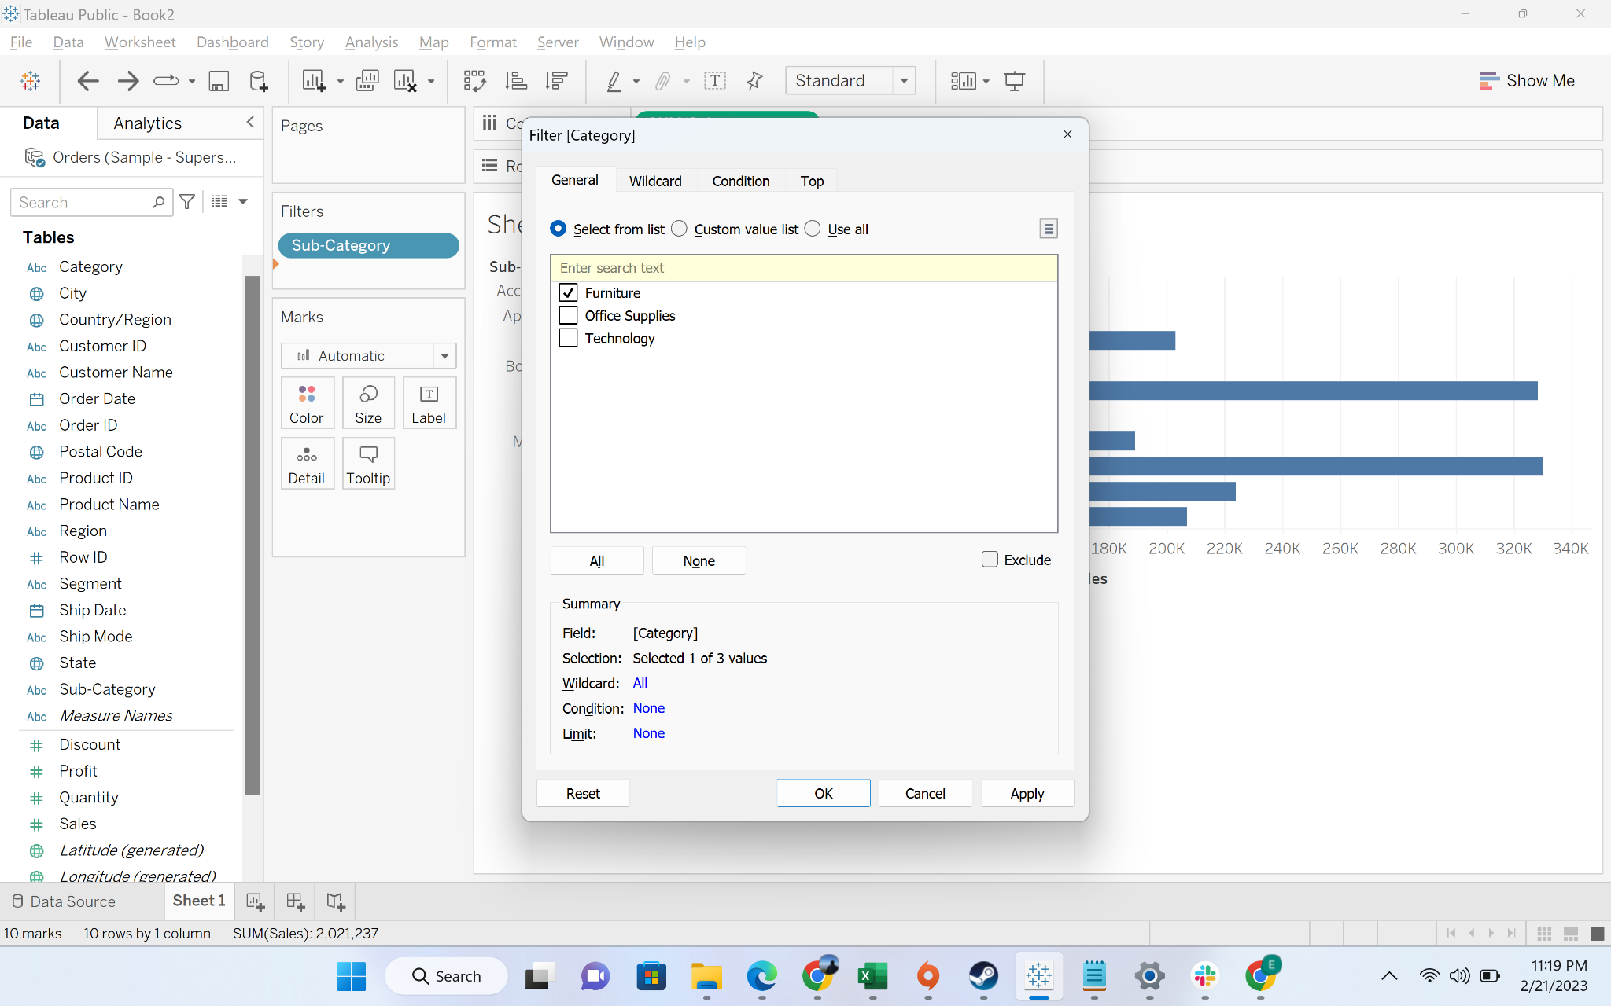

* + Now you will see the three sub-categories in Furniture which are among top 10 sales sub-category. However, all 4 sub-categories within Furniture category should come as we want top 10 furniture items by sales

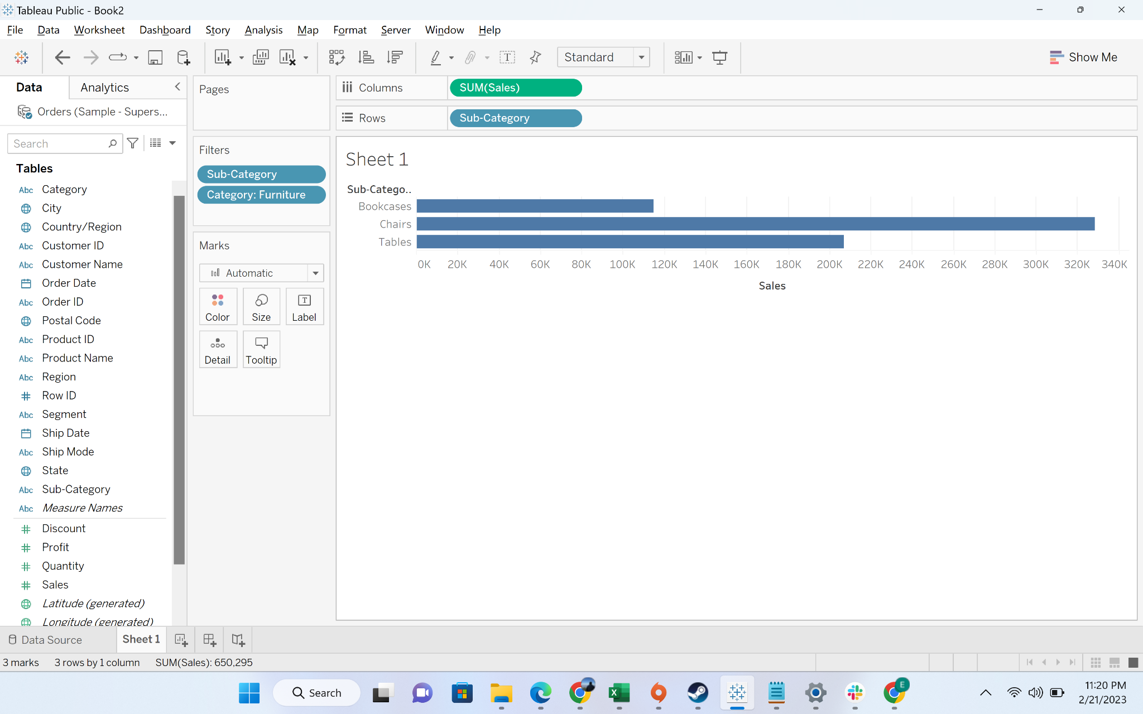

* + We will now convert the Category filter to a context filter. This means data will be first filtered according to context filter and thenother filters apply

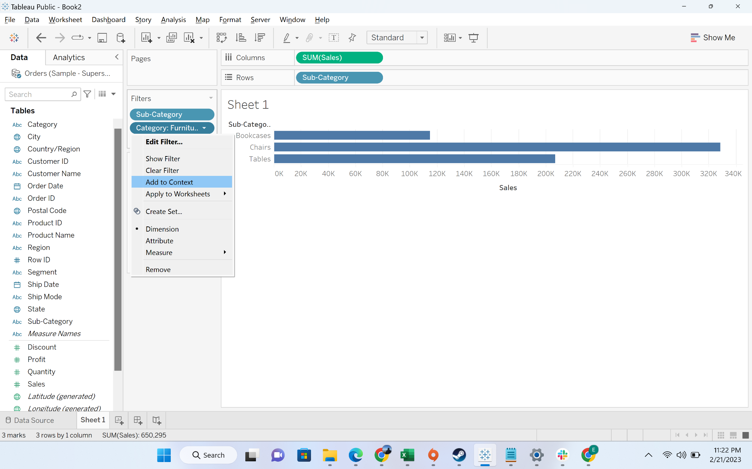

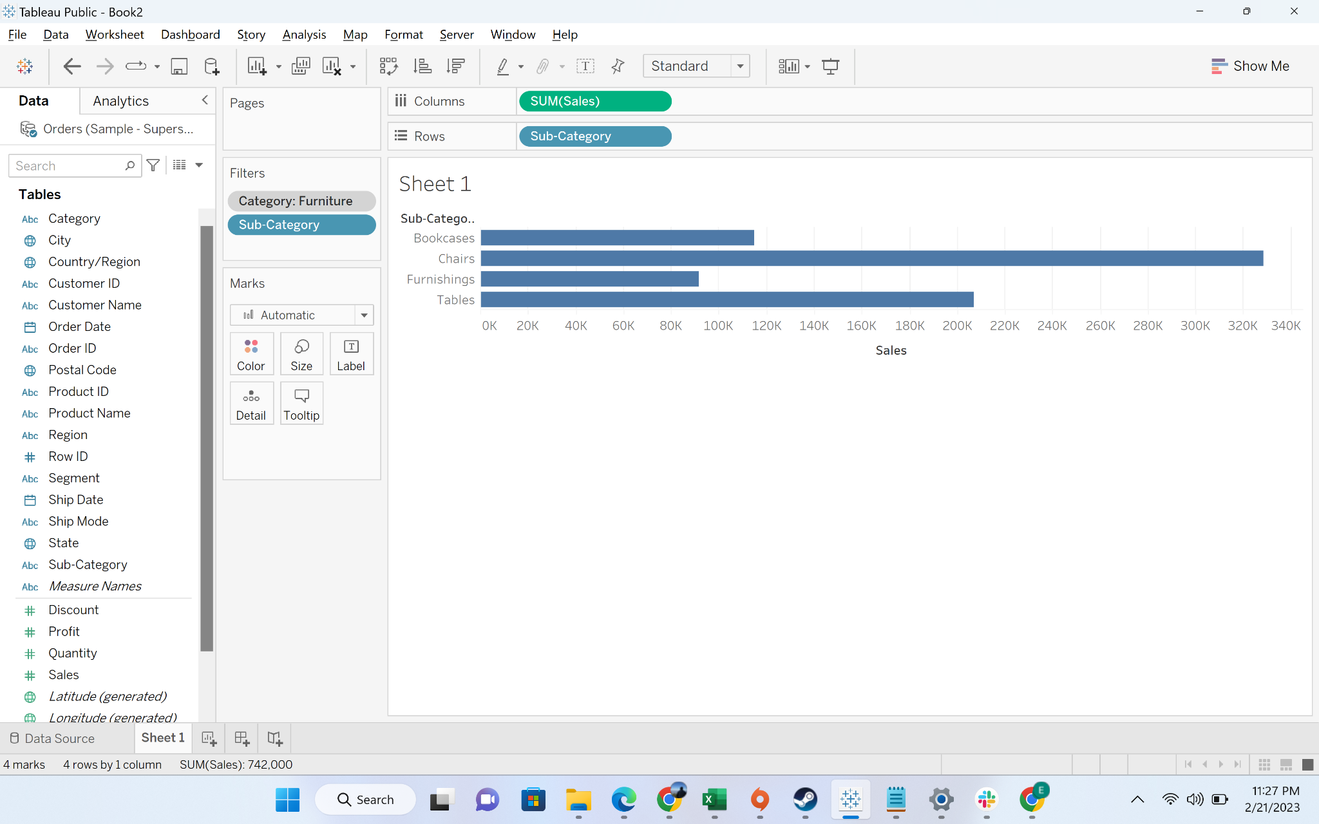

#### **Business problem 4**: Allow users to filter out the top n products subcategories by average discount.

Solution:

* **Business Context**
  + More than often, business stakeholders want the functionality to slice and dice data. For example, they might want to see the top 10 customers by sales. They might want to see which are the orders with negative profit. Hence, they need a functionality to customize the chart per their need
* **Intro to parameter:**
  + A parameter is a workbook variable such as a number, date, or string that can replace a constant value in a calculation, filter, or reference line.
* **Demonstration of creating a parameter**
  + Step-1: Reaching the parameter creation option

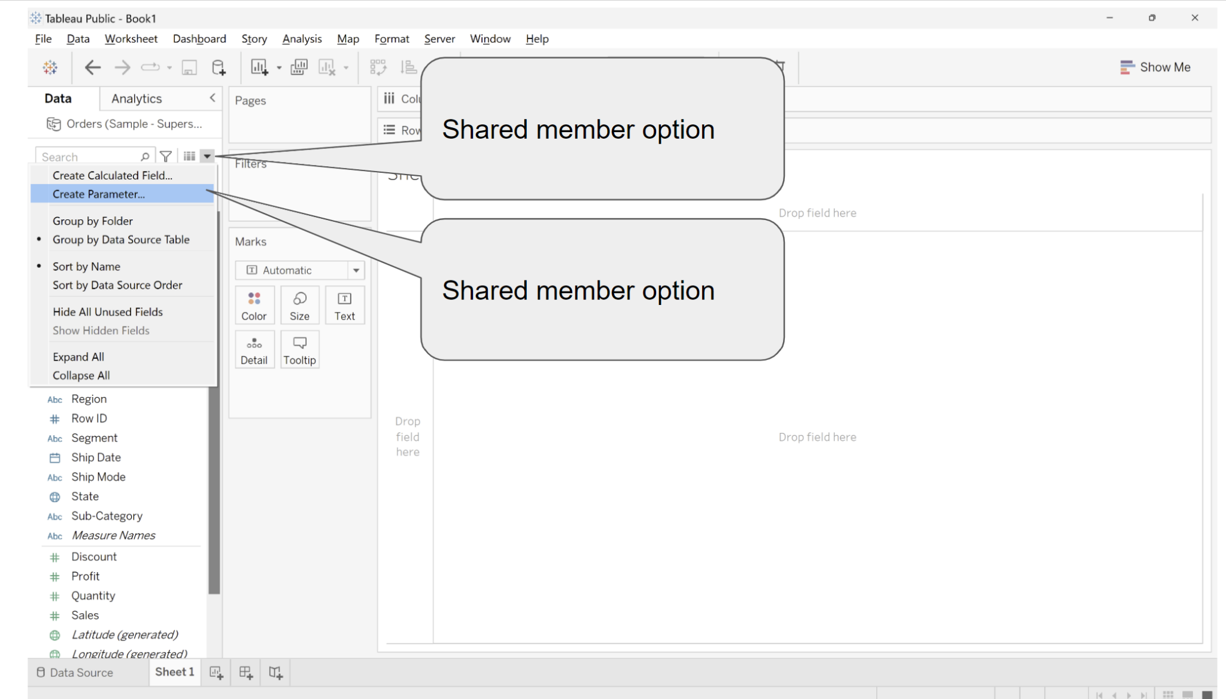

* + Step-2:Understanding the interface

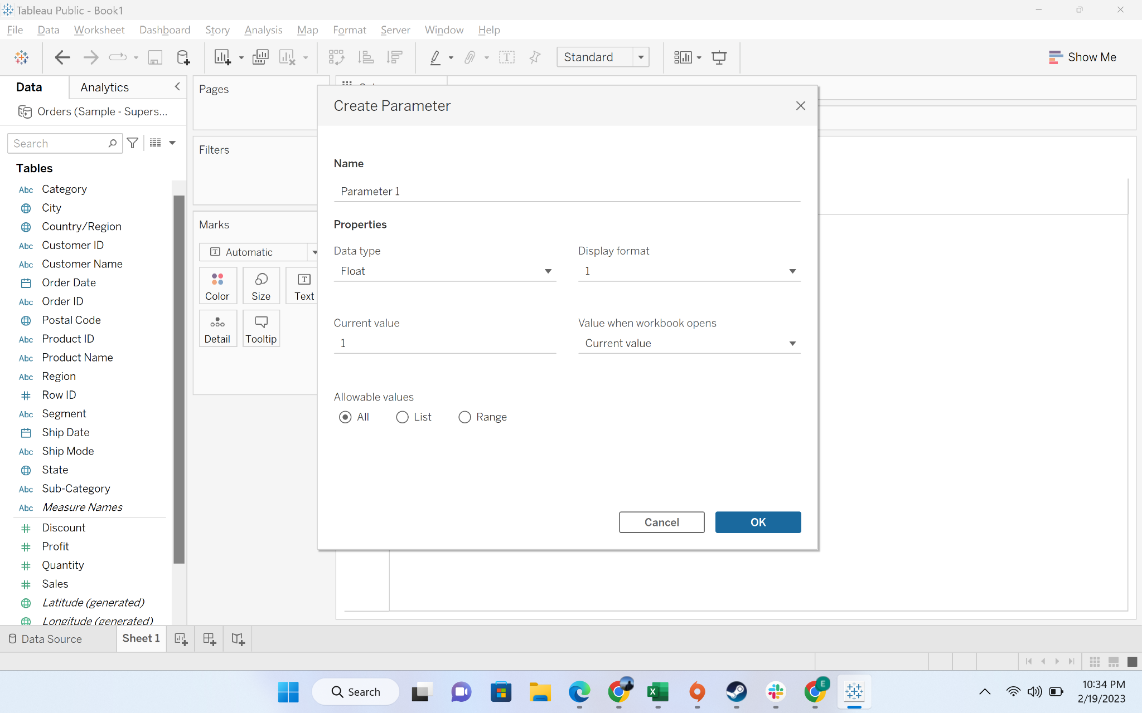

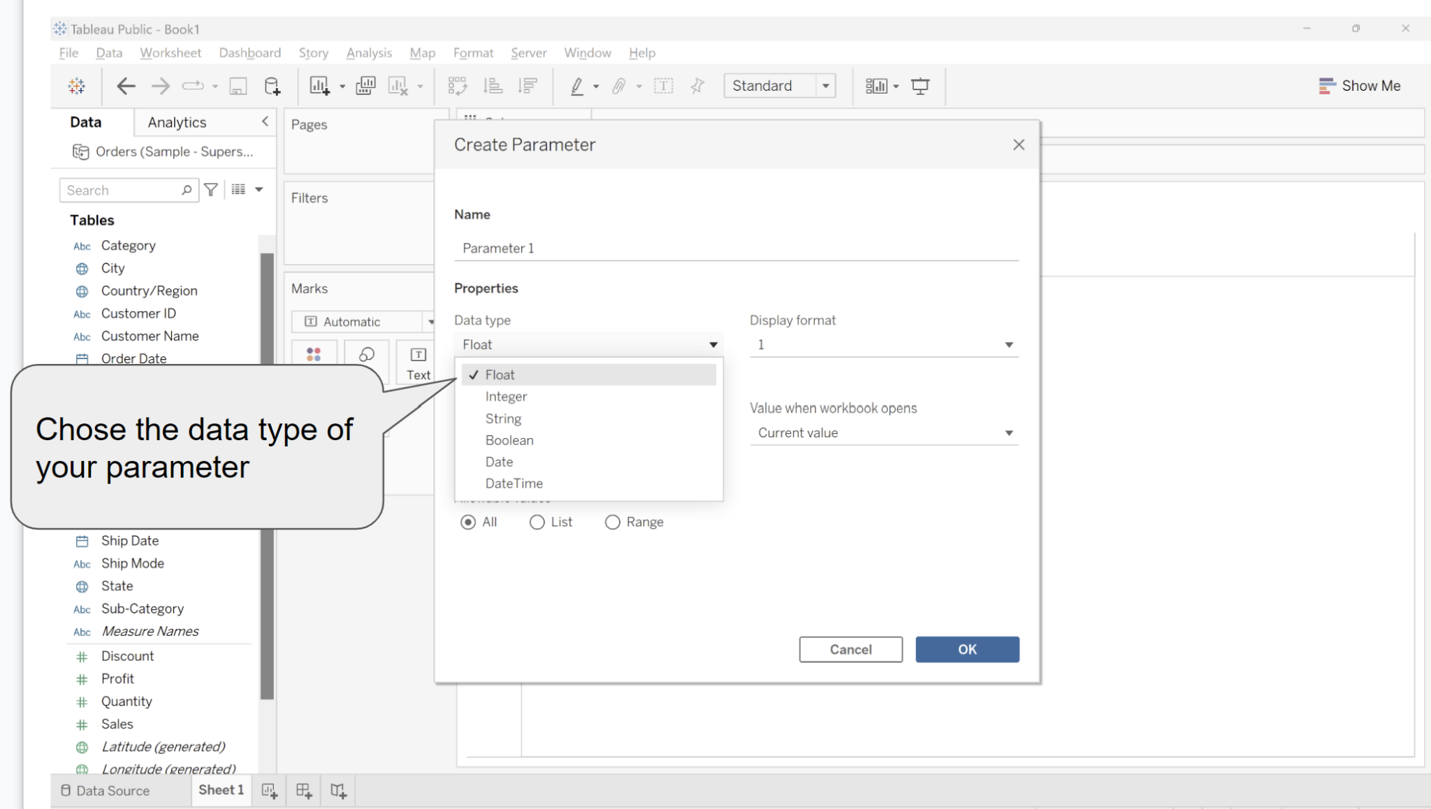

* + Step-3:Deciding allowable values

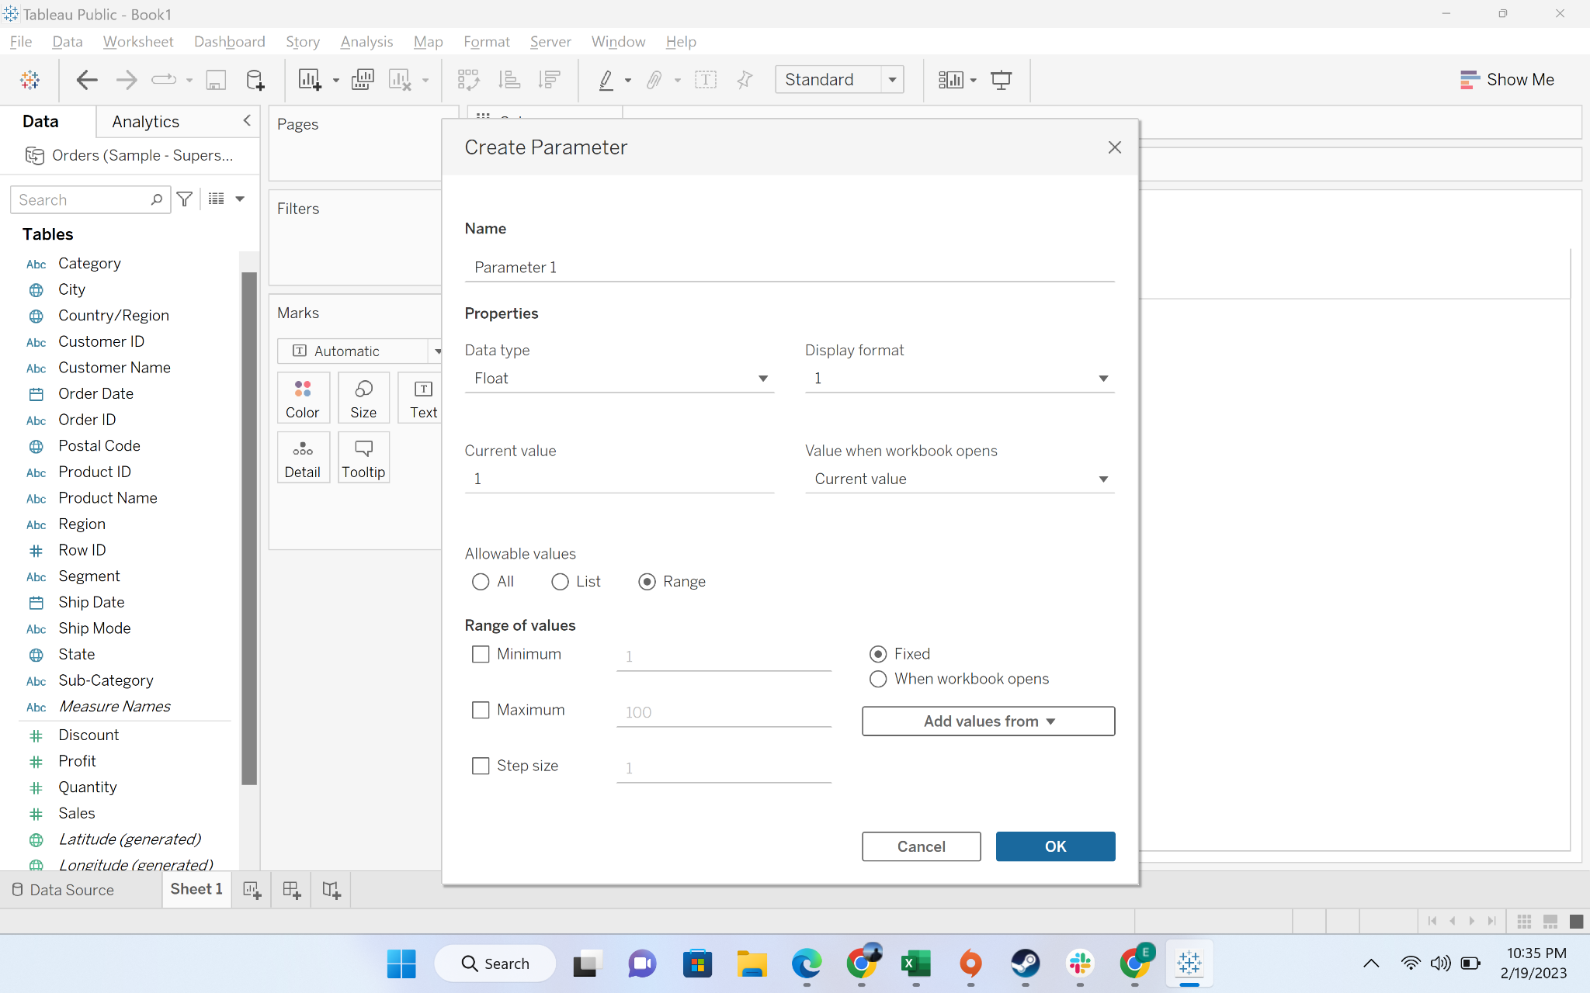

* + Step-4: Parameter creation for the problem

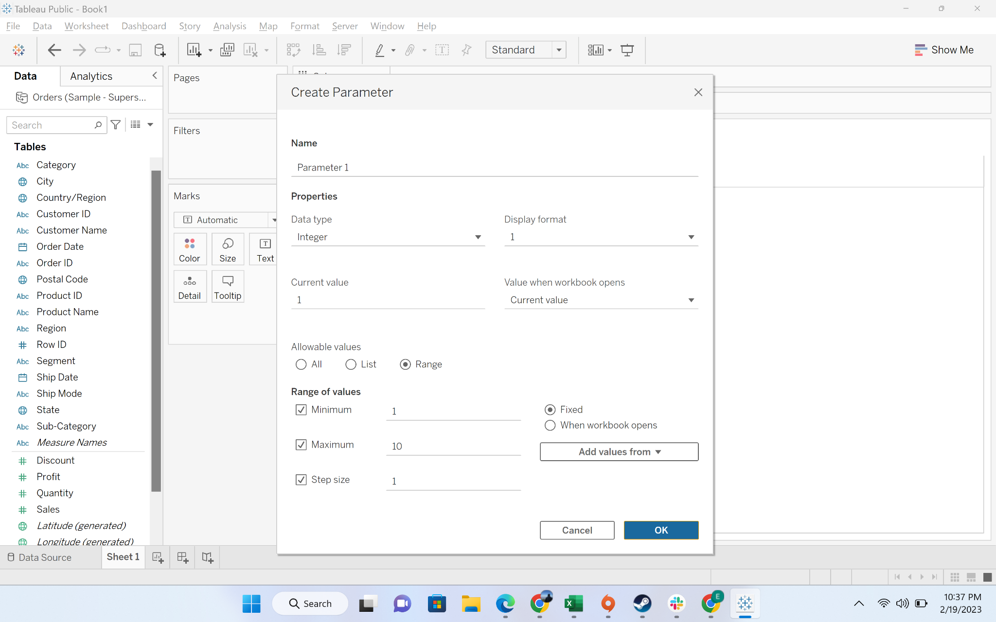

* + Step-5: Parameter created

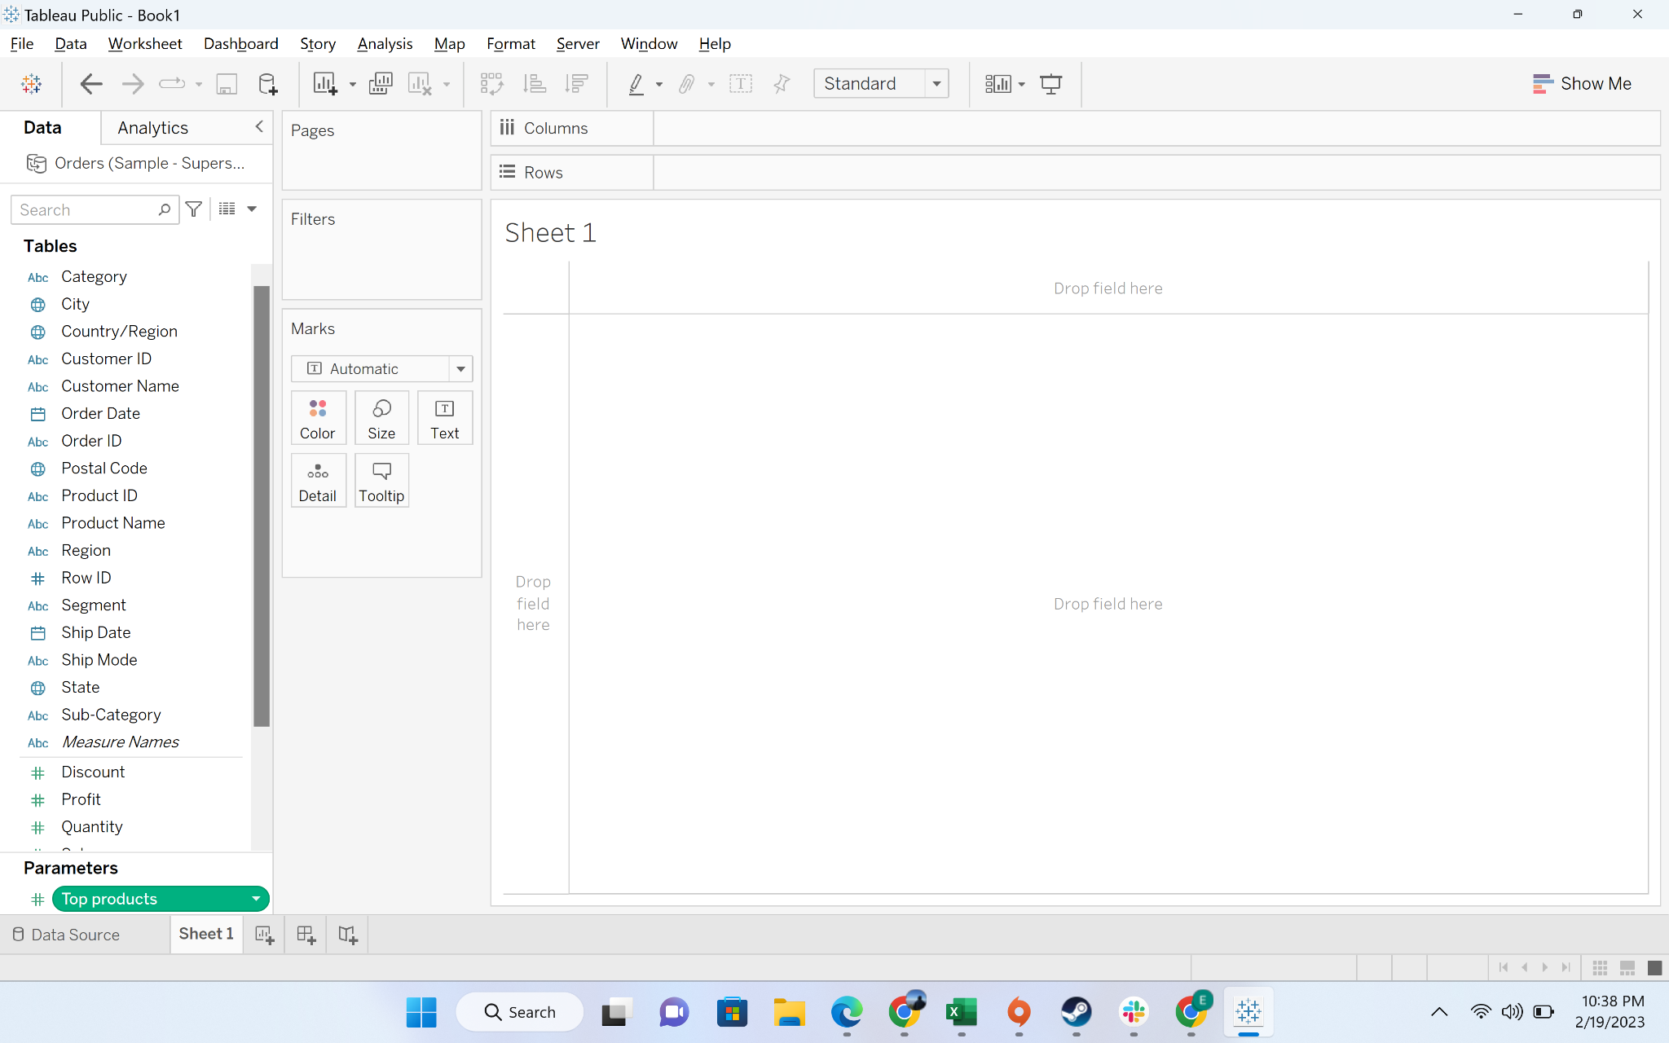

* + Step-6: Create a column chart by dragging “sub-category” to columns, discount to rows. Discount by default choose sum. Let’s convert it into average

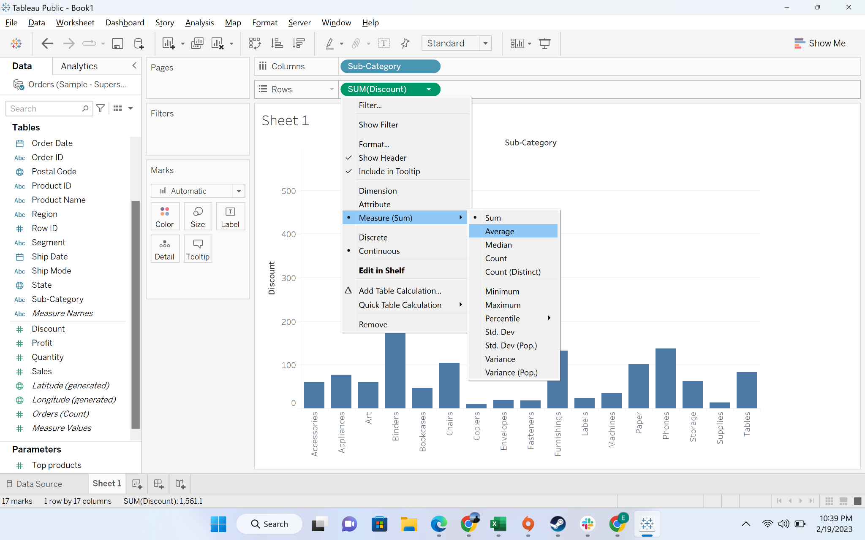

* + Step-7: Choose the option to show parameter

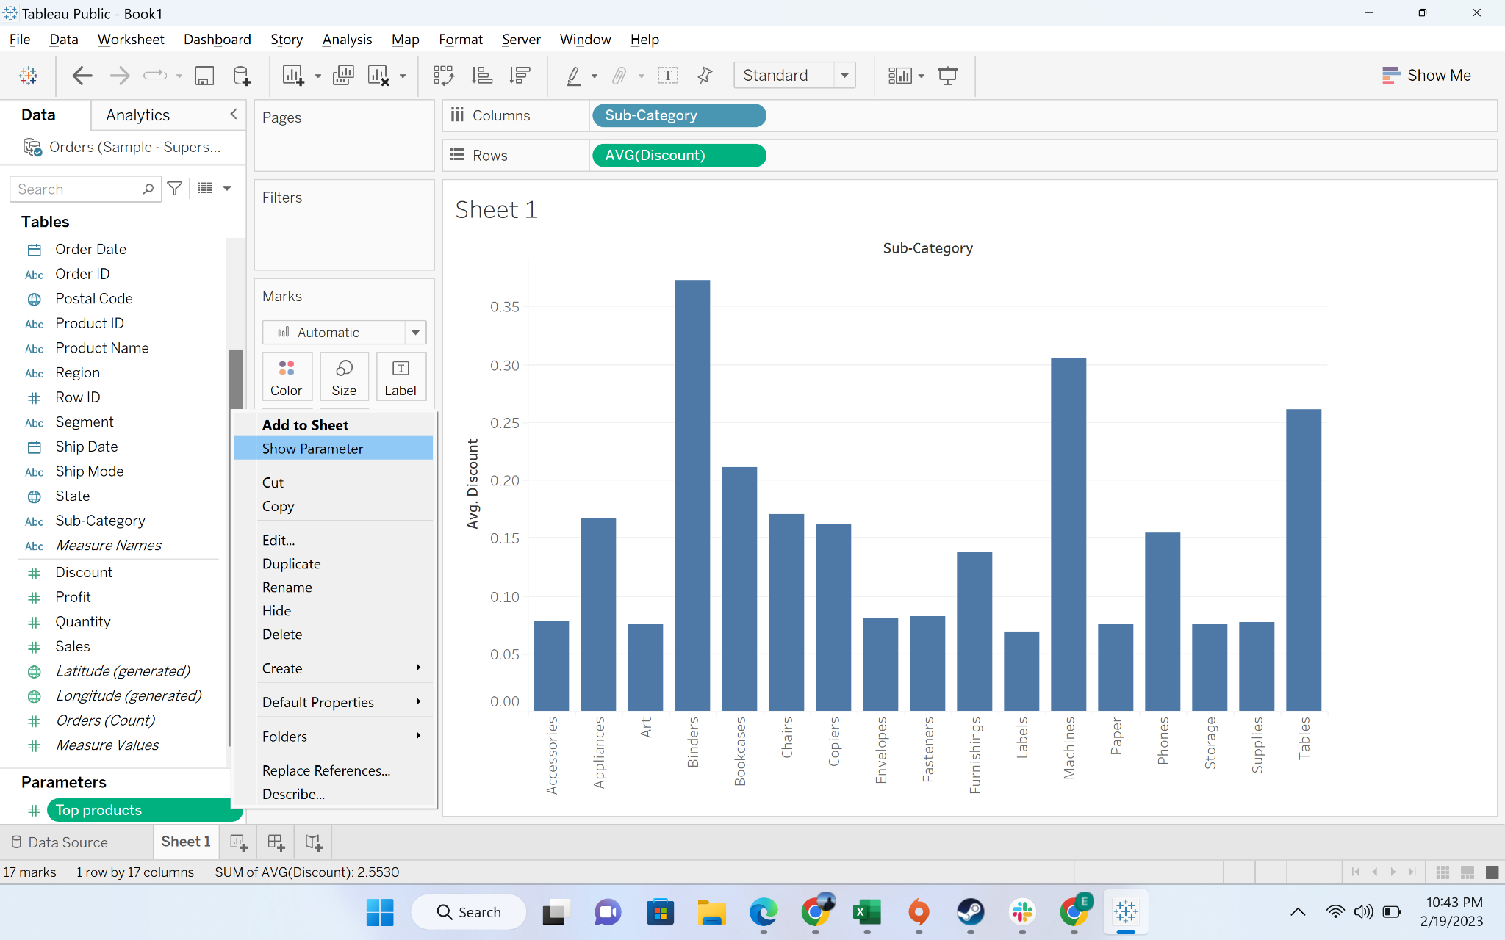

* + Step-8: Move subcategory to the filters and providing input from parameter

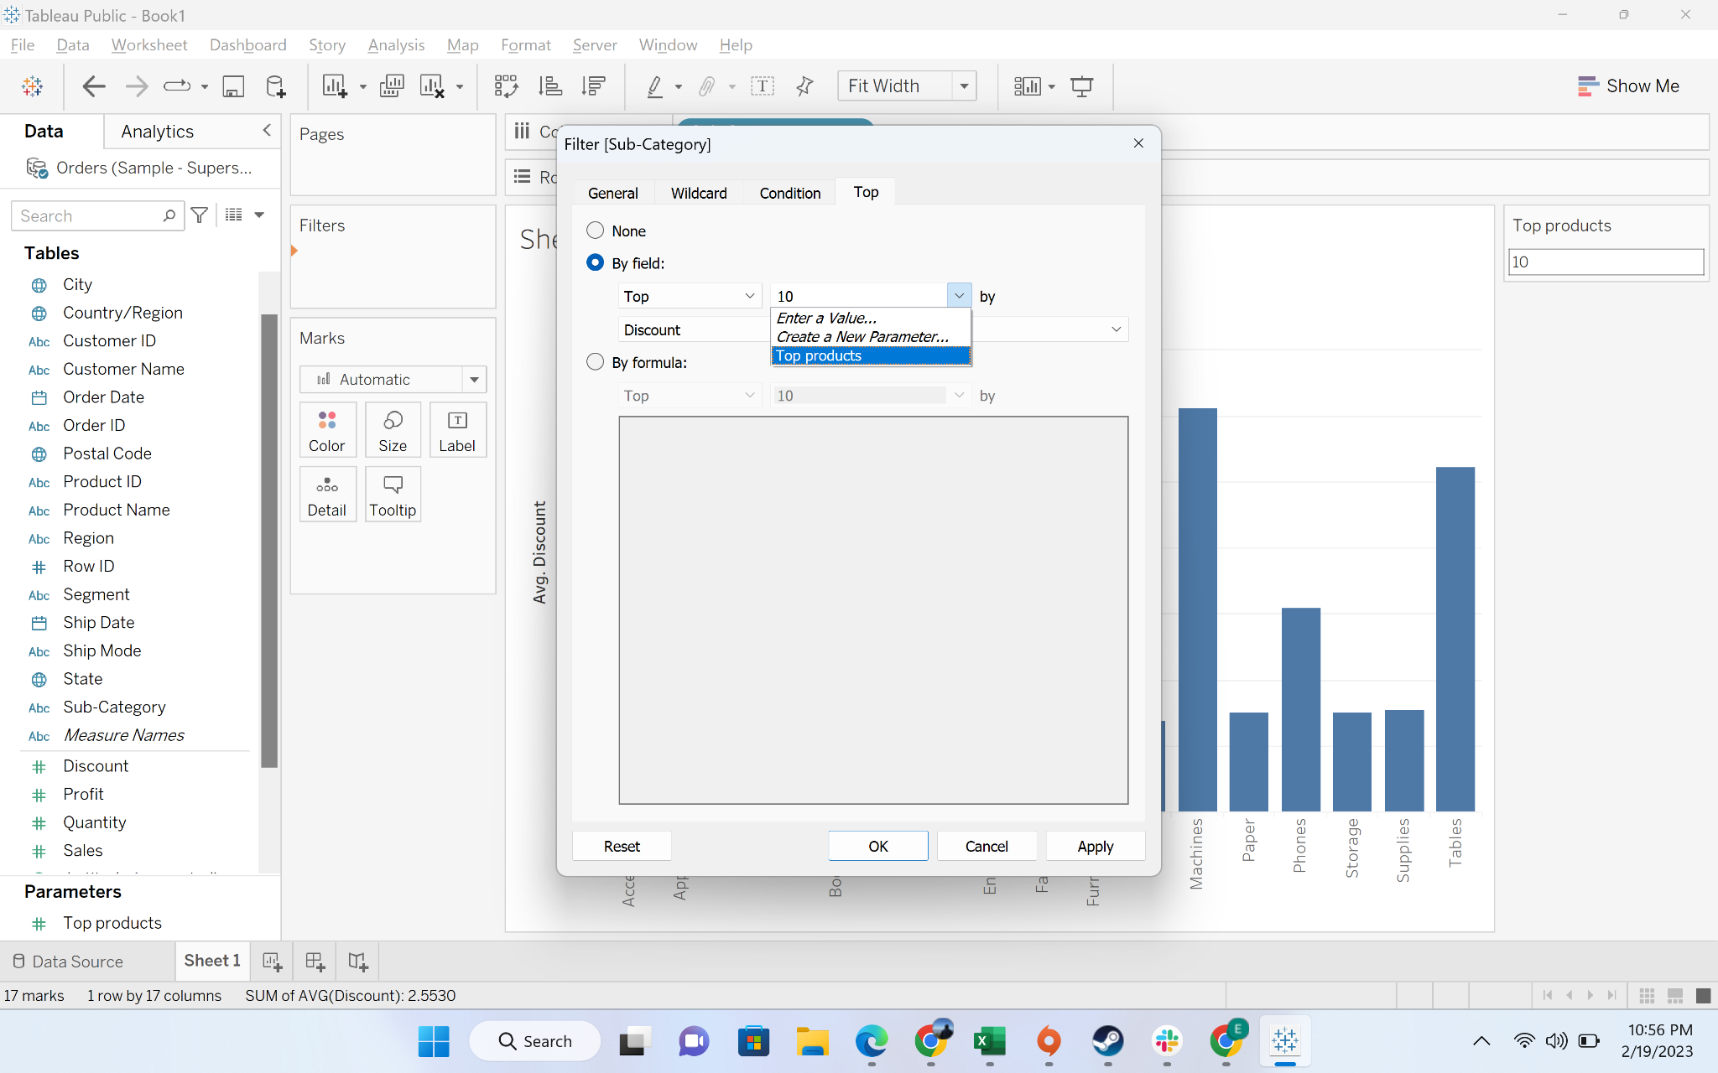

* + Step-9: Put 2 in the parameter

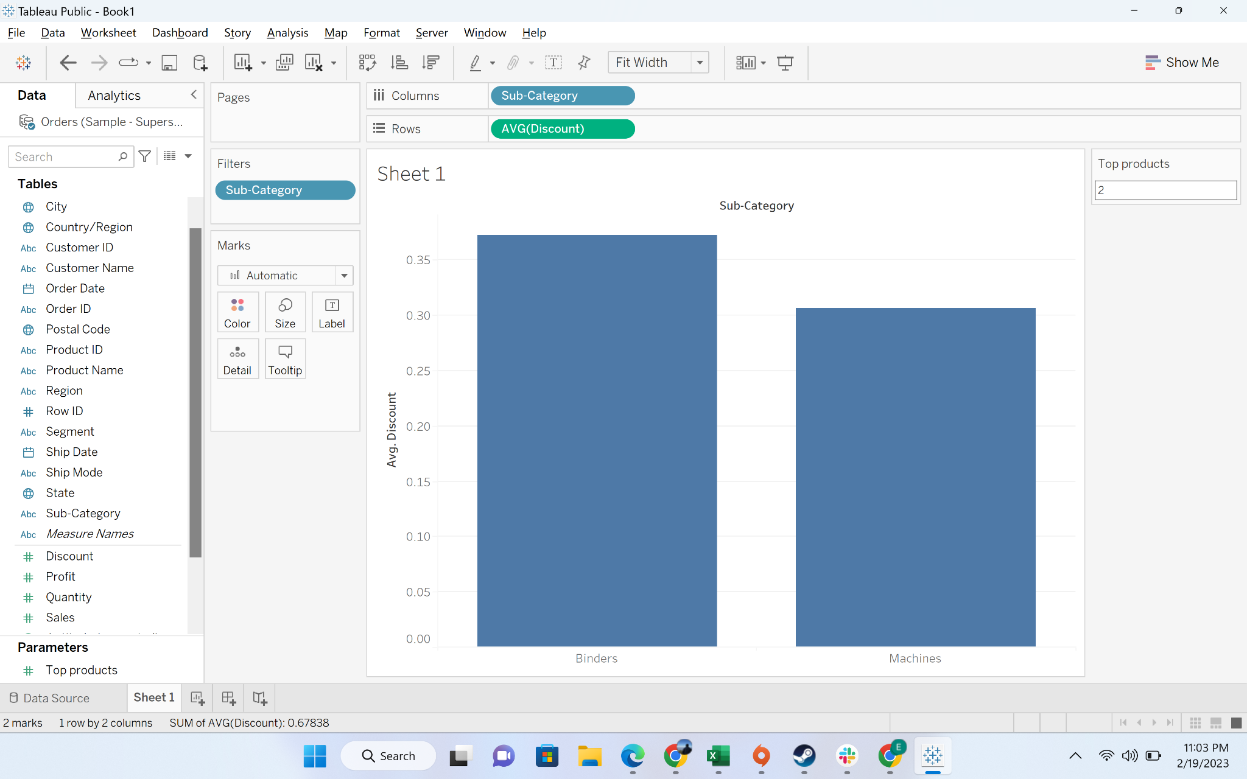

#### Business problem 5: Build a Hierarchy of Product category and Sub Category and have a plot which displays sales of product by category and drill it down using the hierarchy to display sales by sub category

* **Business Context**
  + In a lot of reporting, leadership want a drill down structure. For example: sales at a national level, then region, and then states. We can achieve this view by hierarchy
* **Intro to set:**
  + The Hierarchy in Tableau is **an arrangement where the entities are presented at various levels**. In common terms, Hierarchy is a system or organization that has many levels from highest to lowest; similarly, in Tableau, we can create hierarchies by bringing one dimension as a level under the principal dimension
* **Demonstration of creating a parameter**
  + Step-1: Drag Sub-category to the category column

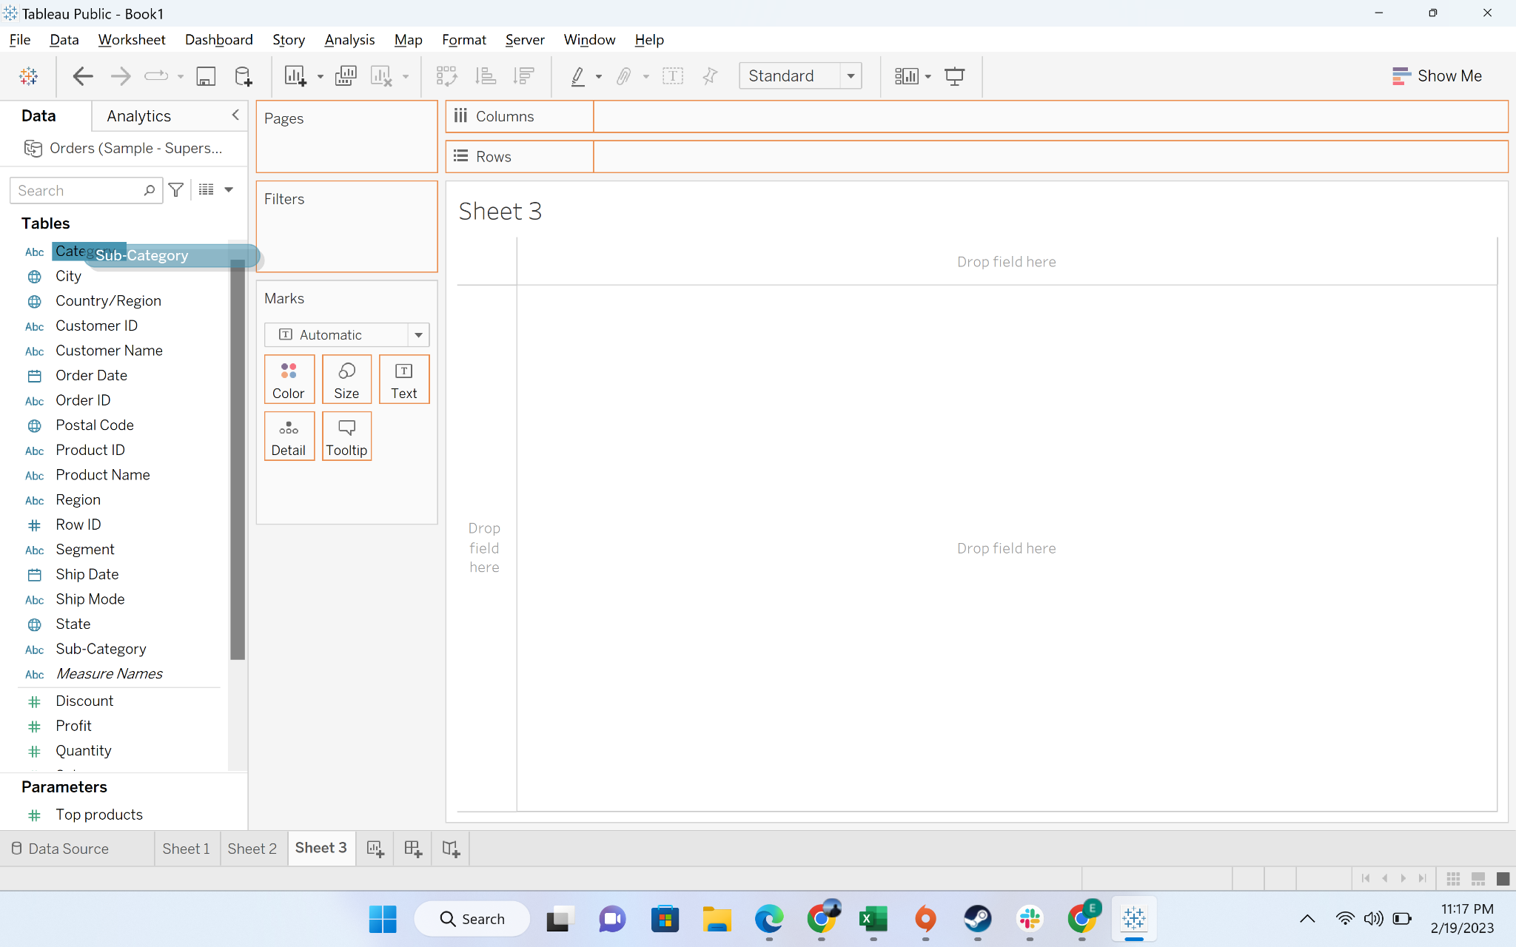

* + Step-2: Rename hierarchy to product

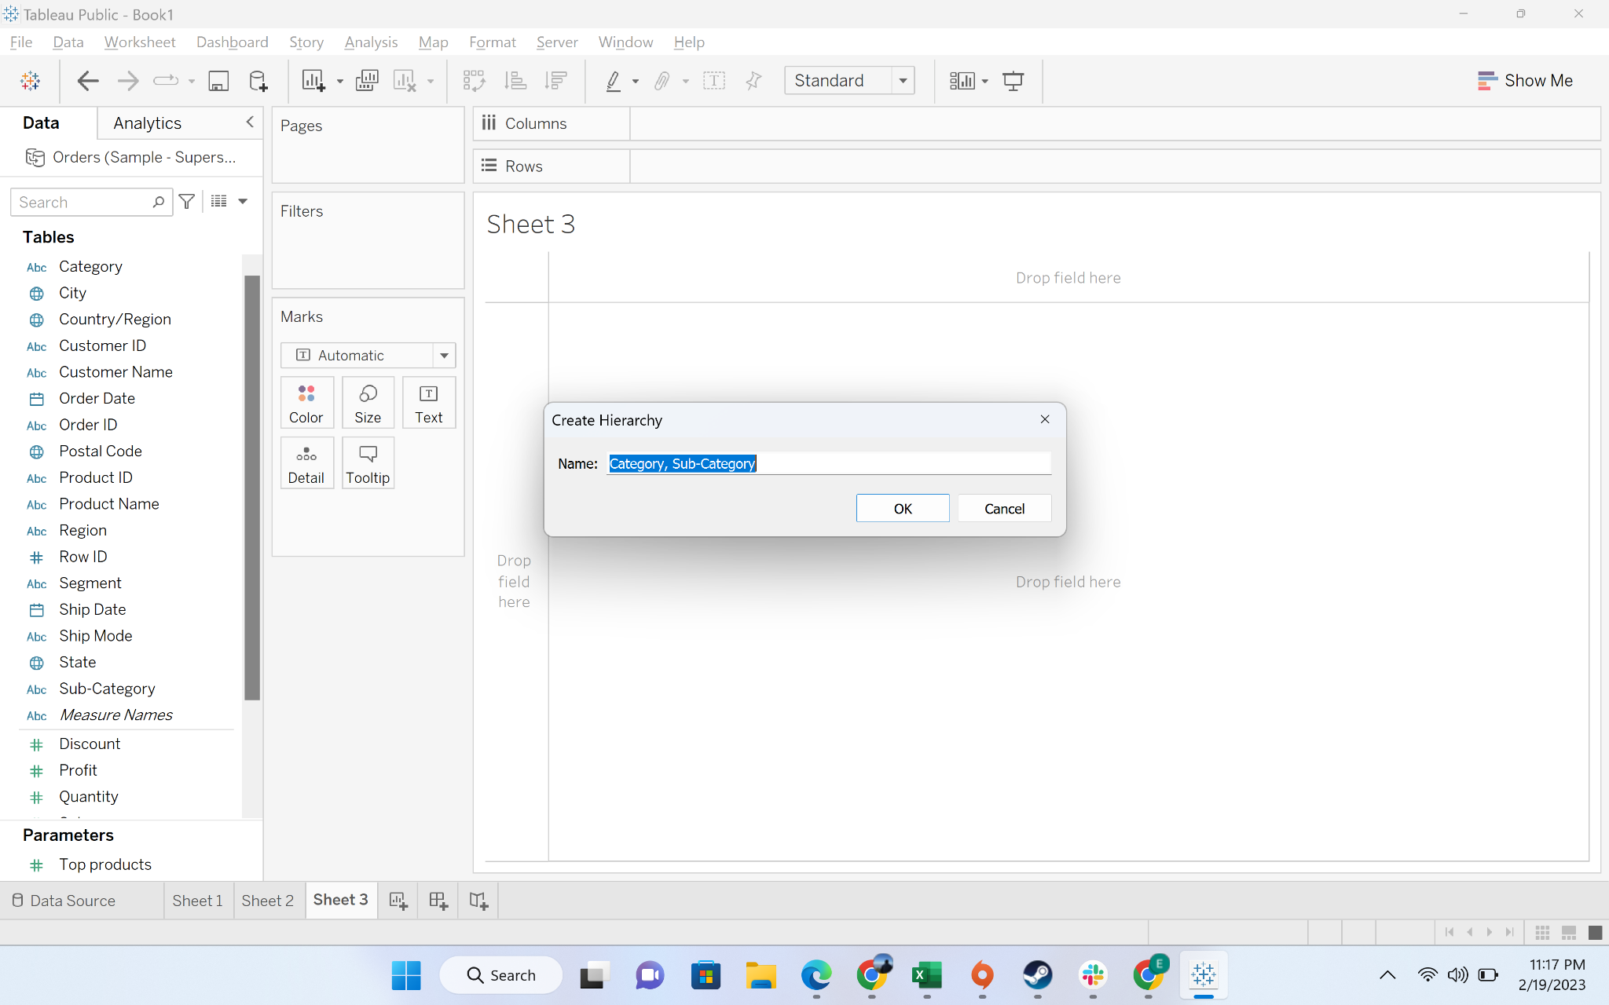

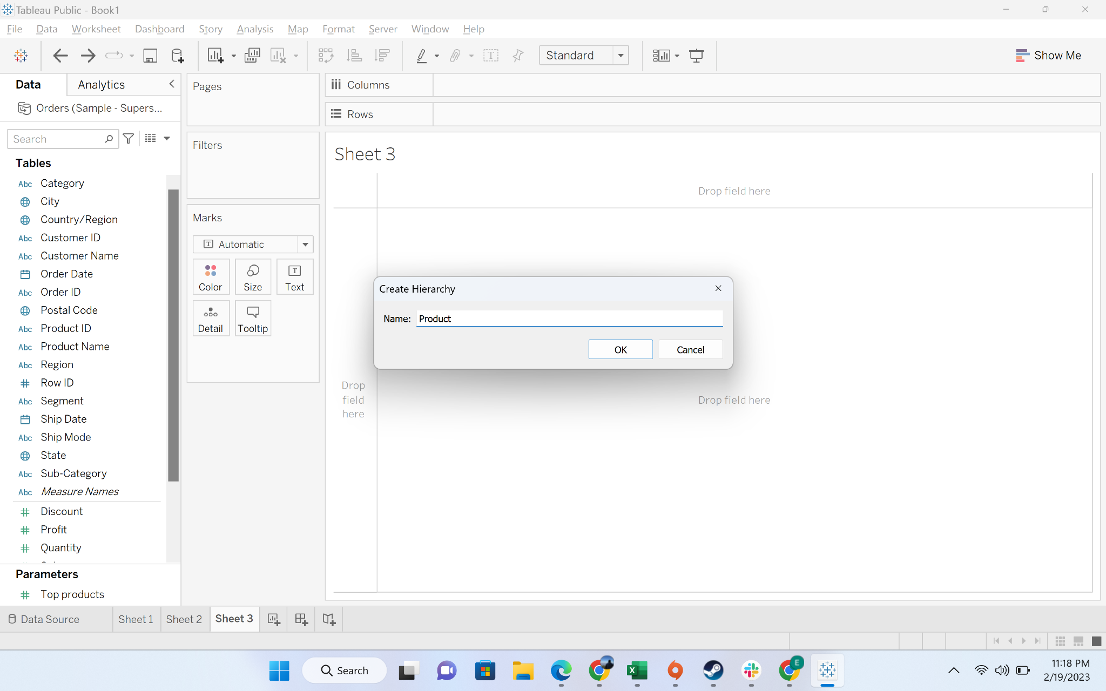

* + Step-3: You can see the hierarchy field

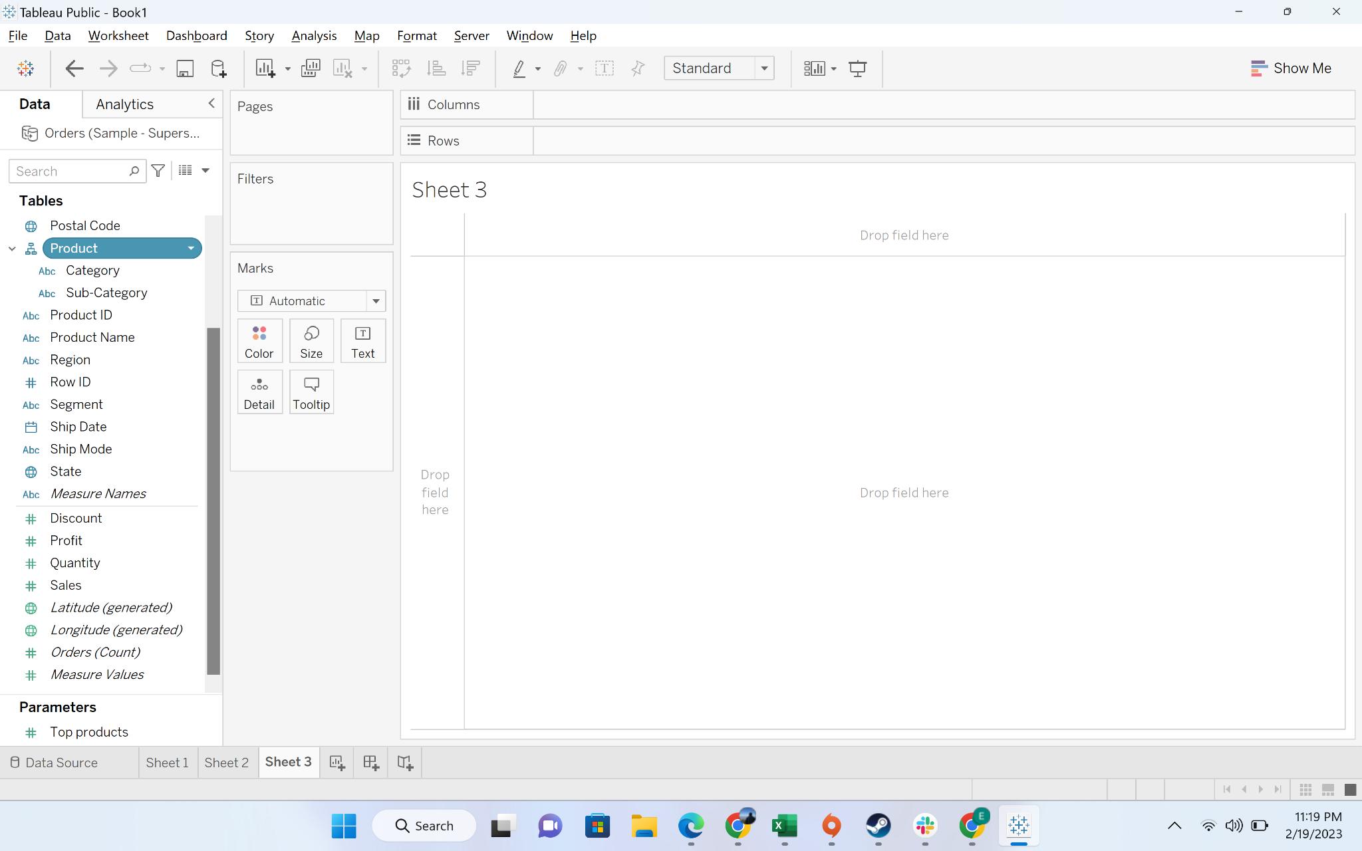

* + Step-4: Drag the product hierarchy to column and sales to row

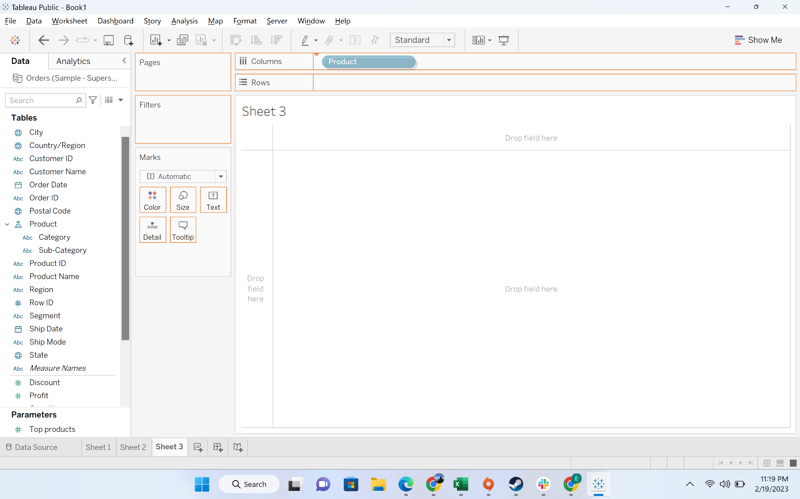

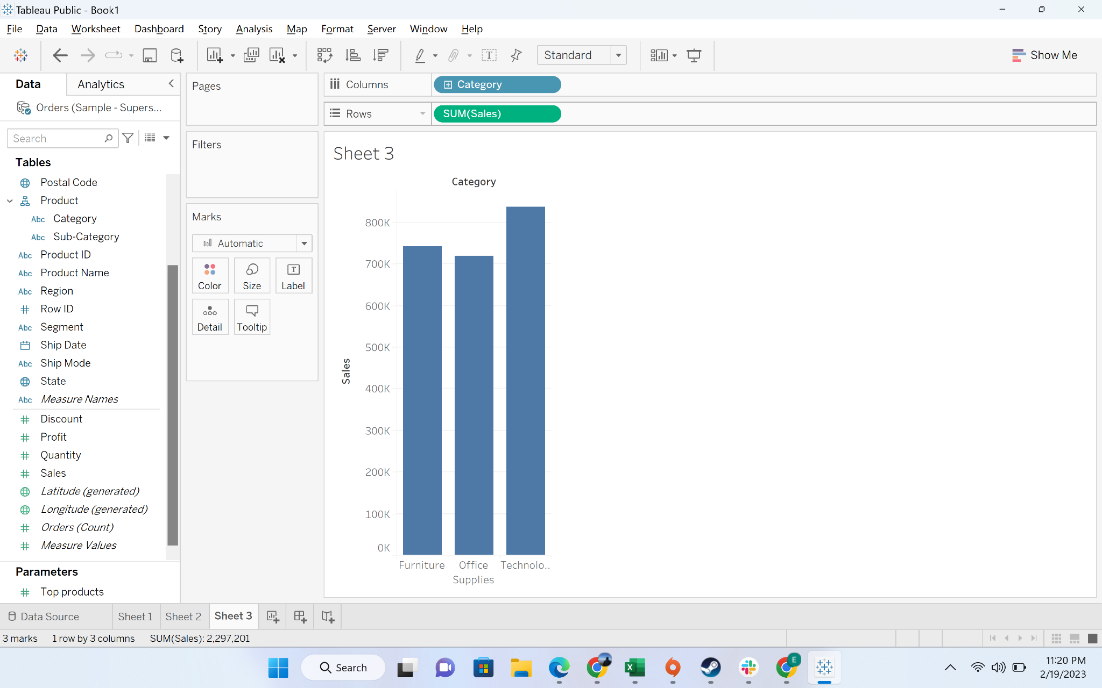

* + Step-5: click on the hierarchy to expand it and see the breakdown

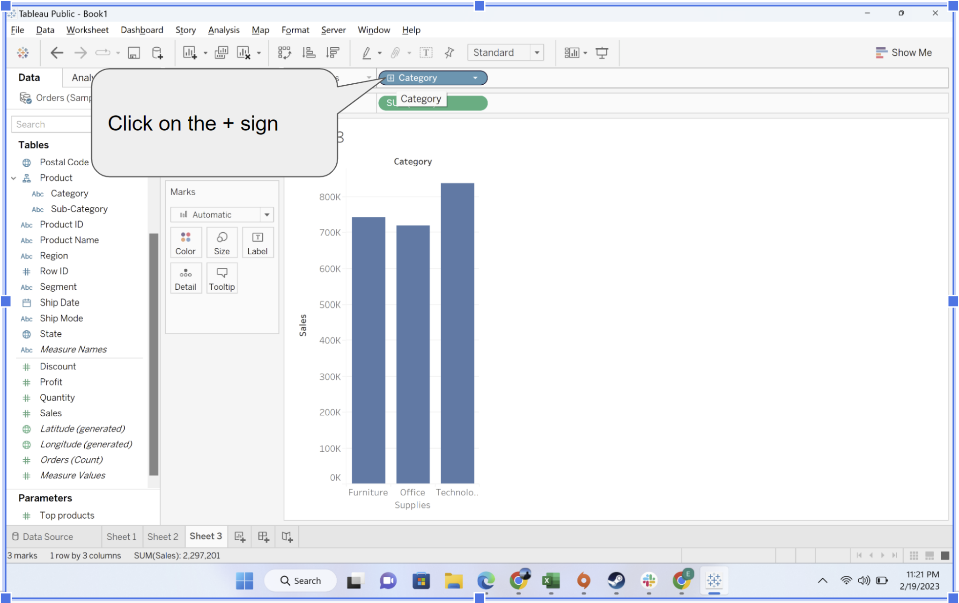

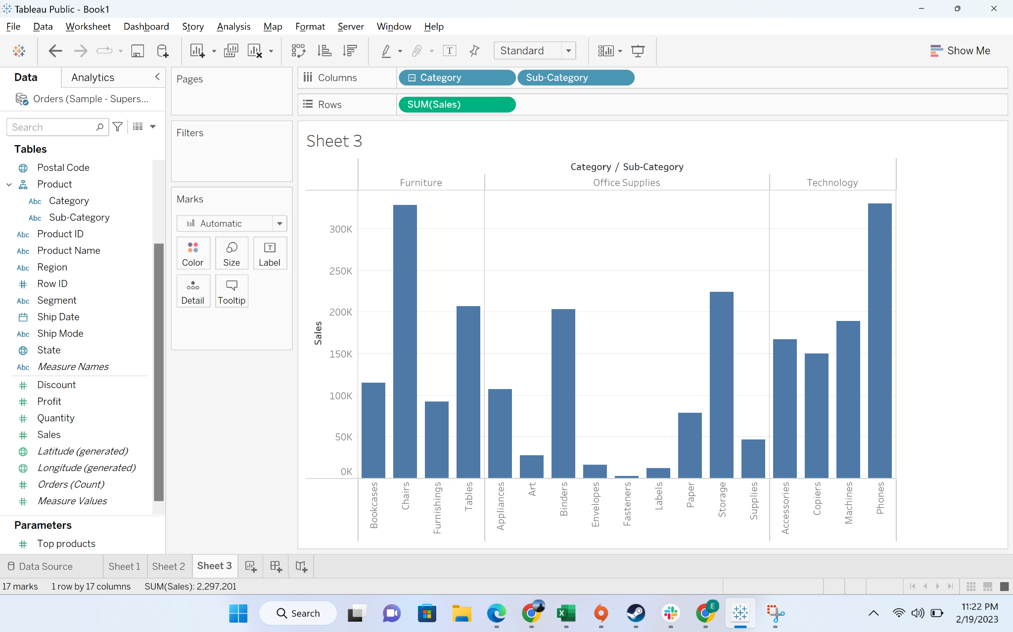

#### 

#### Business problem 6: -find average cost of each product sub categories

Solution:

* **Business context:**Sometimes to understand opportunities in business, data analysts have to derive new metrics to understand performance and identify opportunities. For example:
  + Deriving the profit if you are given sales and cost
  + Calculating return on investment
  + Profit %
* Basic expressions allow you to transform values or members at the data source. Row-Level – Calculation is calculated for each row in the data. Row-level results are then aggregated just like normal fields.
* **Demonstration of creating a calculated field:**
  + We will create a field cost = sales - profit
  + We have two options to create a calculated field
  + Option-1: creating from the top drop down option

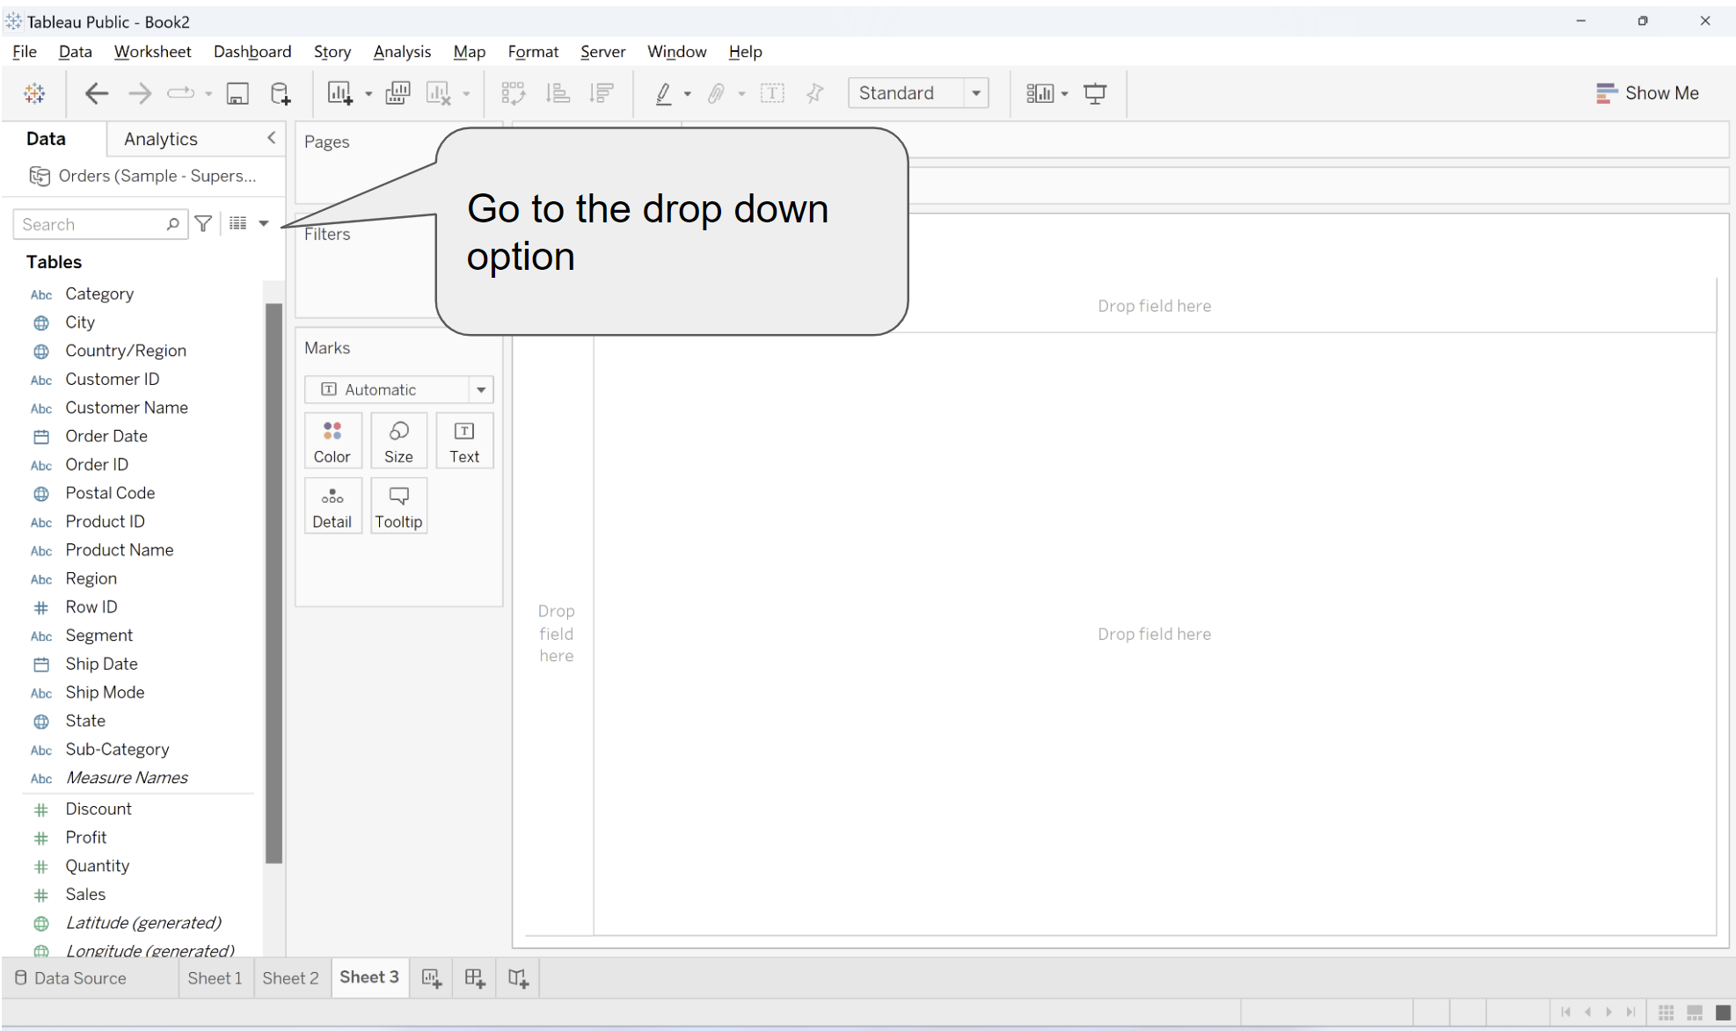

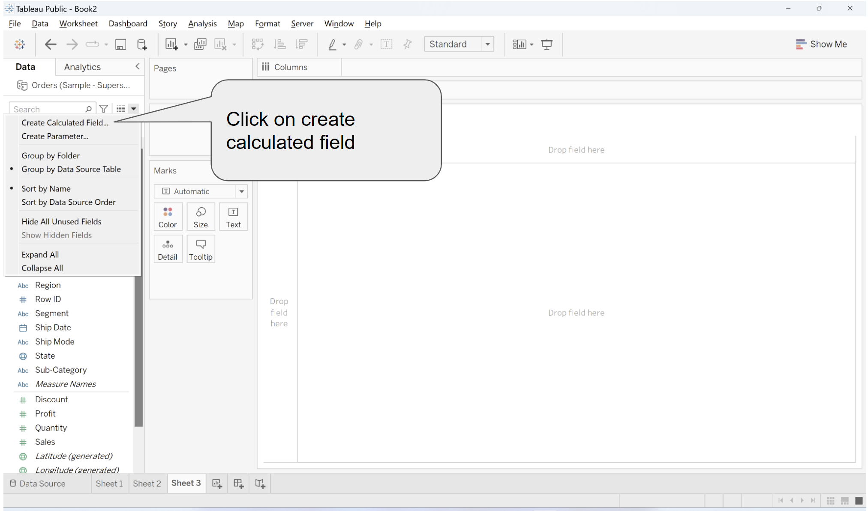

* + Option-2: creating from the measure

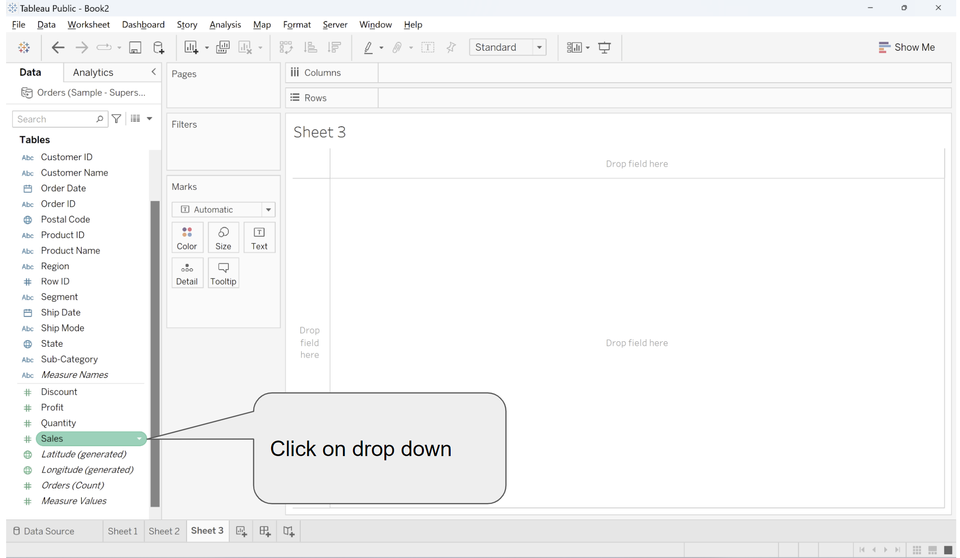

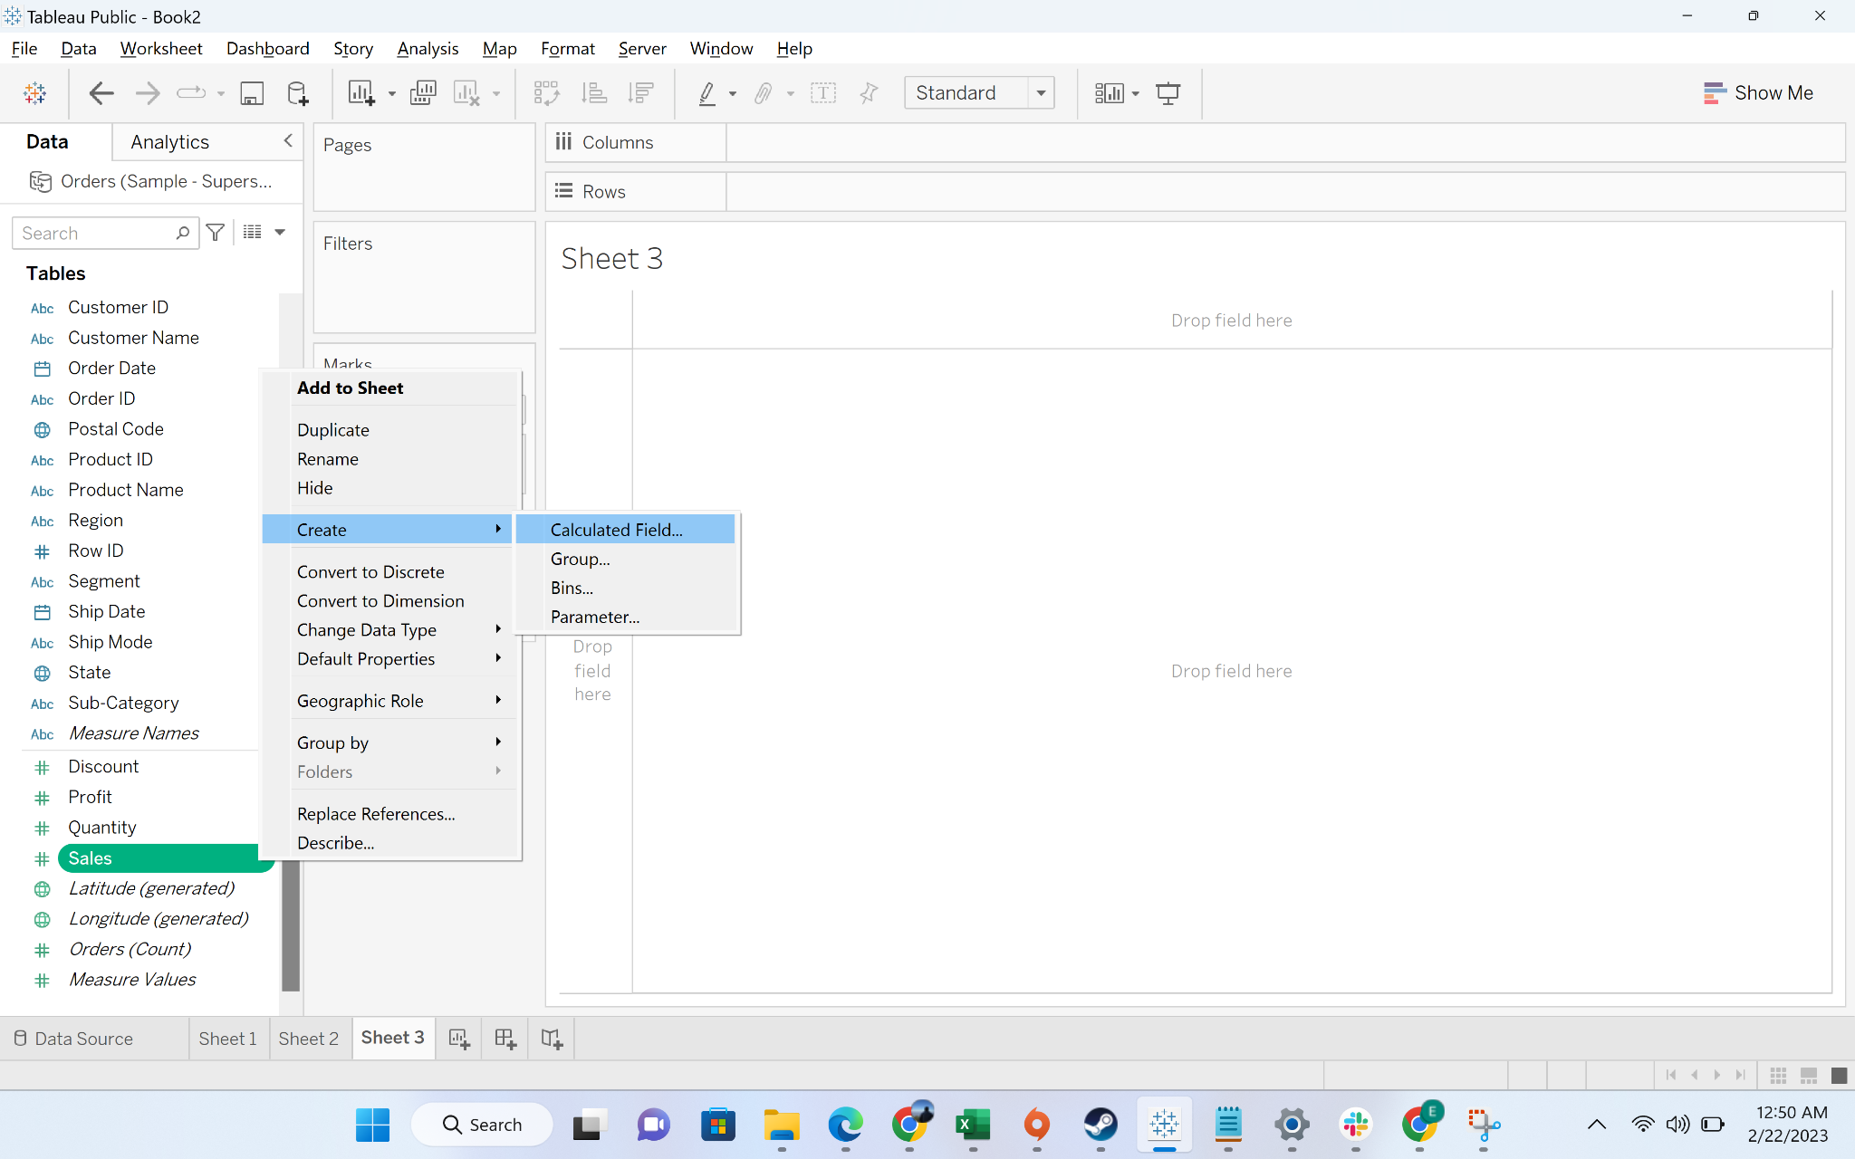

* + Step-1: Go to create calculated field
  + Step-2: click on the create calculated field to open the formula pane
  + Step-3: write the command to get sales column

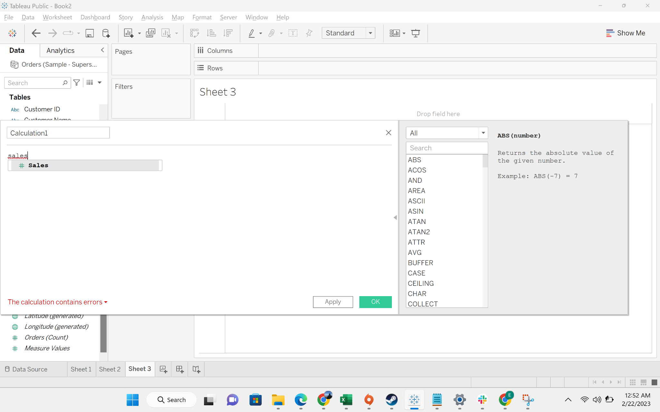

* + Step-3: write the command to get profit column

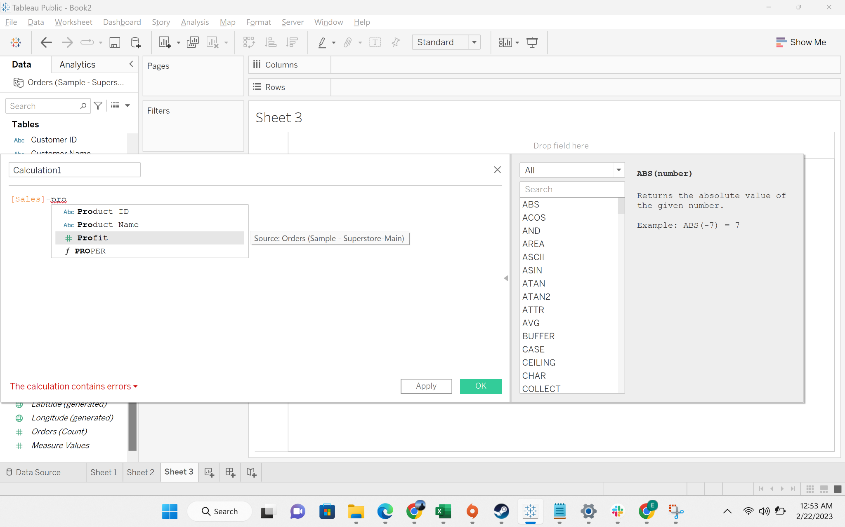

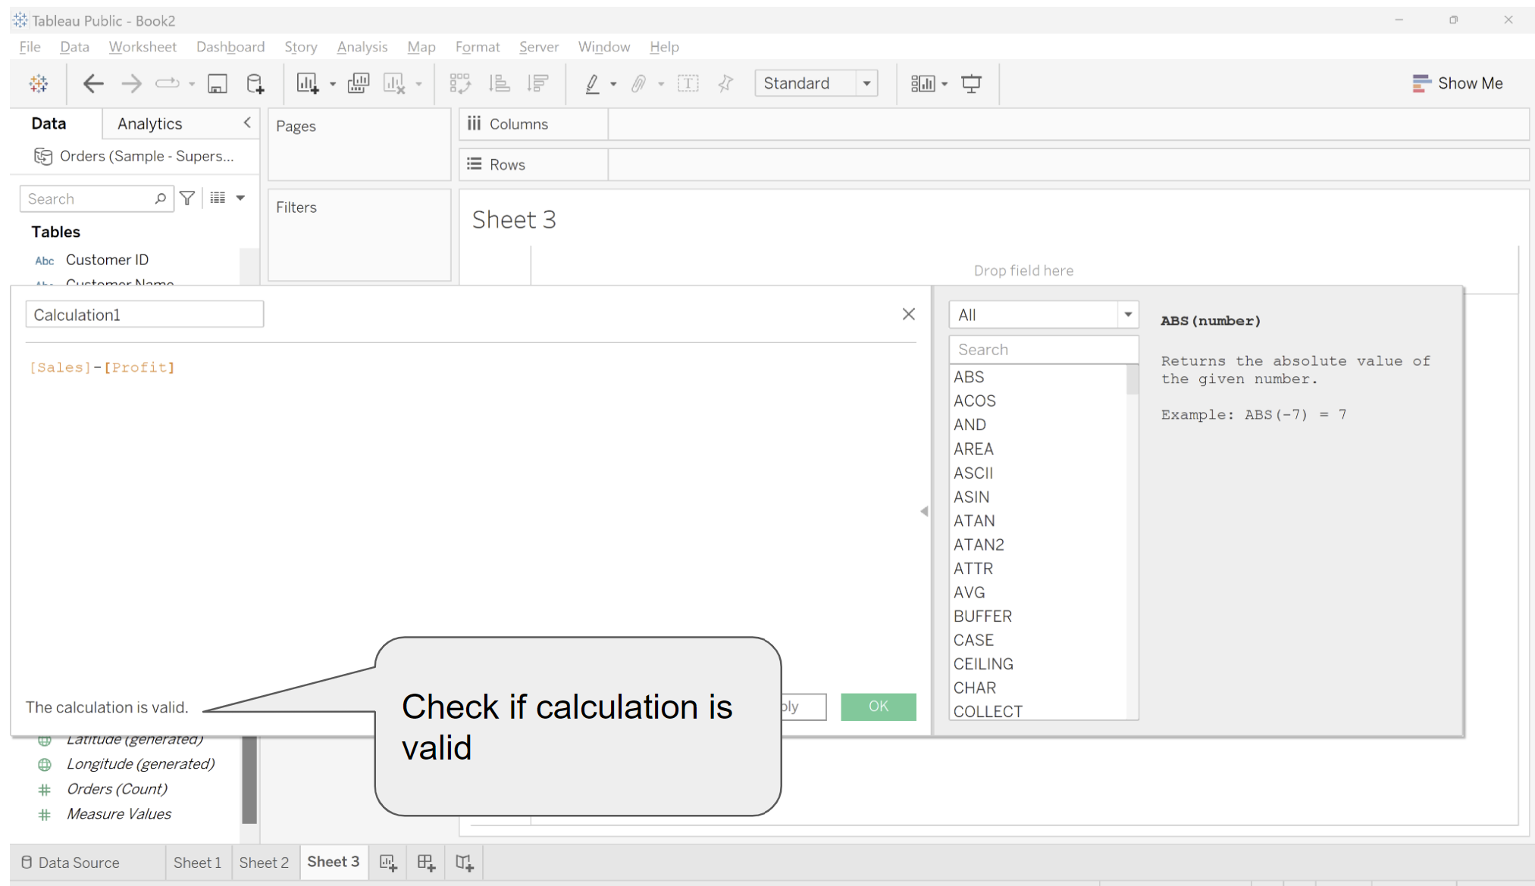

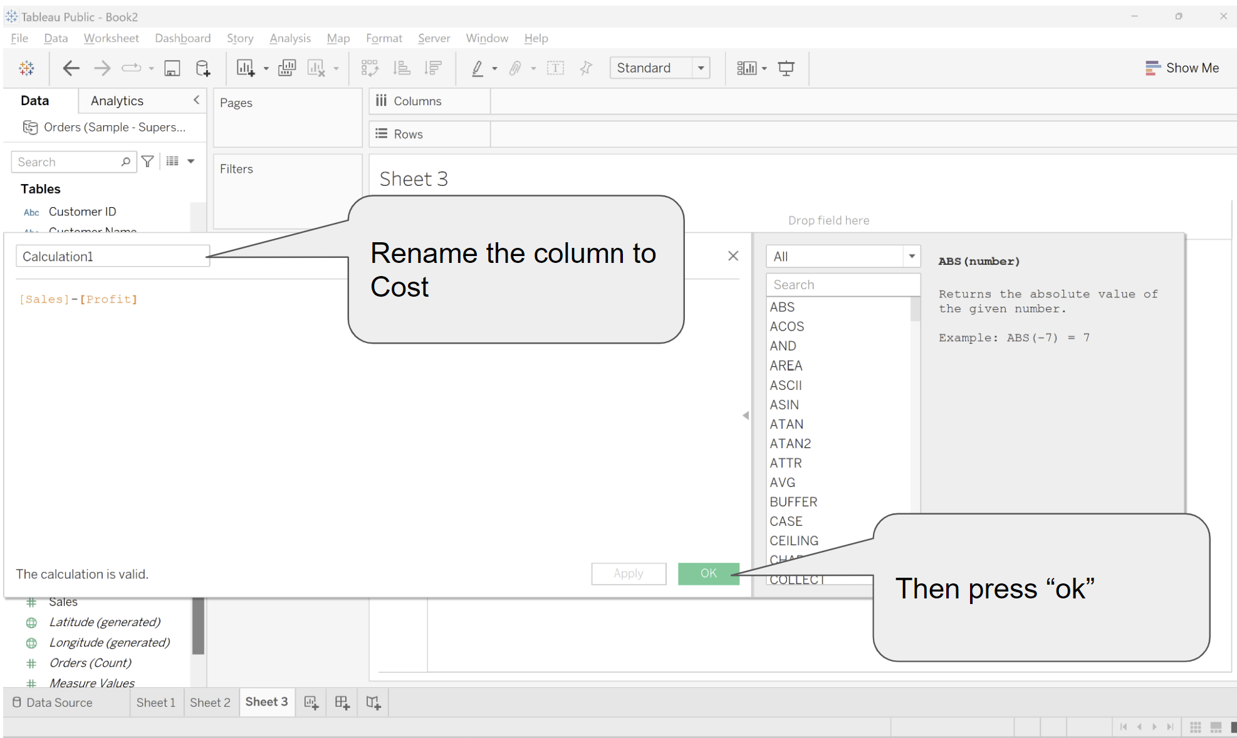

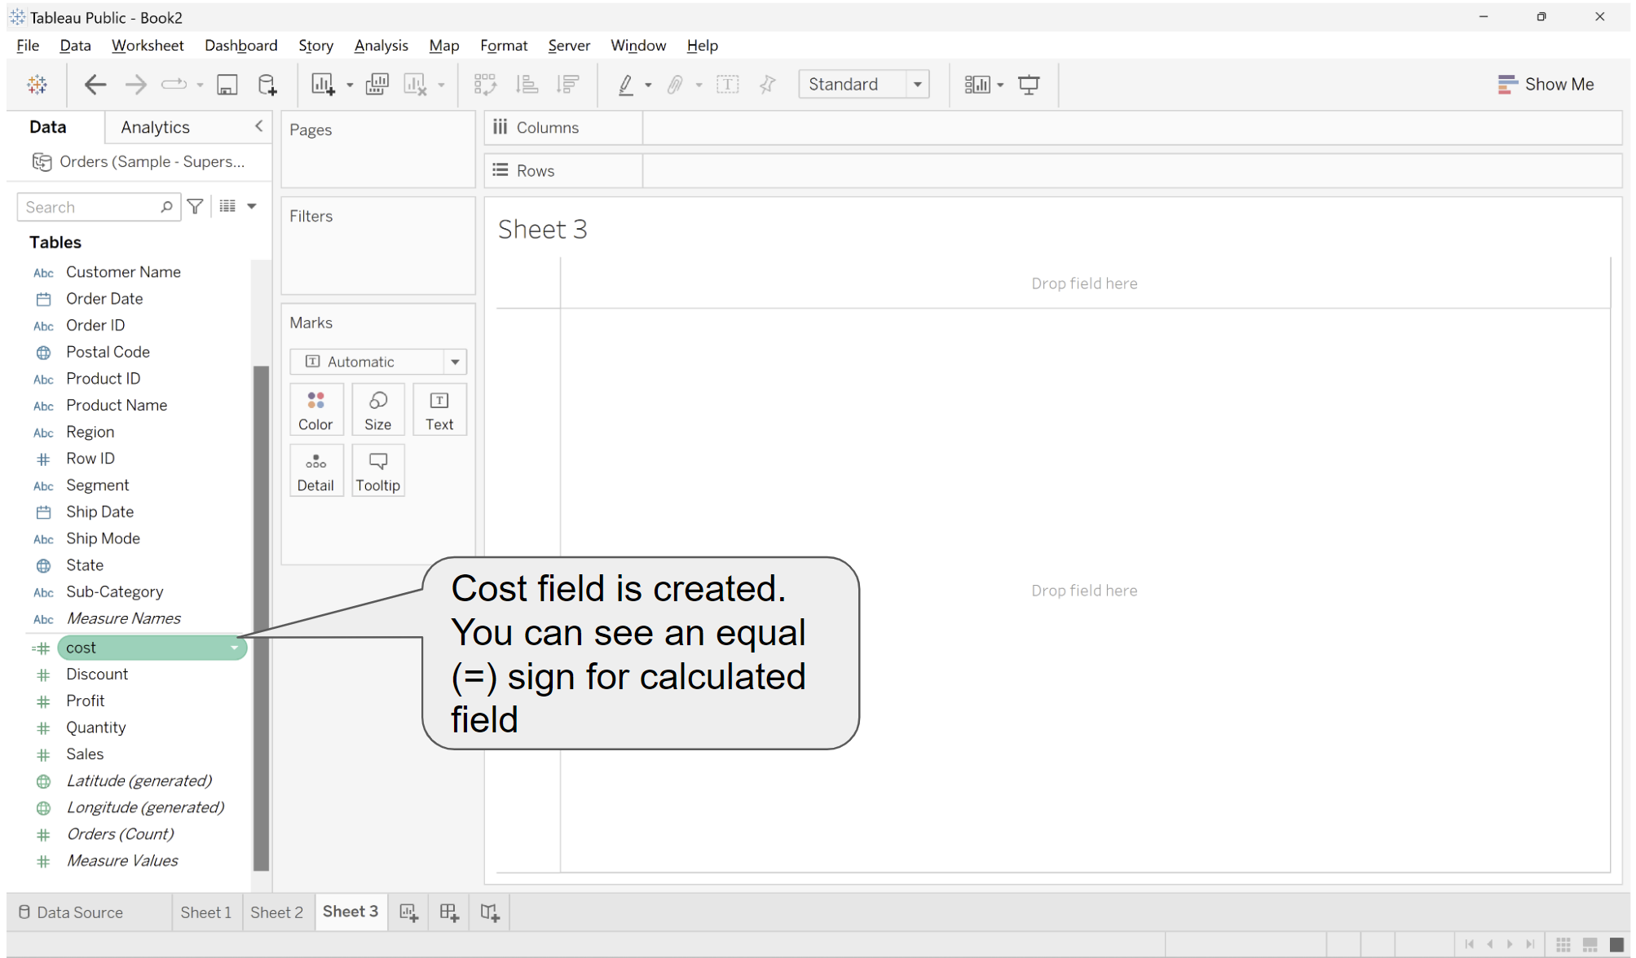

* + Step-4: drag subcategory to rows and cost to label

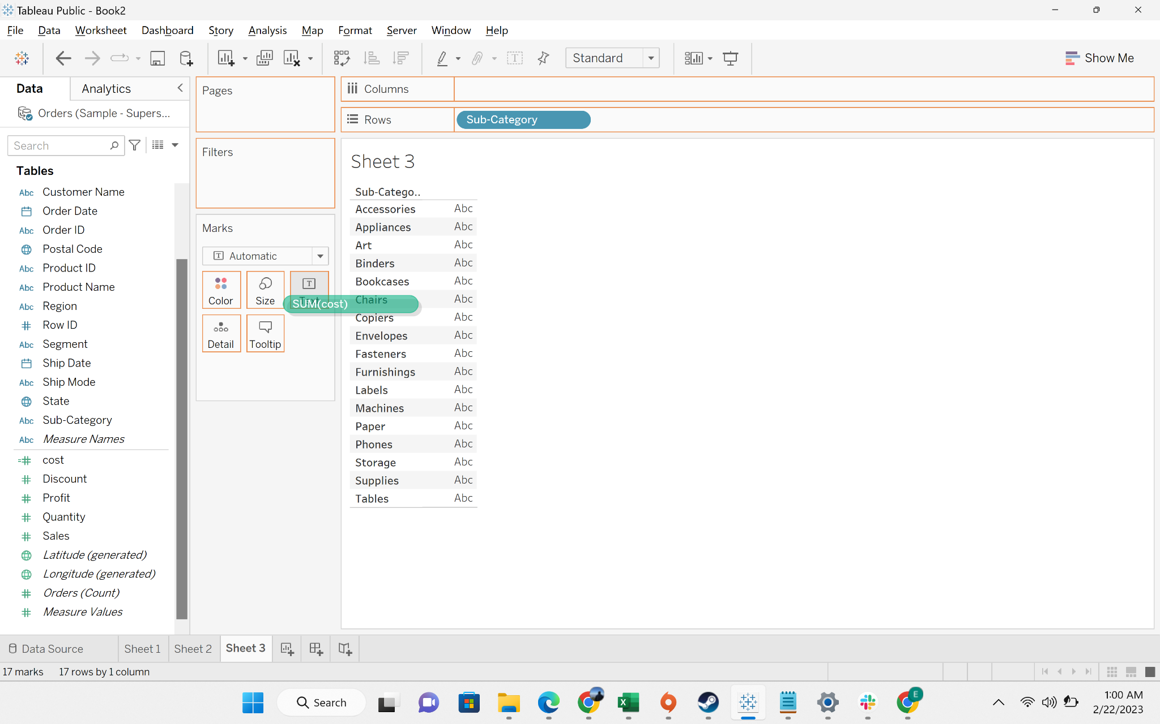

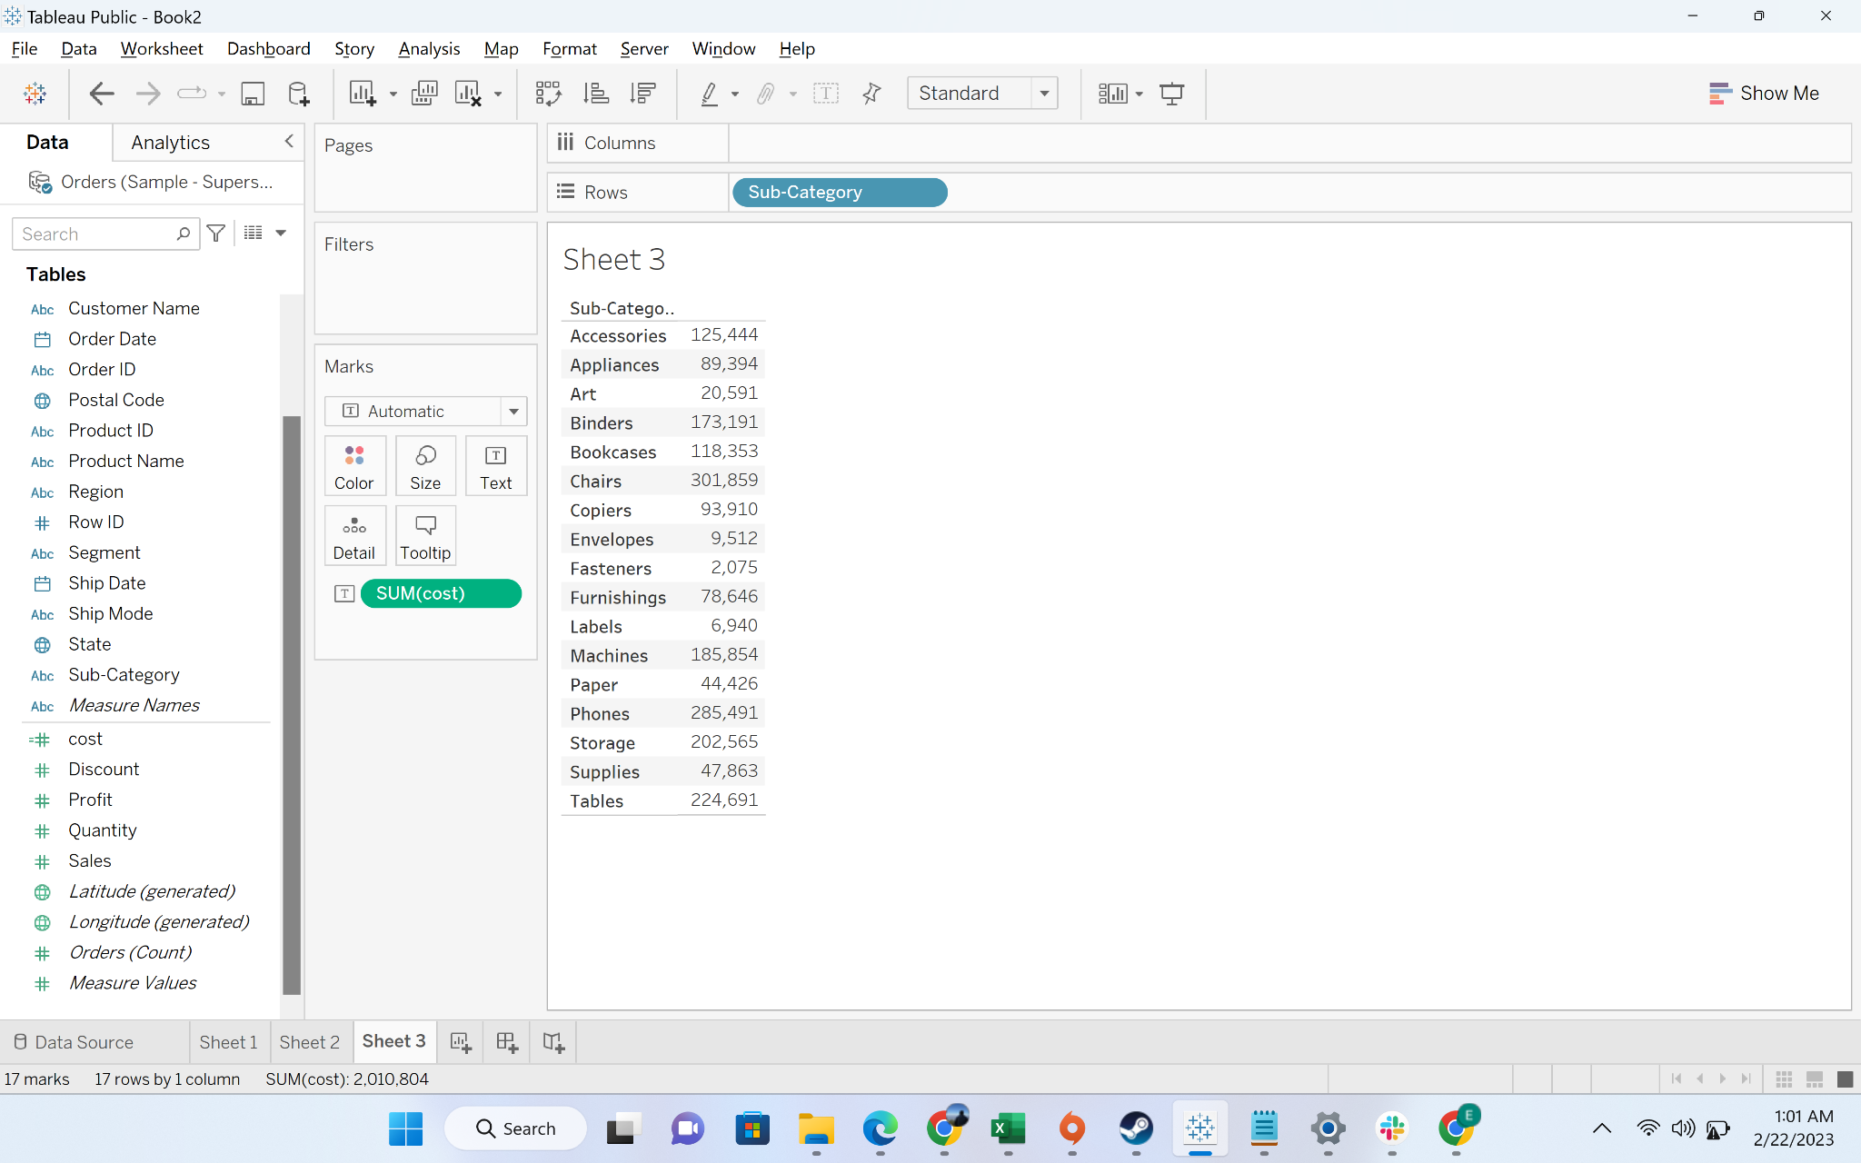

#### Business problem 7 - Find profit ratio of each product sub categories

Solution:

* Aggregate – Measures are first aggregated, and the calculation is then run on the aggregated result
* Steps to do aggregate calculation:
  + Step-1: go to create calculated field

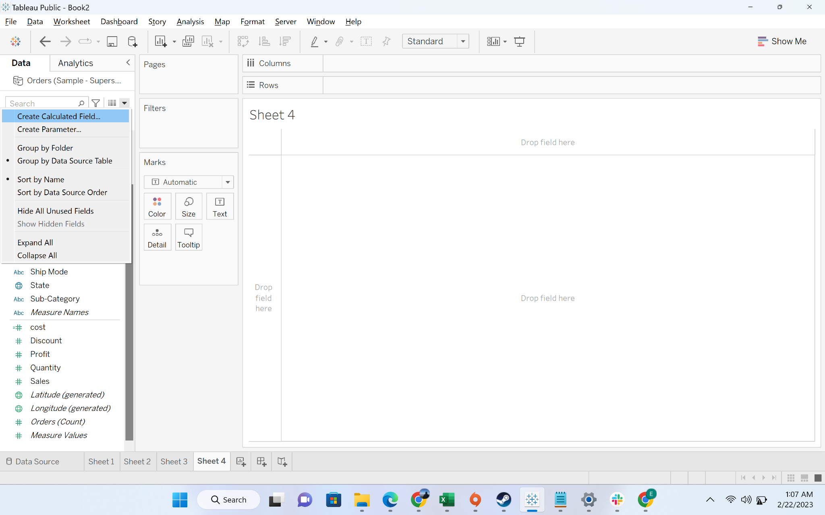

* + Step-2: write the formula for sum to get the formula prompt, and put the profit column, and then aggregate sales

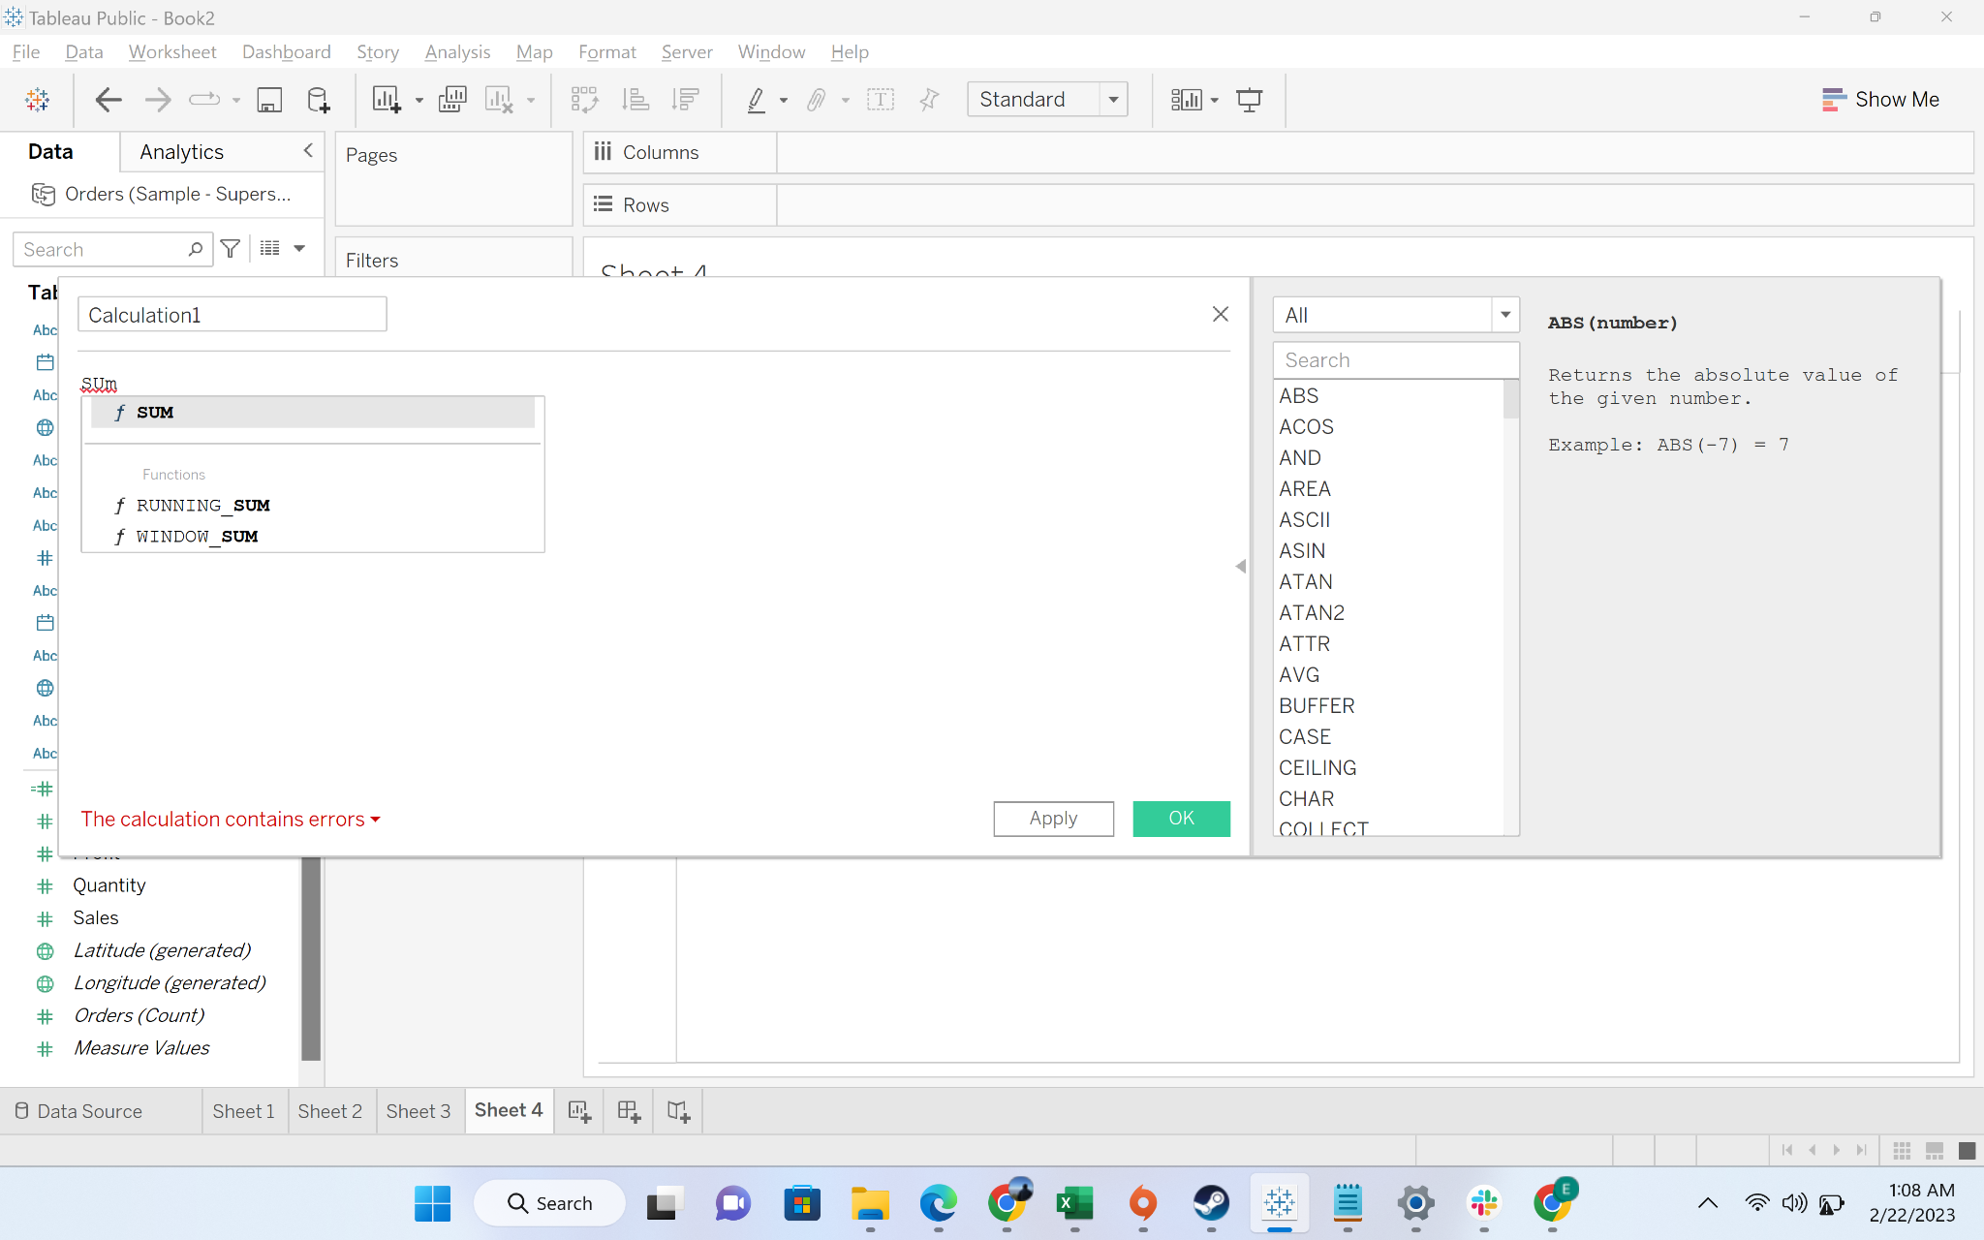

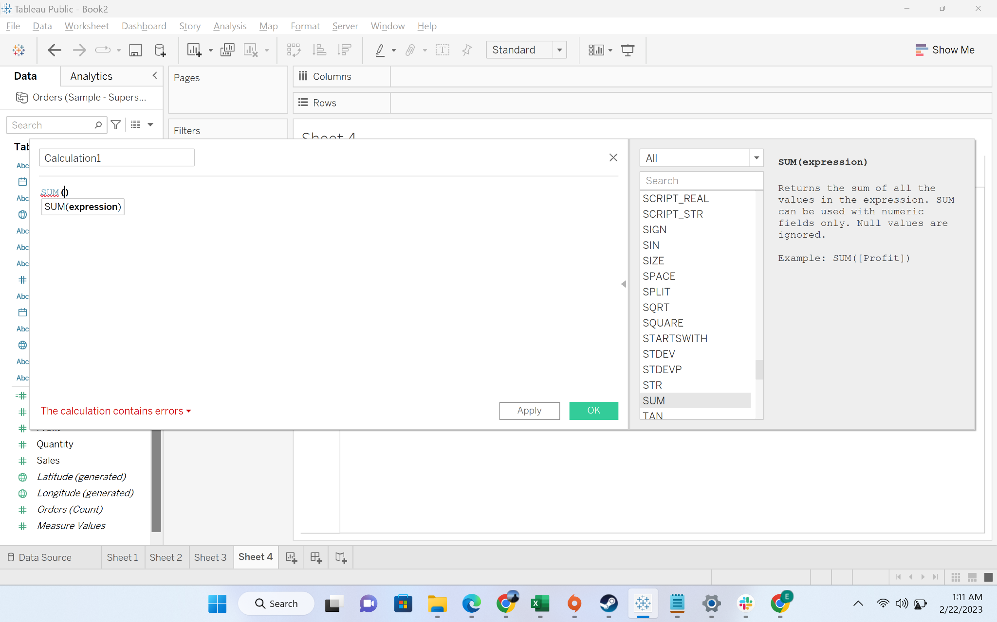

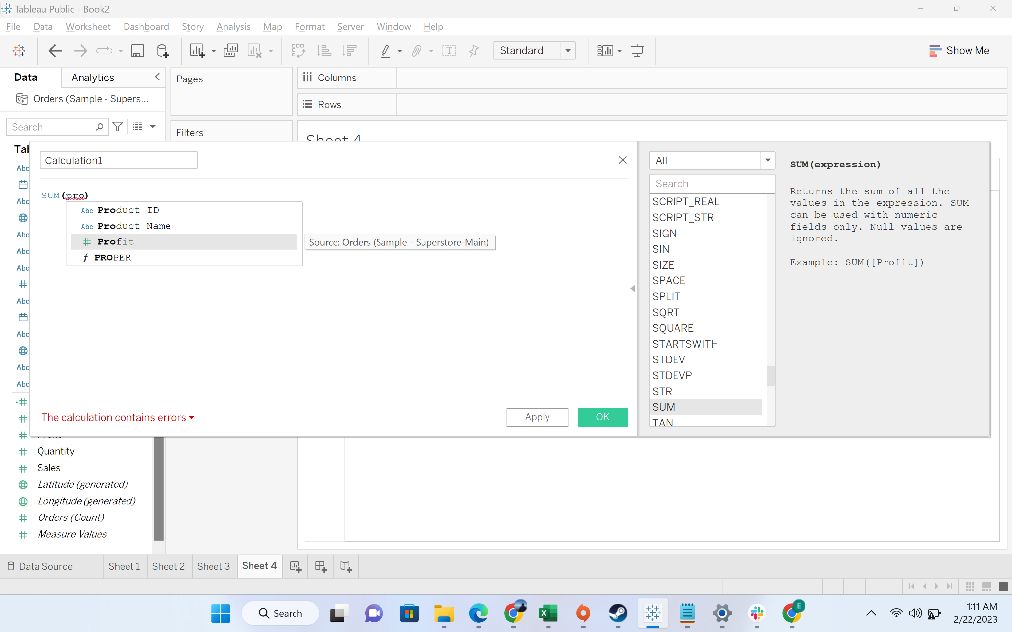

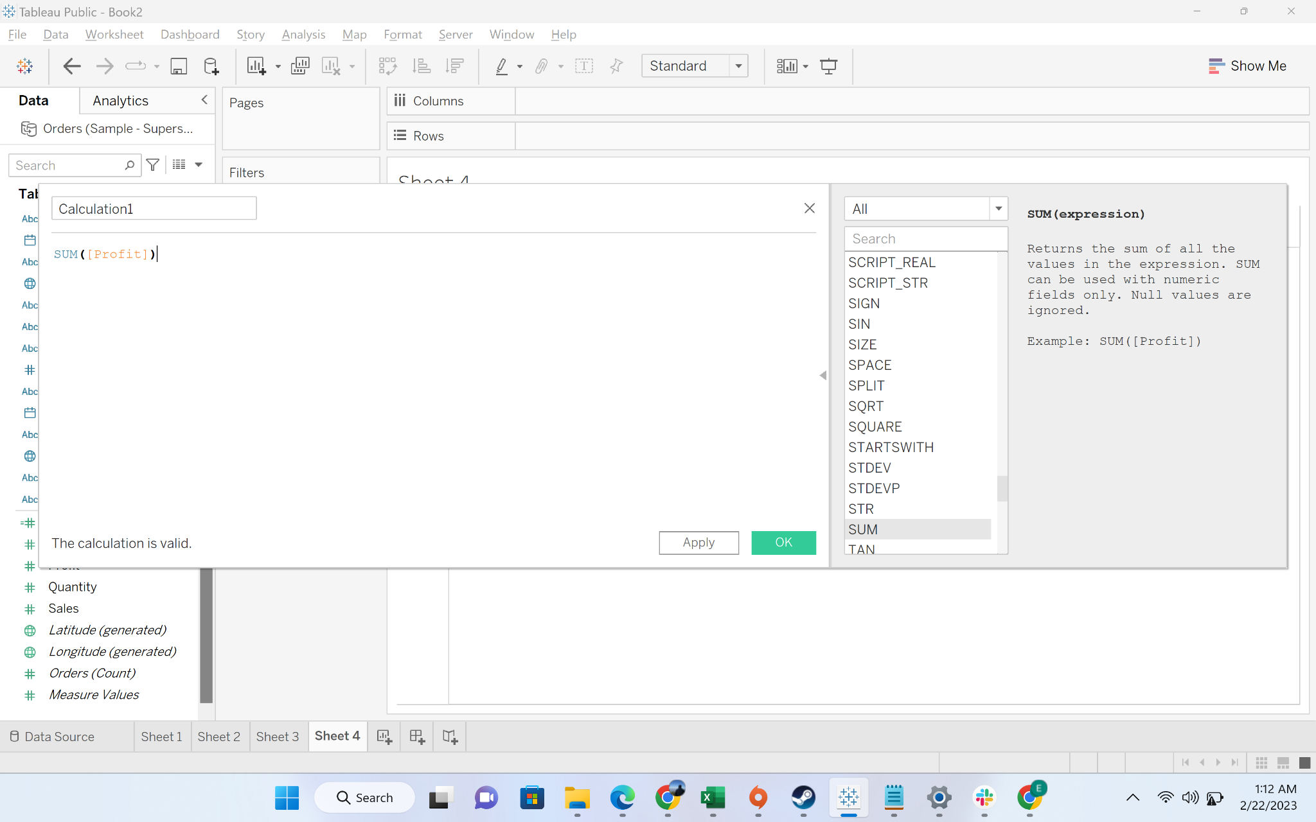

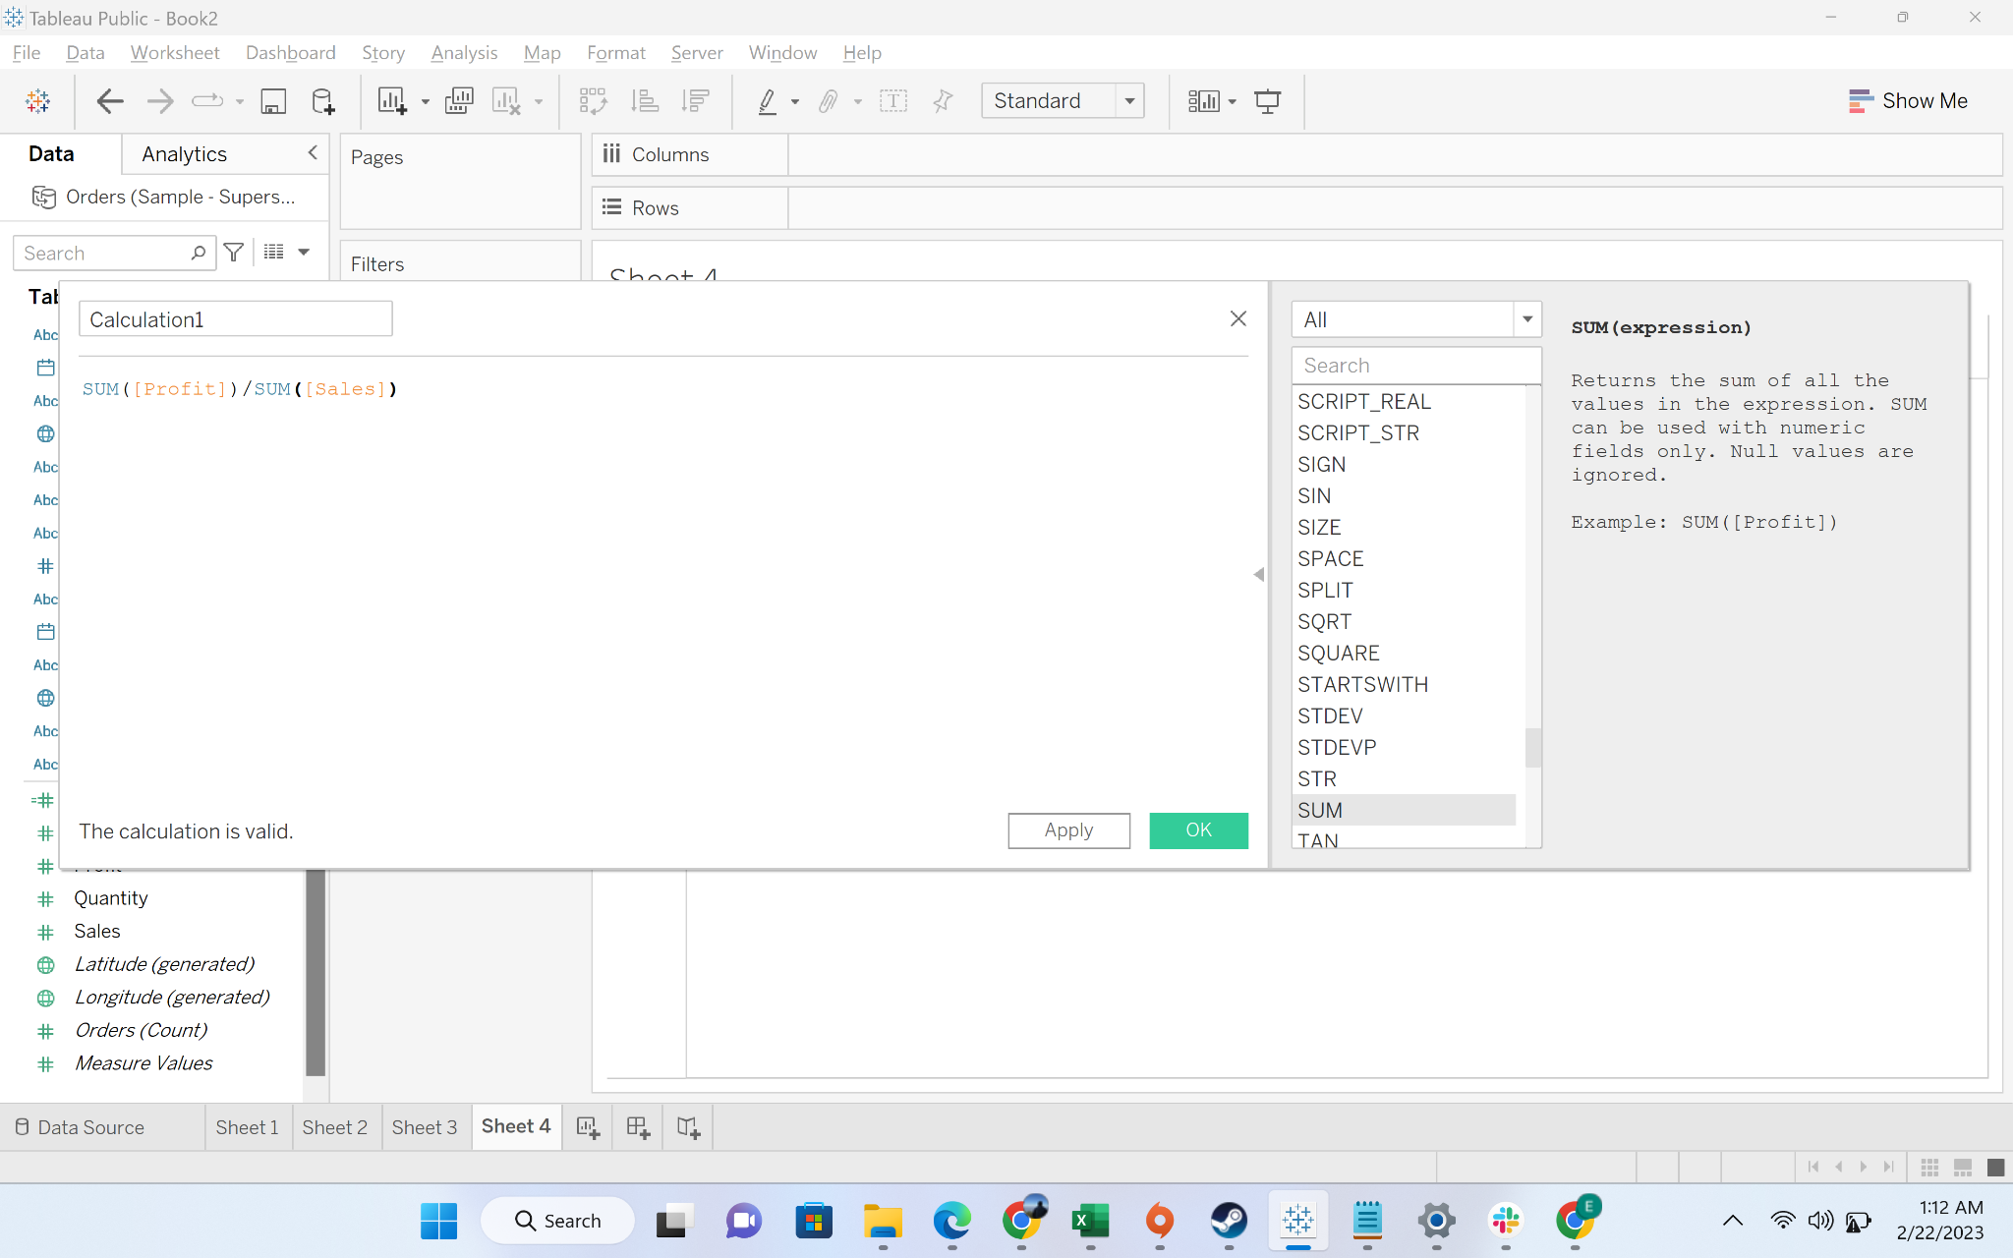

* + Step-3: Rename the calculated field to profit ratio

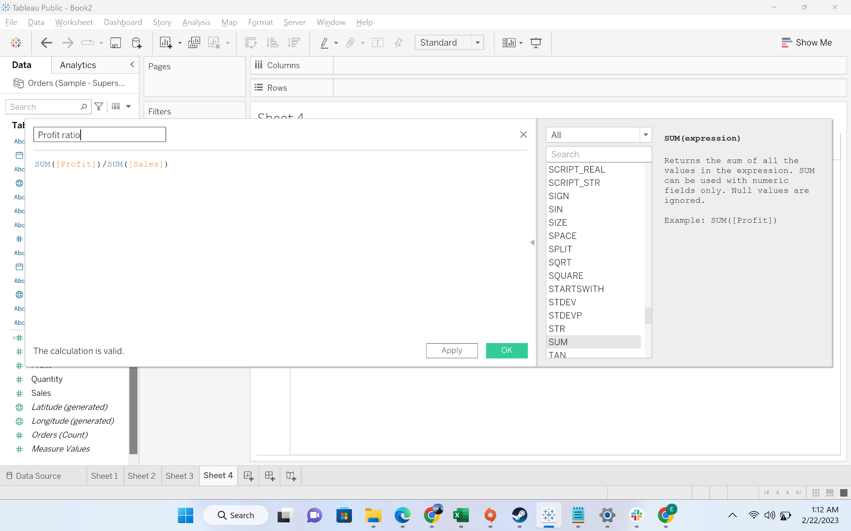

* + Step-4: Drag the subcategory to row and profit ratio to text

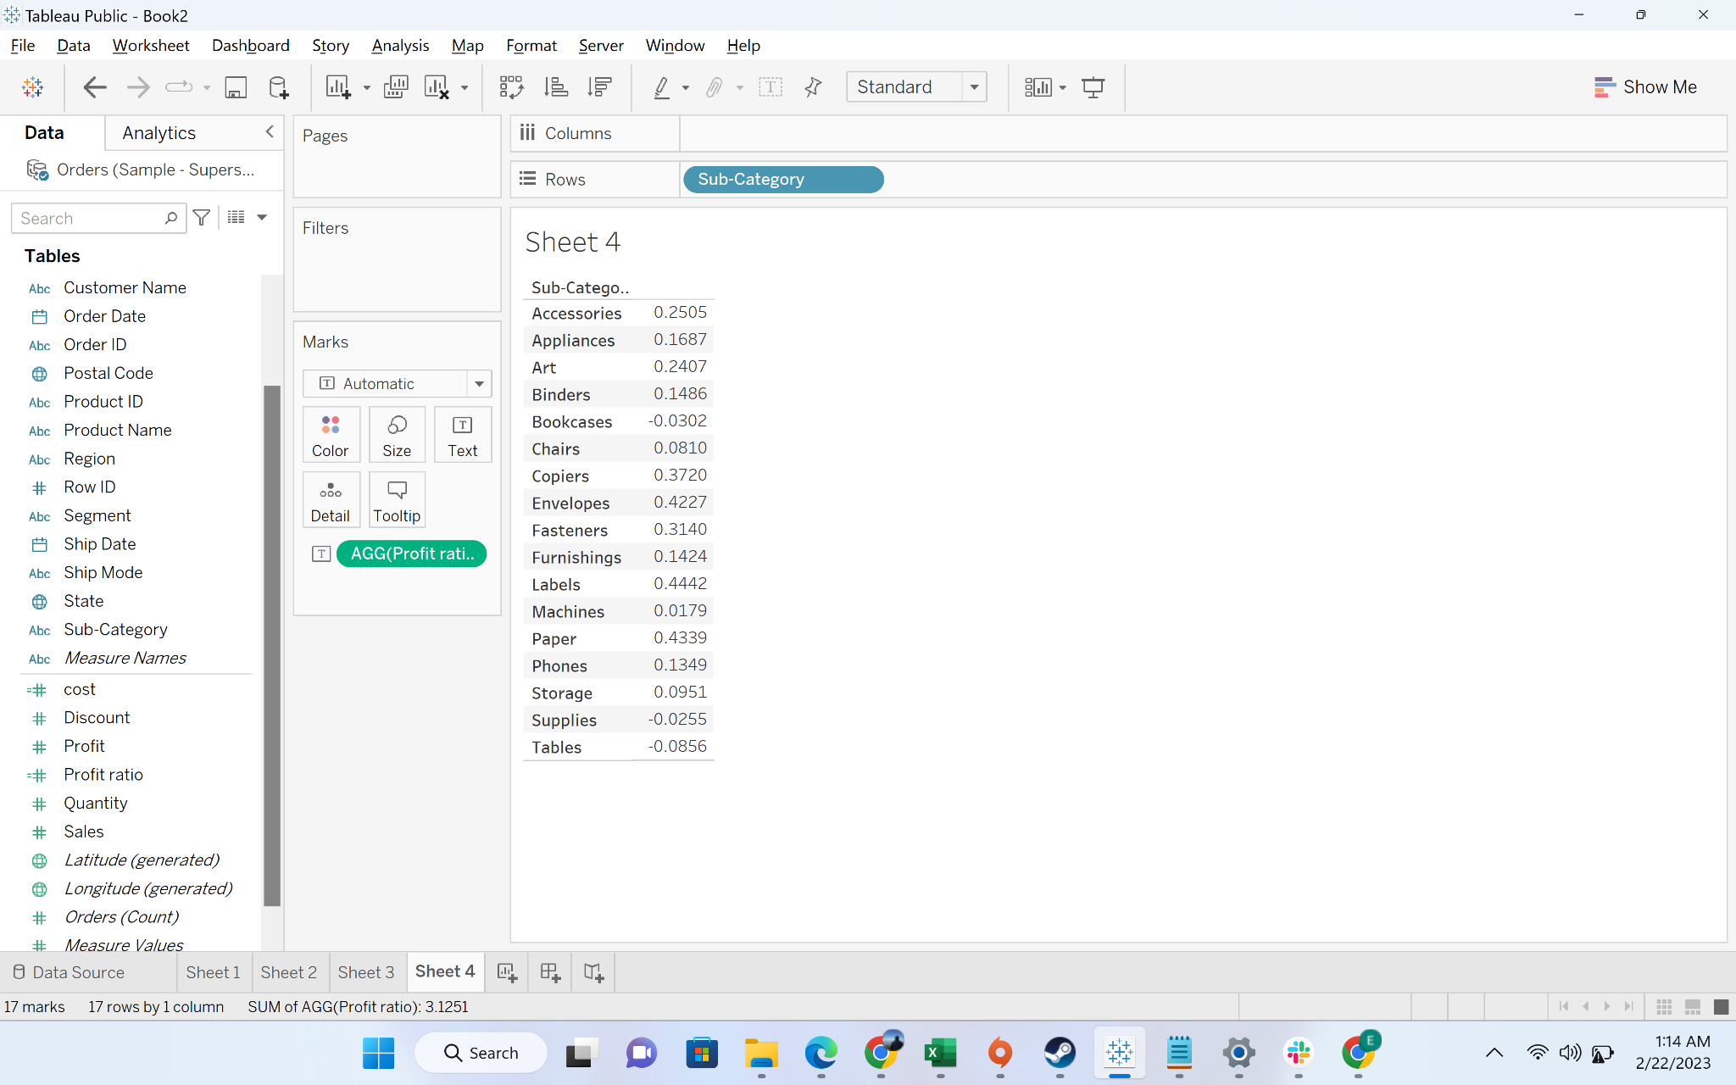

* + Step-5: Convert the profit ratio to percentage

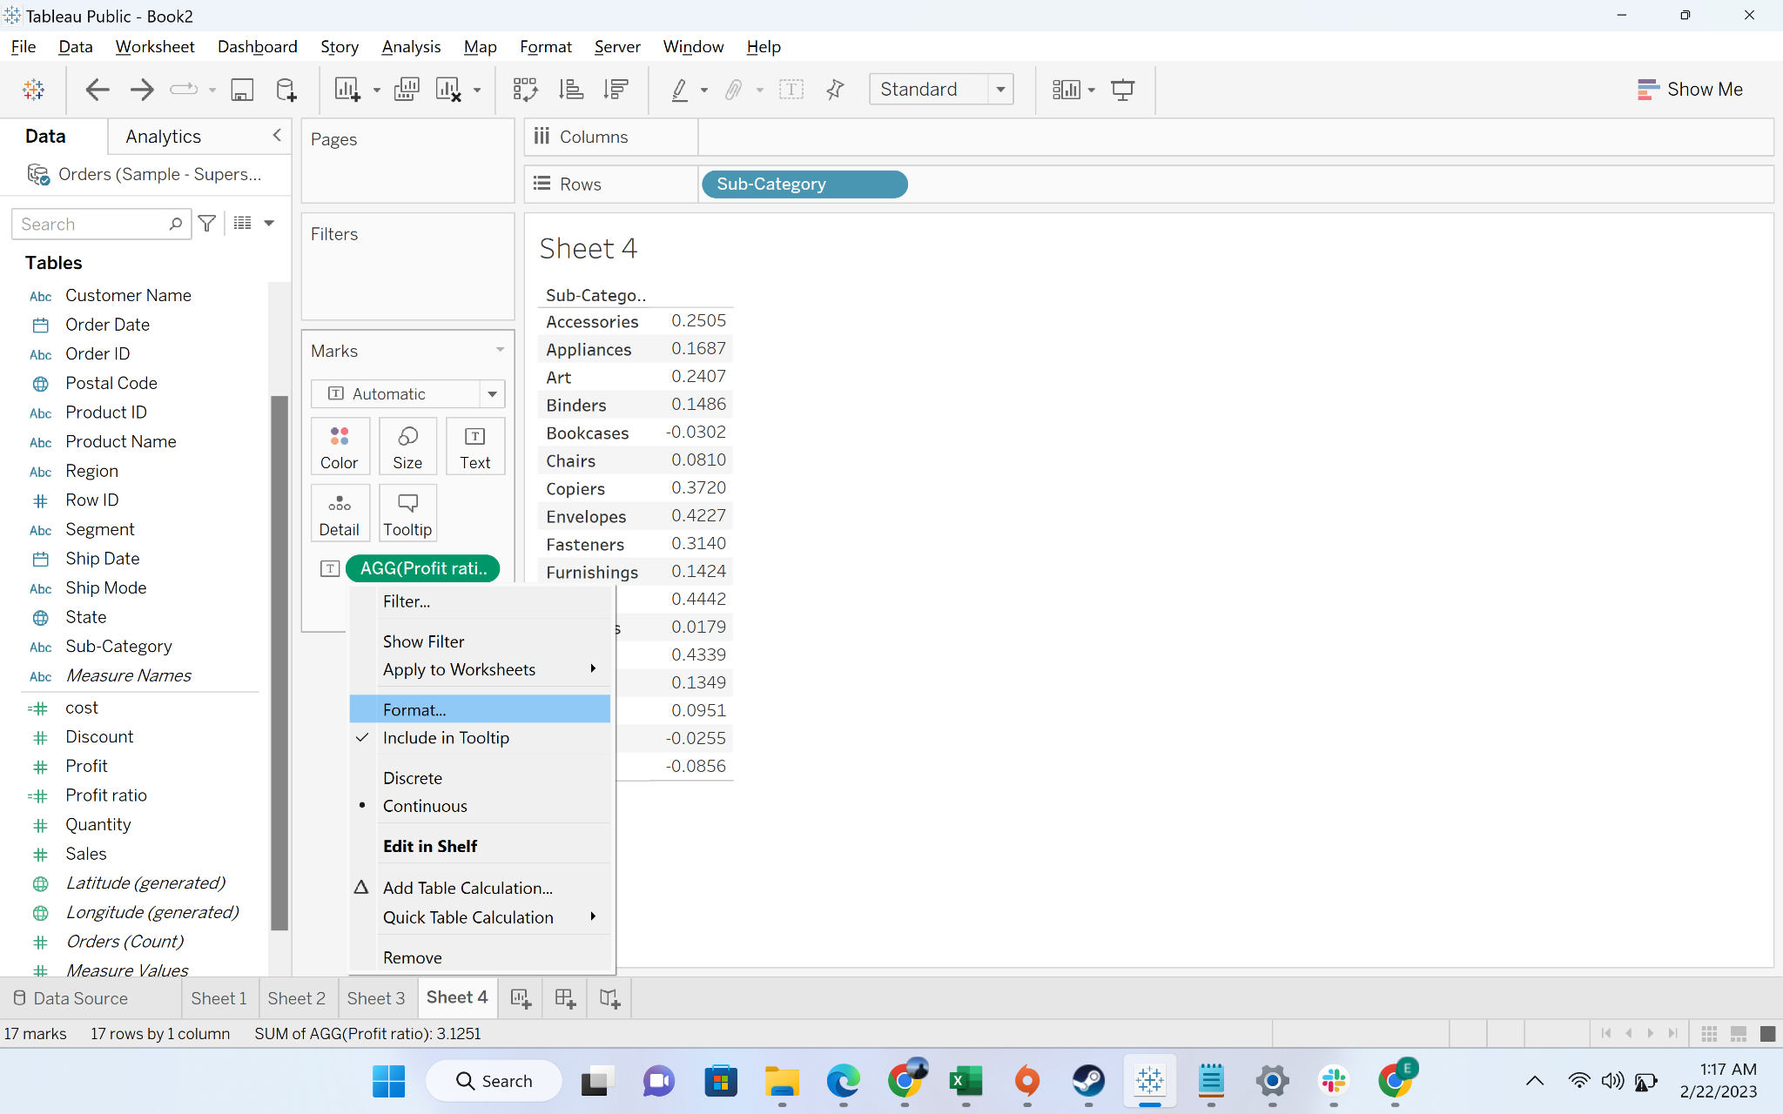

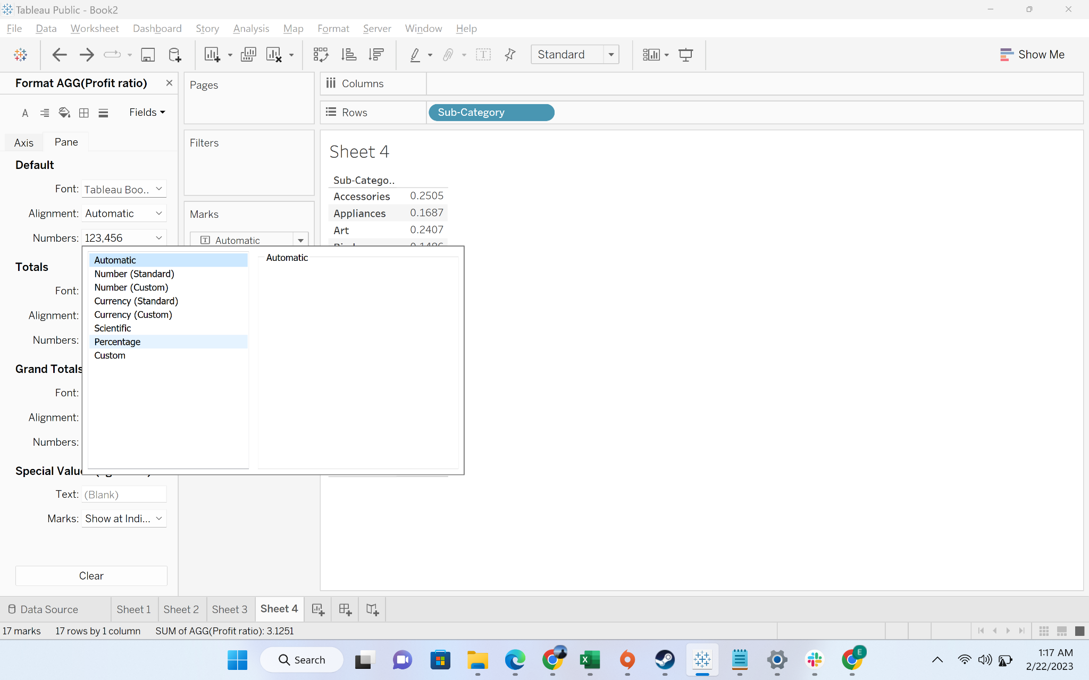

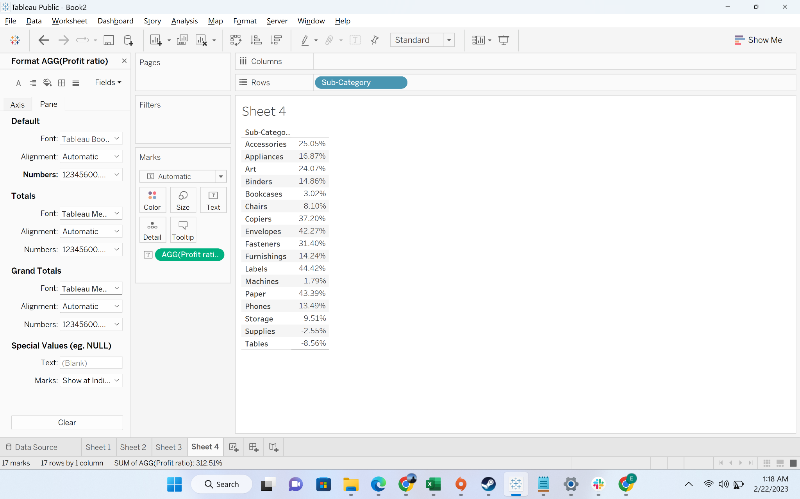

#### Business problem 8: Allow users to select the field against which they want to compare the sales value.

* Business context:
* Steps to do getting the dynamic visualization:
  + Step-1: go to create parameter - “chosen dimension”

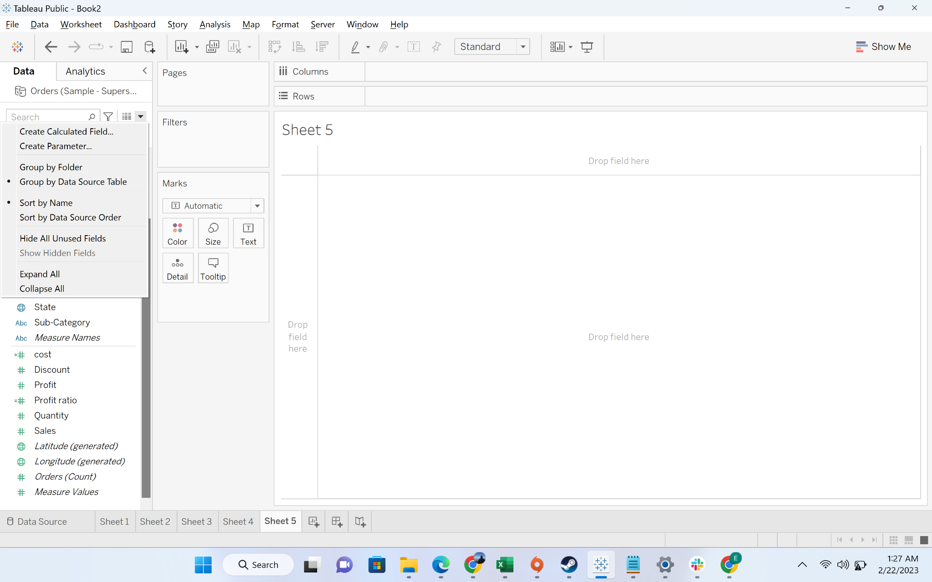

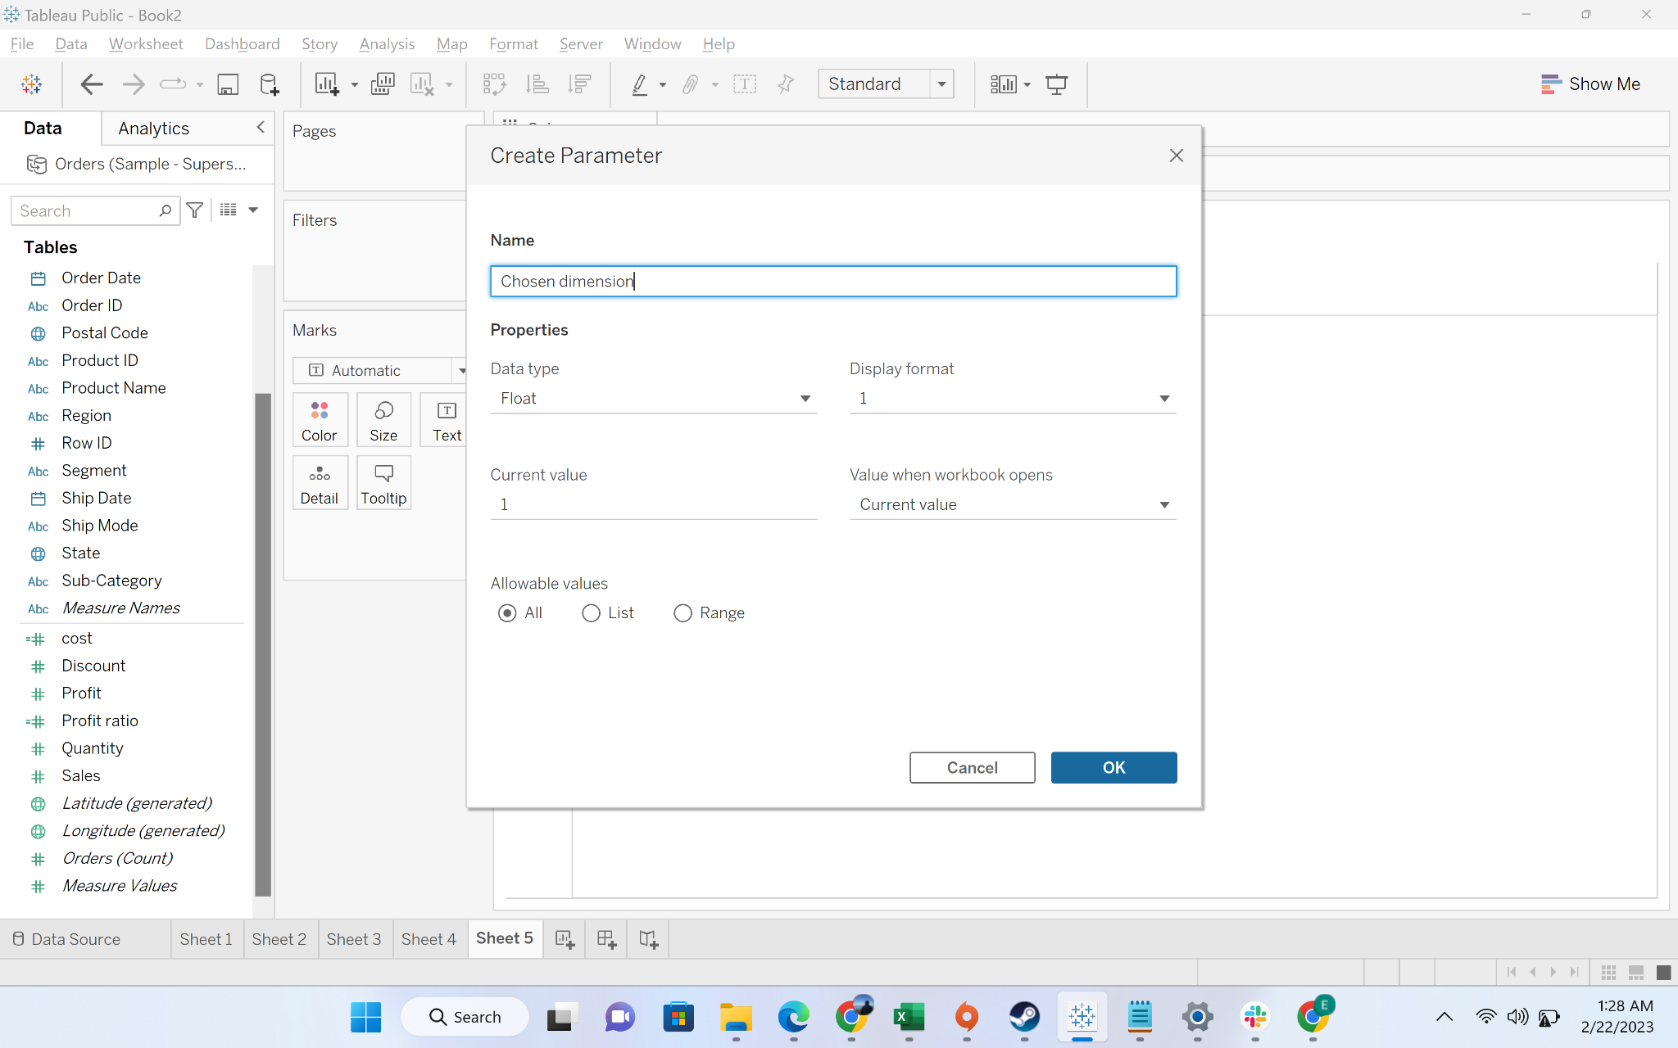

* + Step-2: Change the data type to “String”

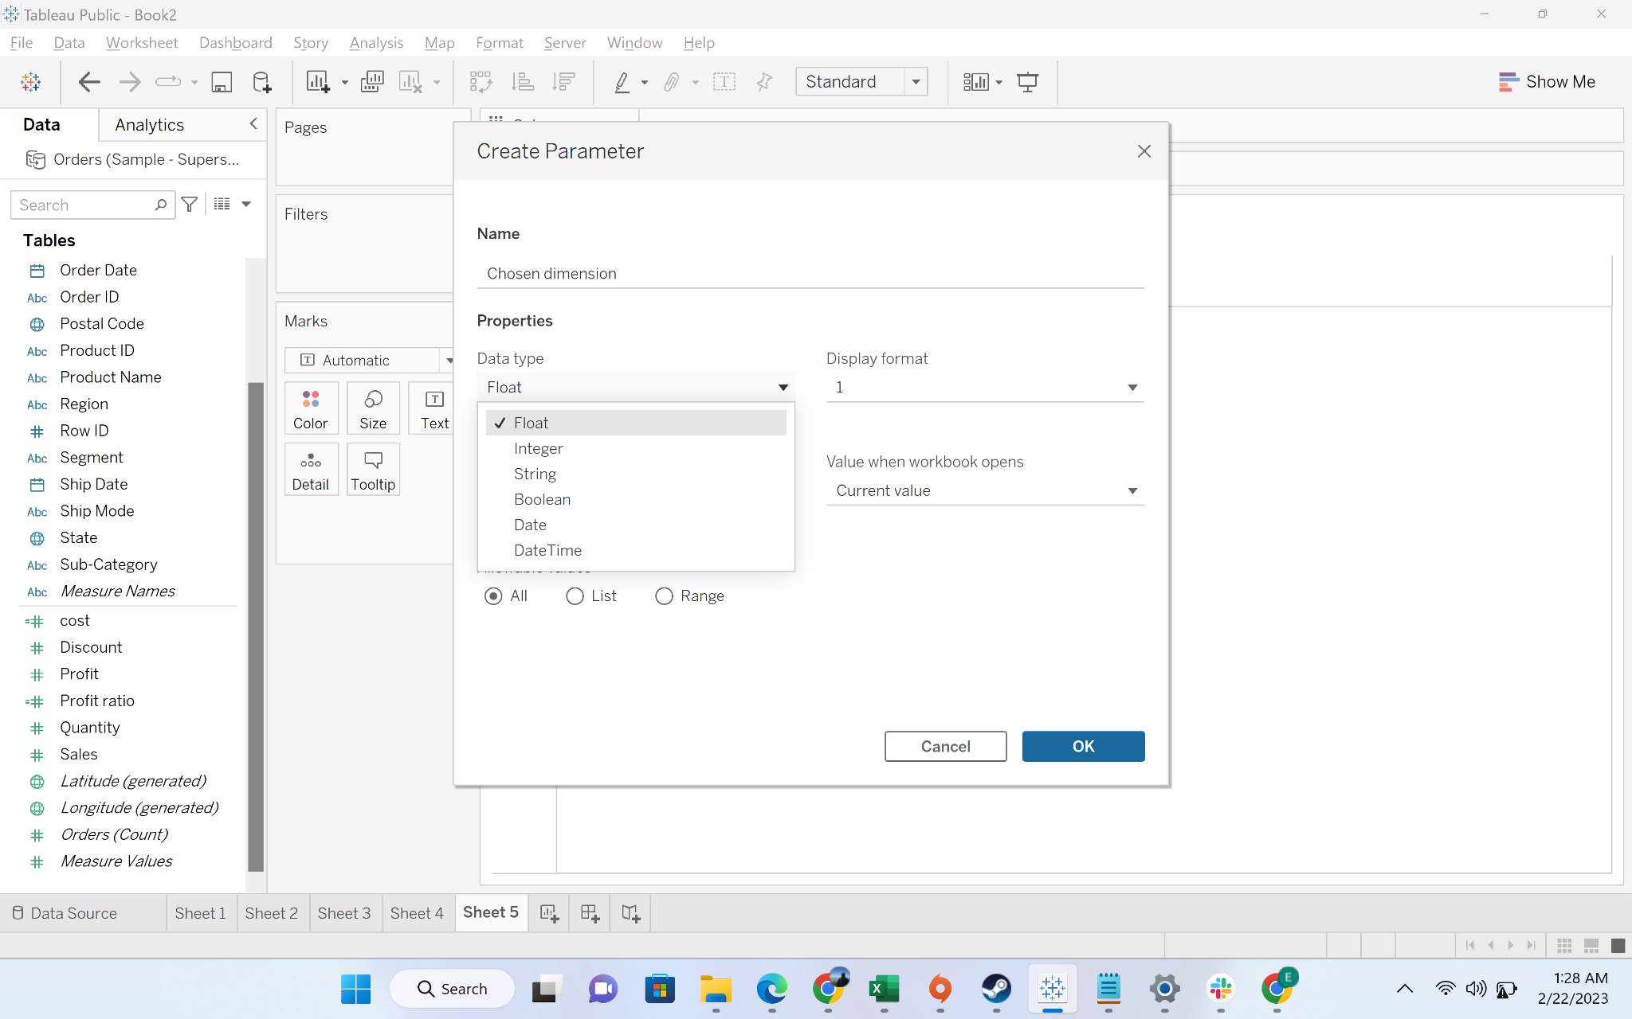

* + Step-3: Change the allowable values to ‘list’

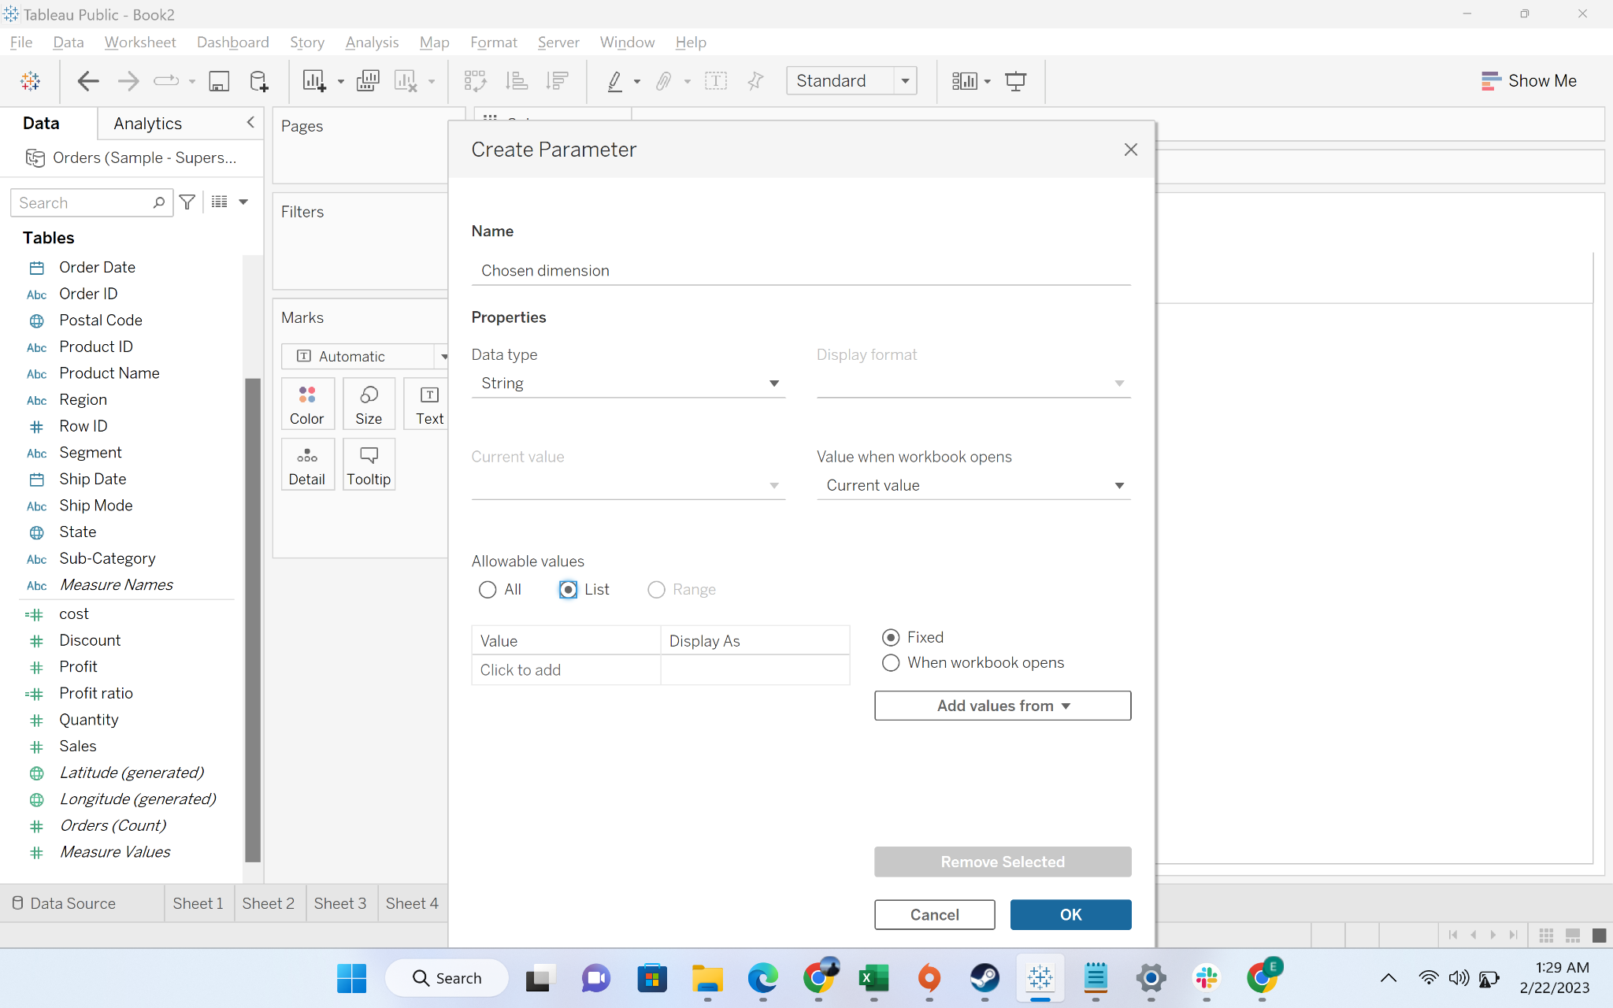

* + Step-4: Add the following values in the list: category, sub-category, state

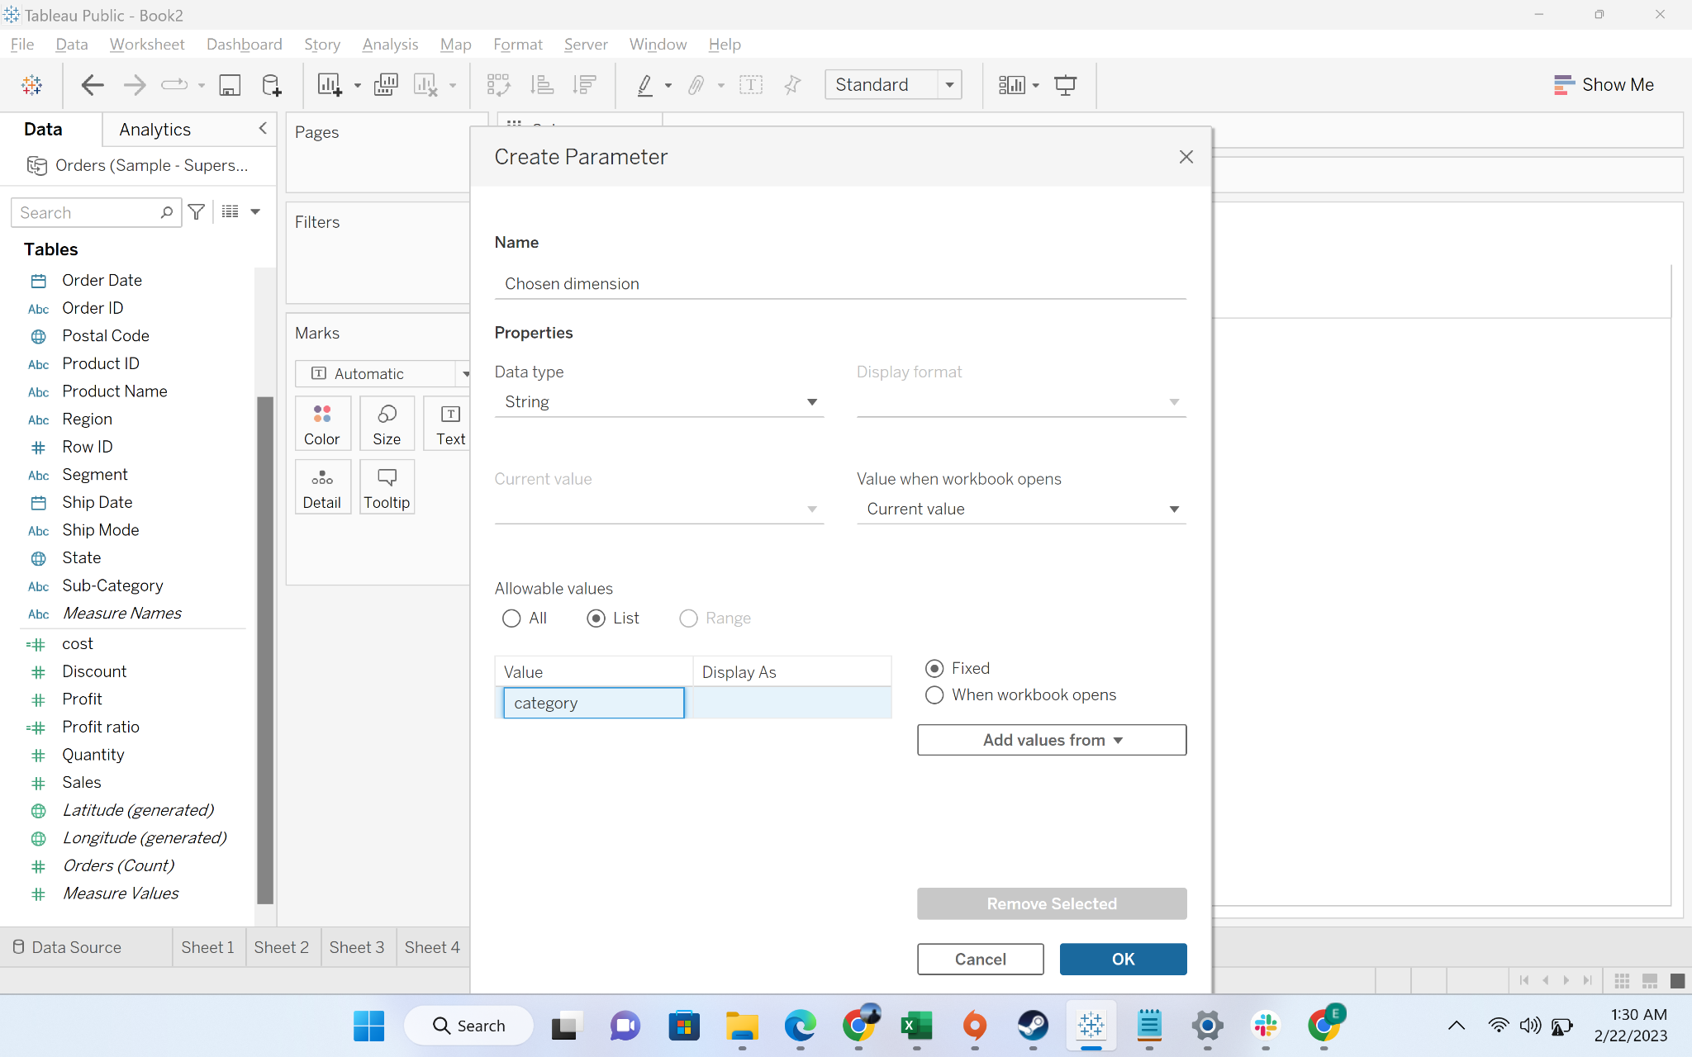

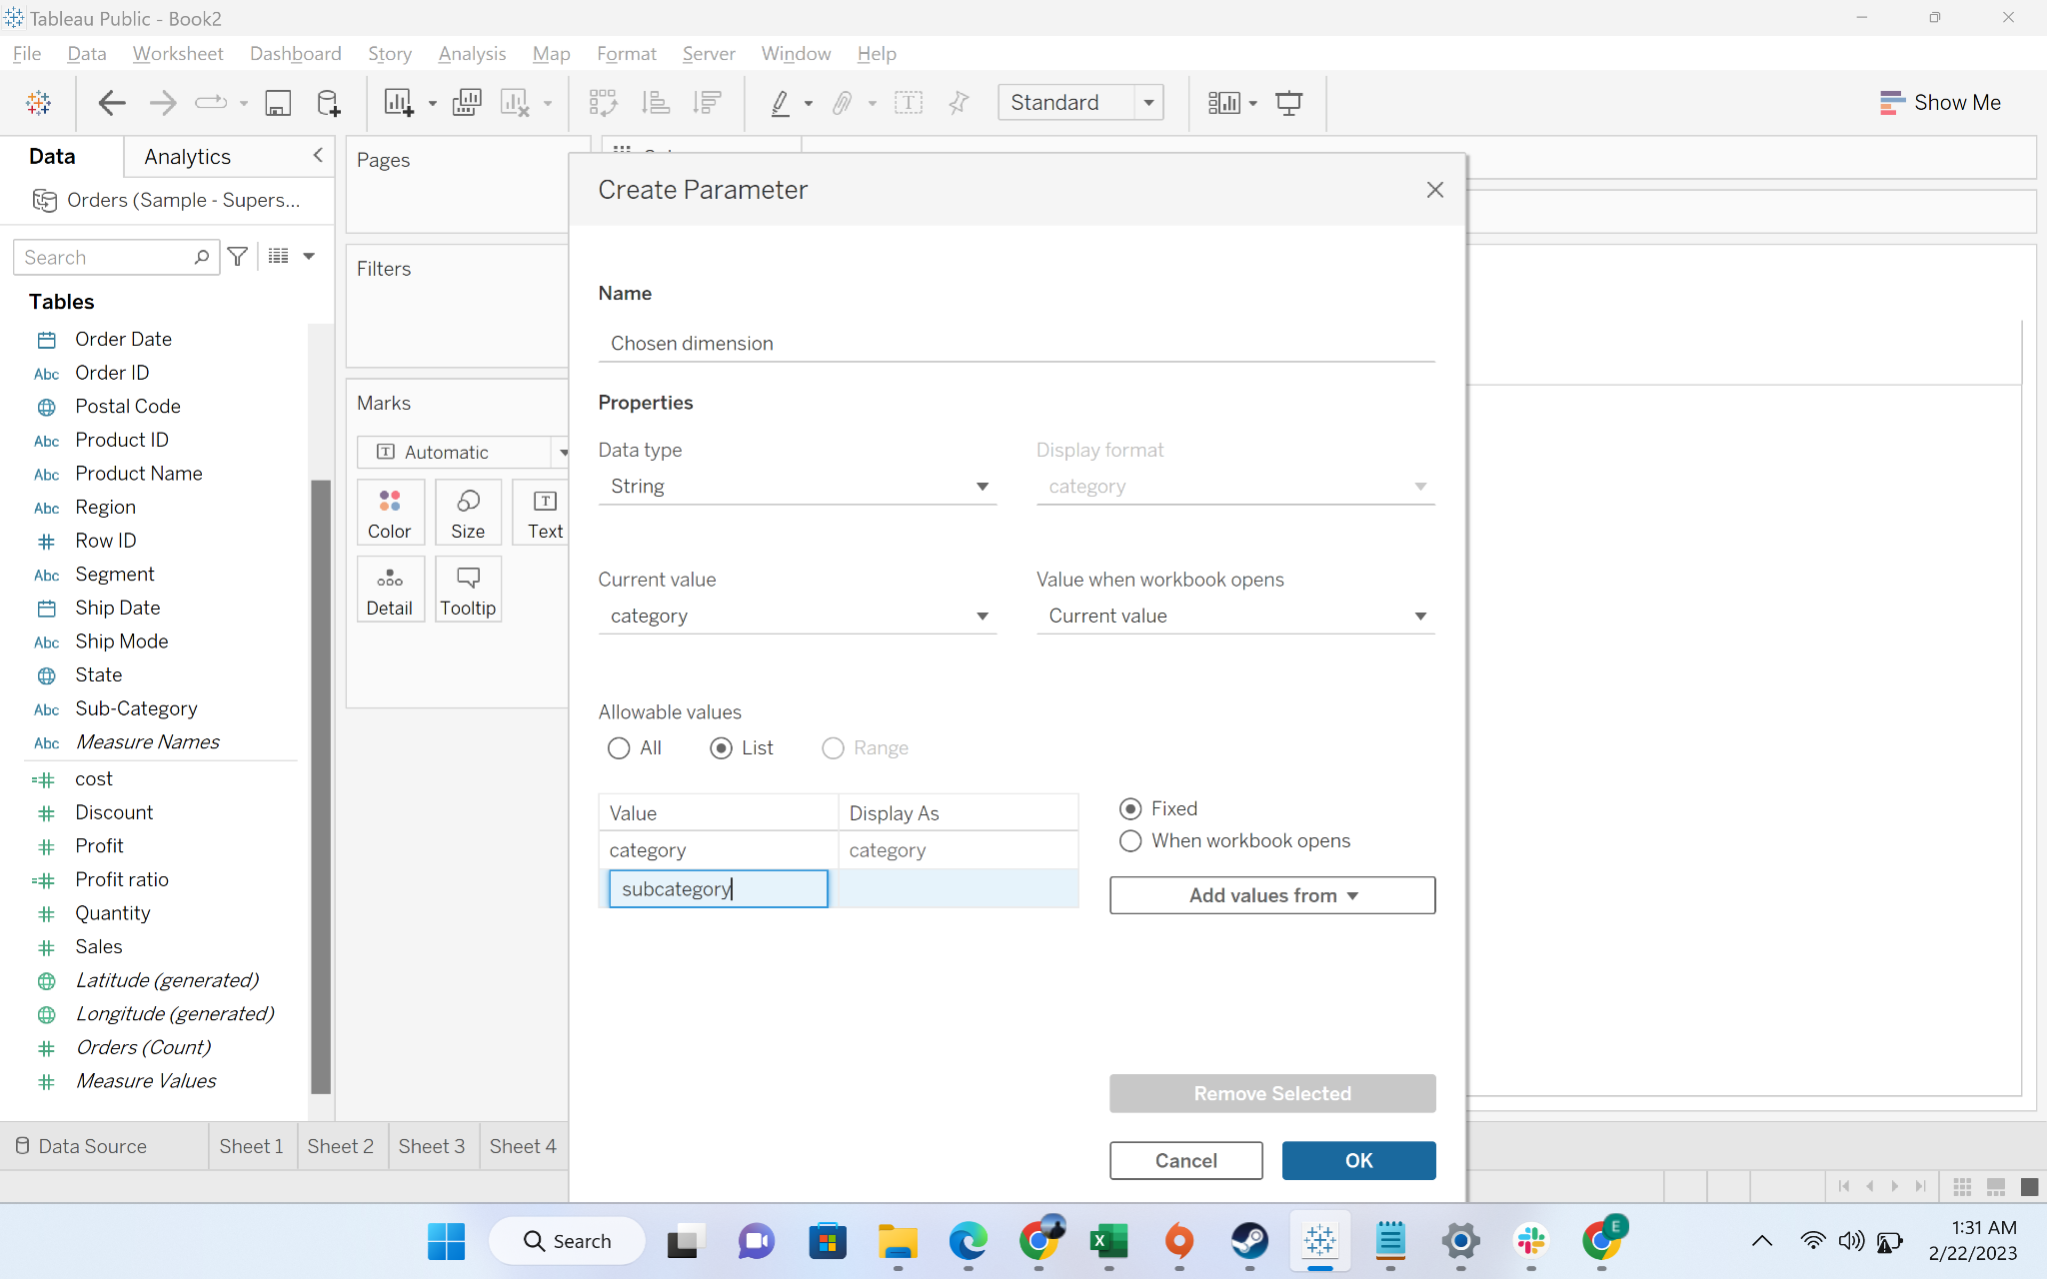

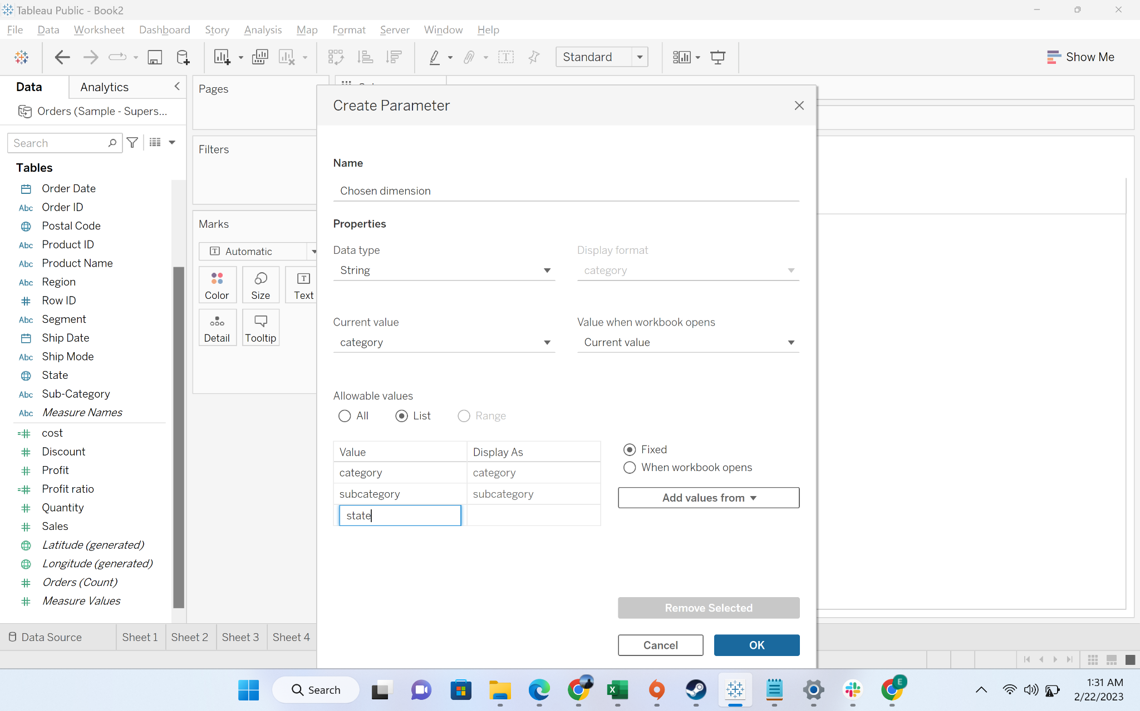

* + Step-5: Show parameter

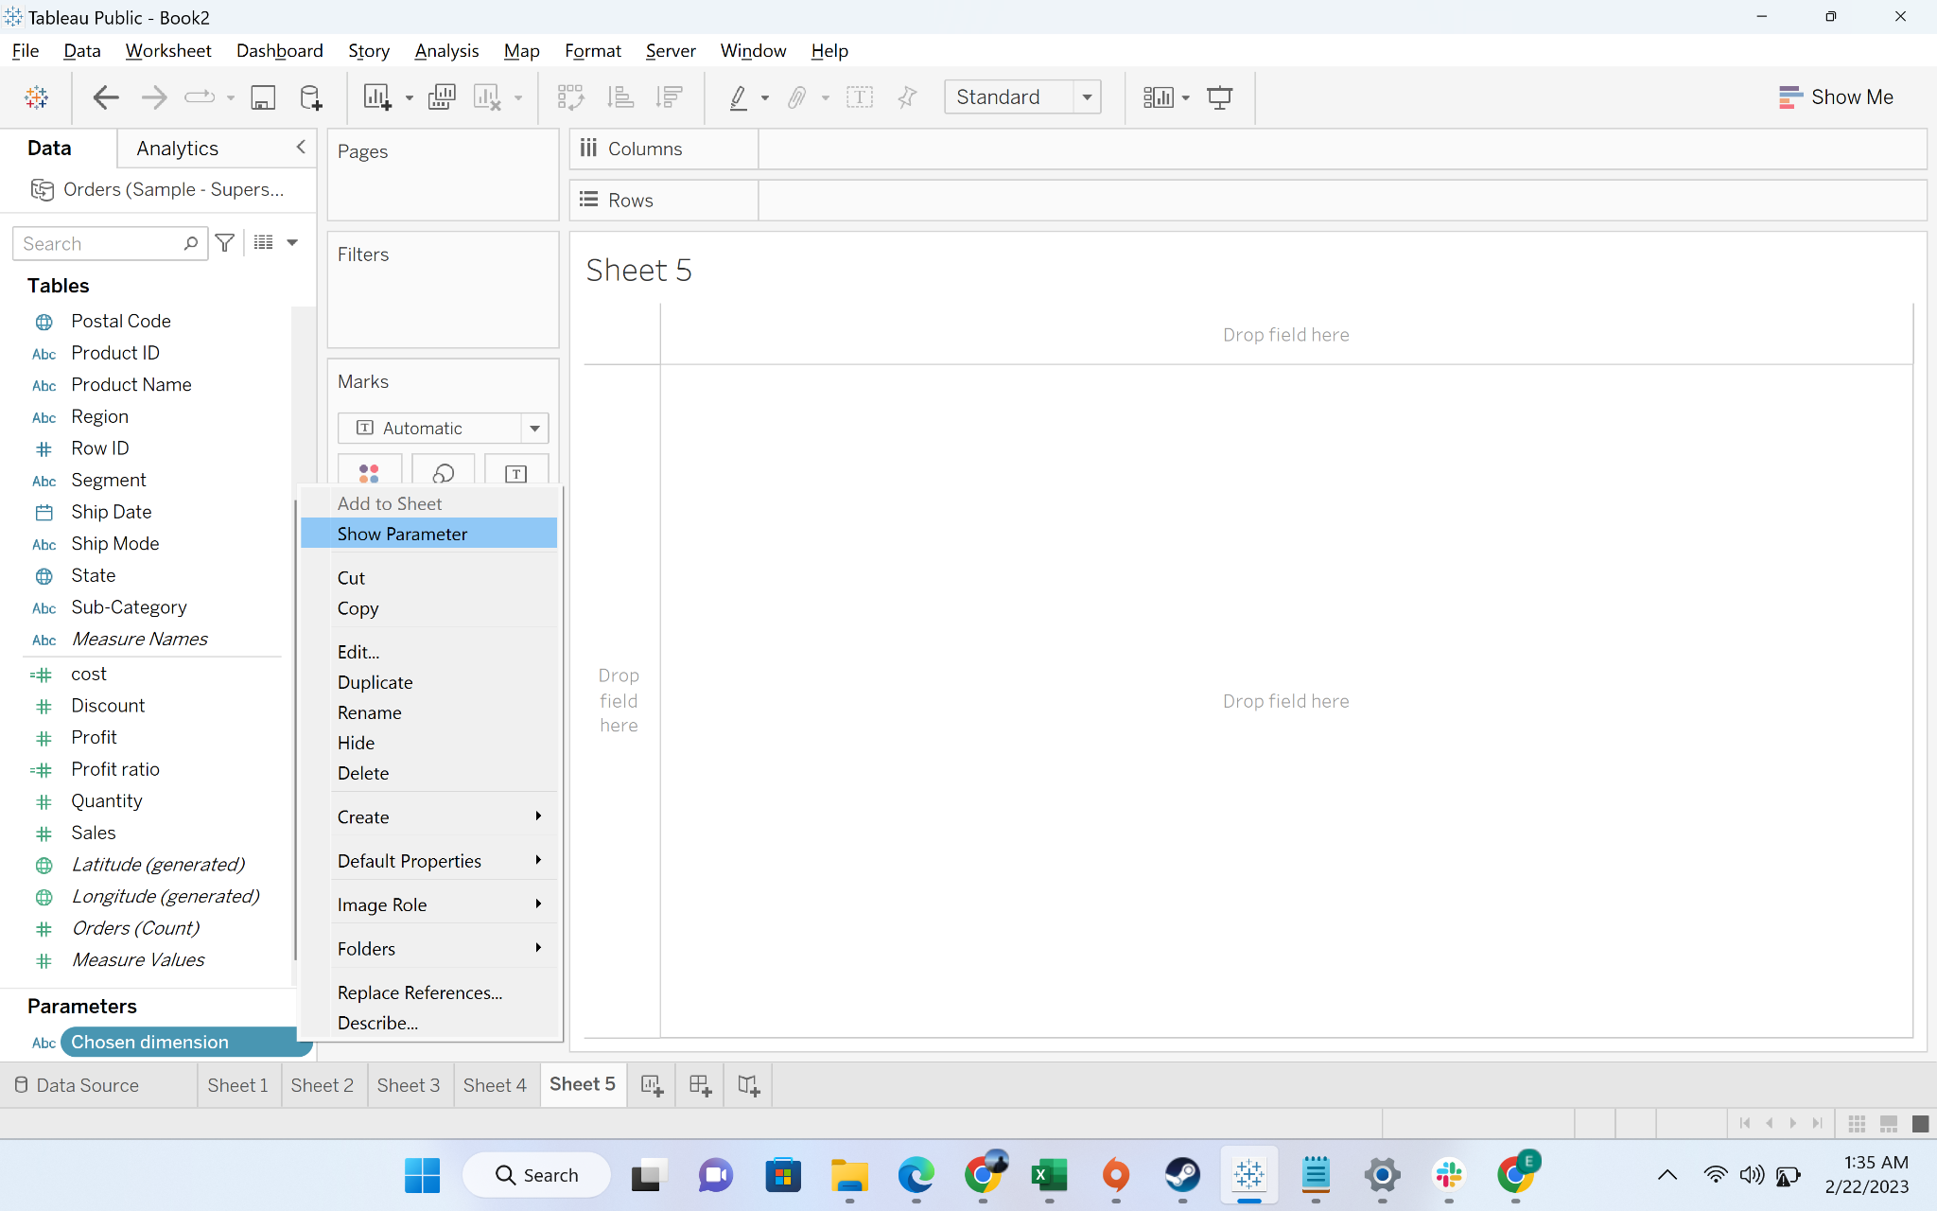

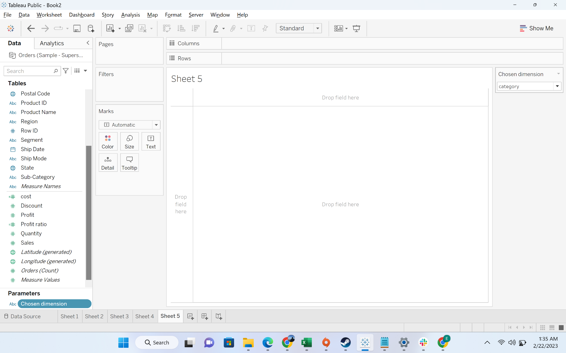

* + Step-6: Now we will create a calculated field called dimension list

**Formula**

CASE [Chosen dimension]

WHEN 'category'

THEN [Category]

WHEN 'subcategory'

THEN [Sub-Category]

WHEN 'state'

THEN [State]

END

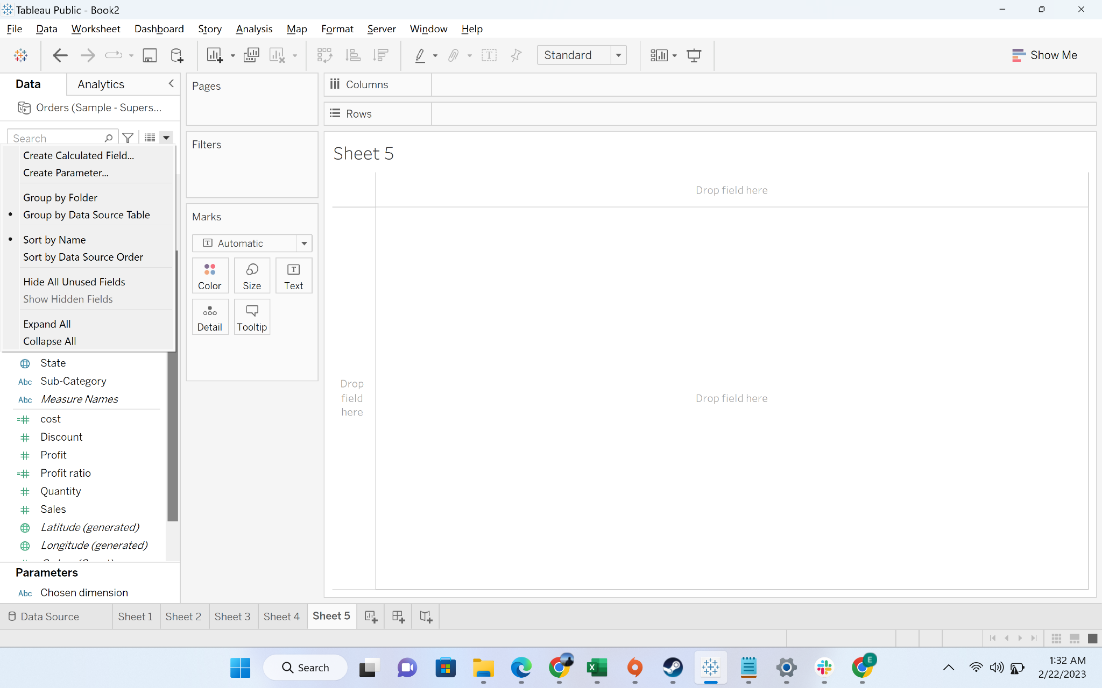

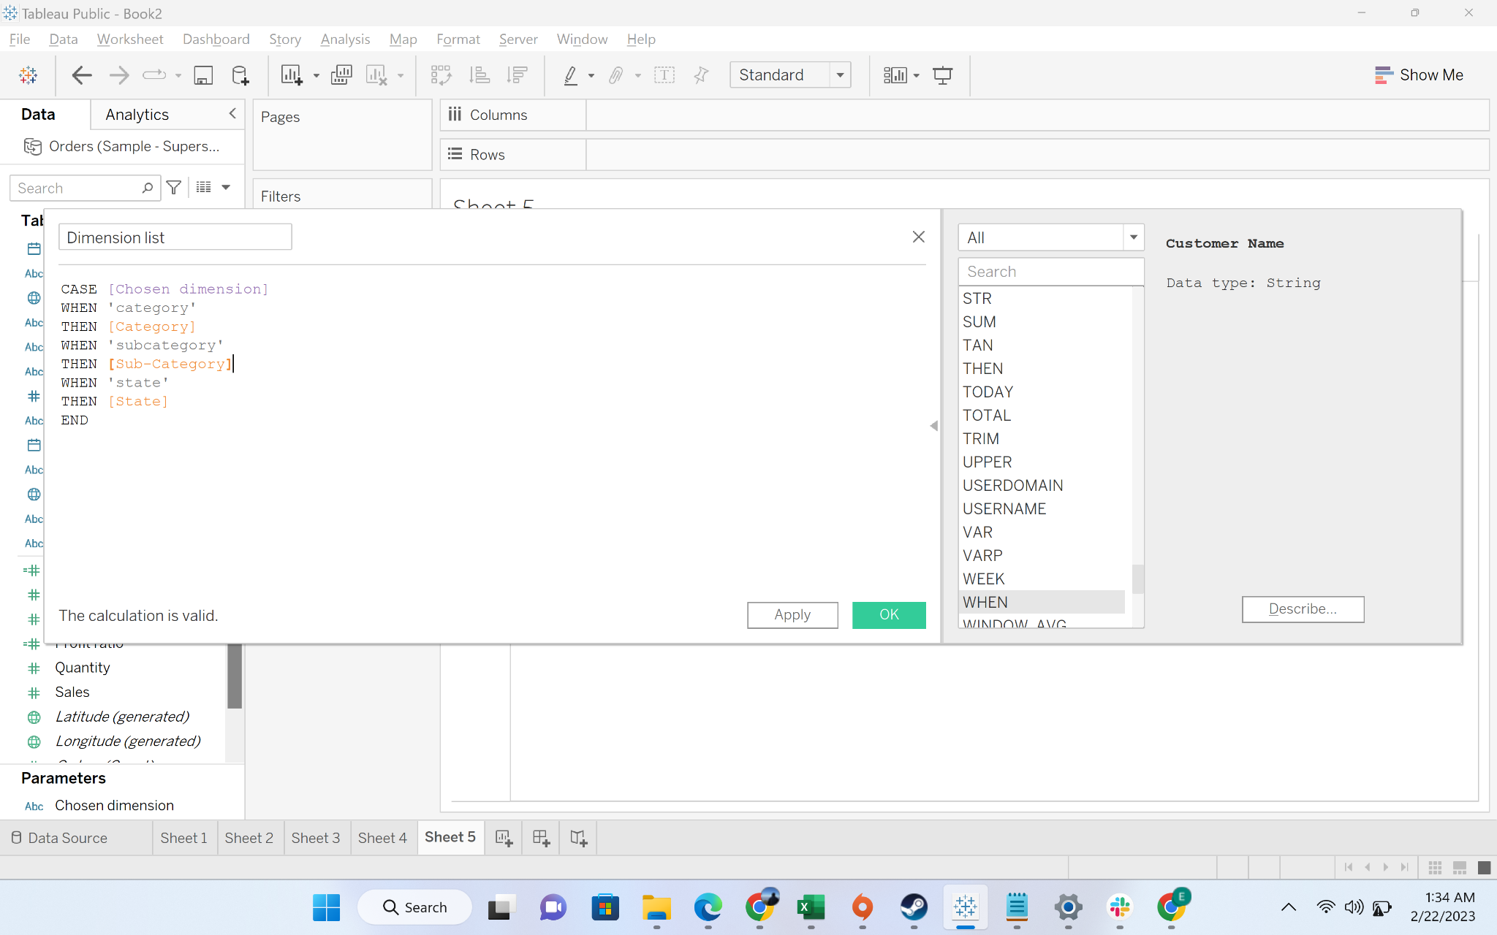

* + Step-7: drag dimension list to rows and sales to columns

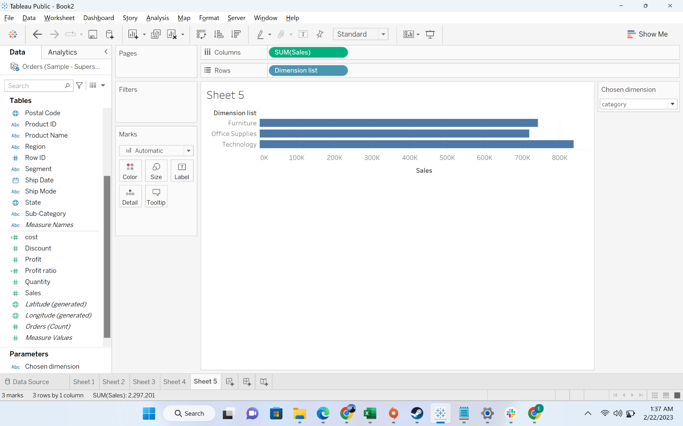

* + Step-8: if we chose subcategory from “Chosen Dimension”

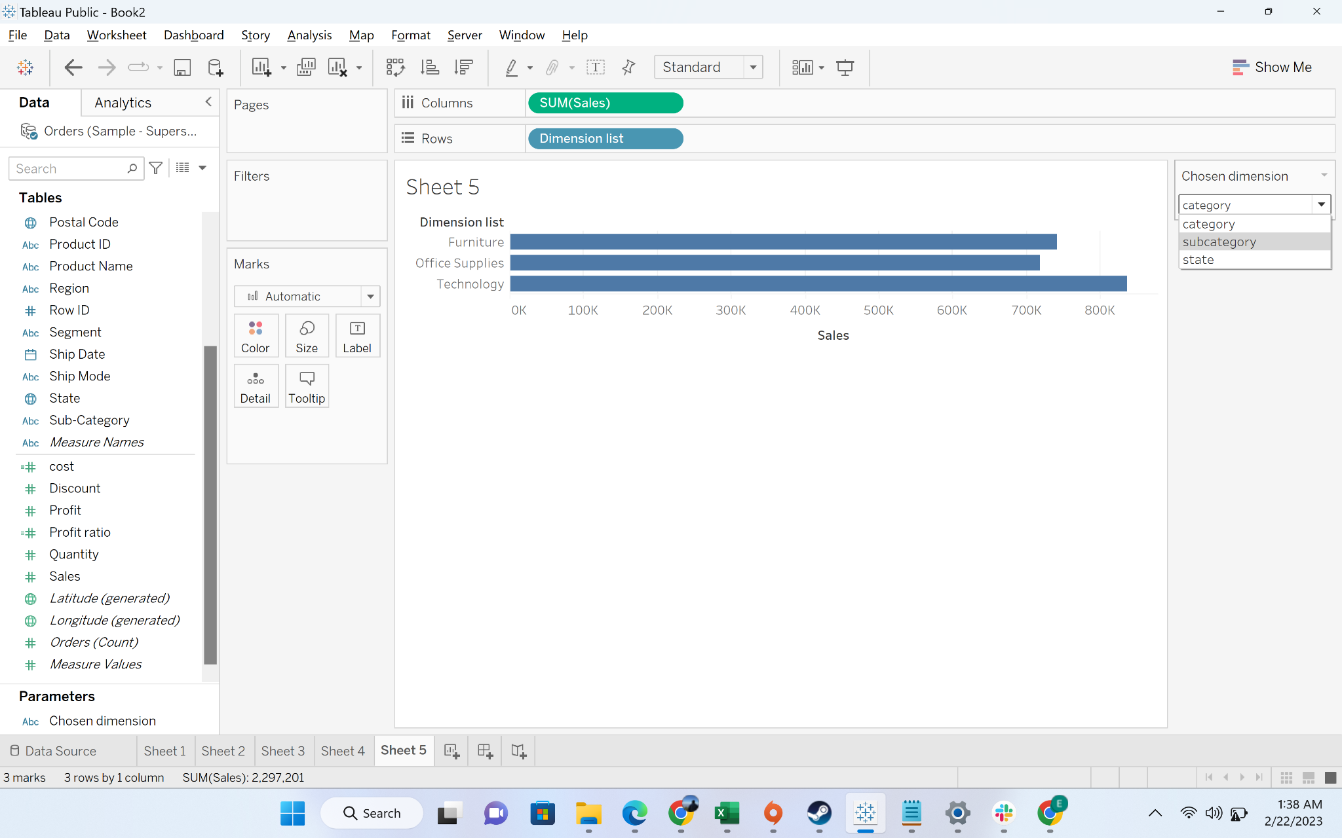

* + Step-9: we will get the sales breakdown by subcategory



 